Supplementary Figure 1.

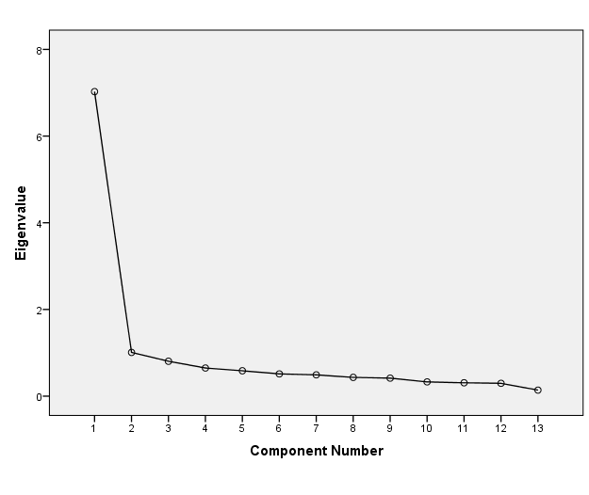
Supplementary Figure 1. Scree plot resulting from factor analysis of MCQ items (extraction method: principle components analysis)

