Appendix
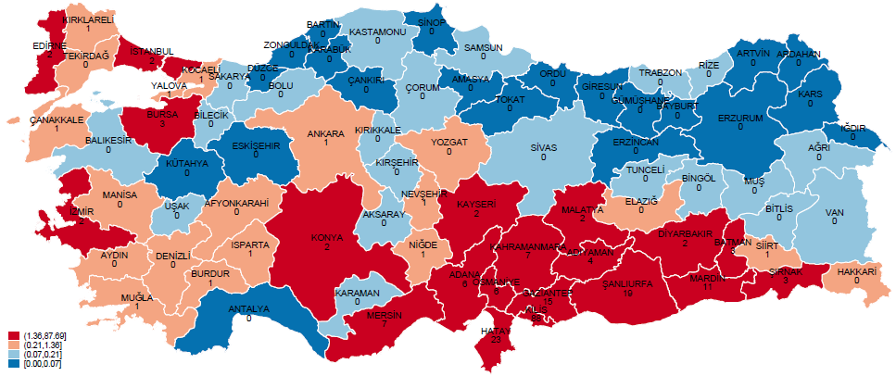

Figure A1. Ratio of Syrian Refugees to Turkish Population in 2015 (%)

Table A1. Description of NUTS-2 level regional division and refugee ratios in NUTS-2 regions in Turkey as of the end of 2015.
NUTS-2 | NUTS-2 name | Provinces in NUTS-2 | Ratio of refugees
TR10 | Istanbul | Istanbul | 2.03
TR21 | Tekirdag | Tekirdag, Edirne, Kirklareli | 0.72
TR22 | Balikesir | Balikesir, Canakkale | 0.22
TR31 | Izmir | Izmir | 1.75
TR32 | Aydin | Aydin, Denizli, Mugla | 0.52
TR33 | Manisa | Manisa, Afyonkarahisar, Kutahya, Usak | 0.22
TR41 | Bursa | Bursa, Eskisehir, Bilecik | 1.85
TR42 | Kocaeli | Kocaeli, Sakarya, Duzce, Bolu, Yalova | 0.48
TR51 | Ankara | Ankara | 0.80
TR52 | Konya | Konya, Karaman | 1.60
TR61 | Antalya | Antalya, Isparta, Burdur | 0.19
TR62 | Adana | Adana, Mersin | 6.05
TR63 | Hatay | Hatay, Kahramanmaras, Osmaniye | 14.33
TR71 | Kirikkale | Kirikkale, Nevsehir, Aksaray, Nigde, Kirsehir | 0.39
TR72 | Kayseri | Kayseri, Sivas, Yozgat | 1.39
TR81 | Zonguldak | Zonguldak, Karabuk, Bartin | 0.03
TR82 | Kastamonu | Kastamonu, Cankiri, Sinop | 0.07
TR83 | Samsun | Samsun, Tokat, Corum, Amasya | 0.11
TR90 | Trabzon | Trabzon, Ordu, Giresun, Rize, Artvin, Gumushane | 0.06
TRA1 | Erzurum | Erzurum, Erzincan, Bayburt | 0.04
TRA2 | Agri | Agri, Kars, Igdir, Ardahan | 0.08
TRB1 | Malatya | Malatya, Elazig, Bingol, Tunceli | 1.08
TRB2 | Van | Van, Mus, Bitlis, Hakkari | 0.14
TRC1 | Gaziantep | Gaziantep, Adiyaman, Kilis | 15.73
TRC2 | Sanliurfa | Sanliurfa, Diyarbakir | 10.61
TRC3 | Mardin | Mardin, Siirt, Batman, Sirnak | 5.63

Note: NUTS2 regions with the highest density of refugees are TRC1 (15.73%), TR63 (14.33%), and TRC2 (10.61%).

Table A2. Definition of variables using study
Variables | Definition | Source
The main outcome of interest
Job vacancies¹ | Employer requests for workers received by the Institution from employers. | ISKUR
Job placement¹ | Job placement means that employers' requests for workers are met by the Institution.
Job vacancy rate² | The division of job vacancies figures to the sum of job vacancies and job placements.
Key independent variable
Unemployment Rate (%)³ | The ratio of unemployed individuals. | TurkStat
Controls
Real GDP per capita (log) | The logarithm of Real Gross Domestic Product per capita.
Real Trade Volume (log) | The logarithm of a deflated total of export and import with the Consumer Price Index.
Education Level (%) | The ratio of educated workers.
Distribution of workers in agriculture (%) | The ratio of workers in agriculture, industry, and service sectors.
Distribution of workers in the industry (%)
Distribution of workers in service (%)
Growth in the number of workers employed in agriculture | The percent growth in the number of workers employed in agriculture, industry, and service sectors.
Growth in the number of workers employed in the industry
Growth in the number of workers employed in service
The ratio of workers who are male (%) | The fraction of male and female workers.
The ratio of workers who are female (%)
Growth in the number of male workers | The percent growth in the number of female and male workers.
Growth in the number of female workers
Informal (%) | The proportion of individuals working informally in the labour market. | LFS
¹https://www.iskur.gov.tr/kurumsal-bilgi/istatistikler/
²EUROSTAT definition is used (Source: https://ec.europa.eu/eurostat/web/labour-market/job-vacancies).
³According to TurkStat, the unemployed are "individuals aged 15 and over who are not employed in the reference period (who have never worked for profit, wage, salaried or unpaid and have no connection with such a job), who have used at least one of the job search channels in the last 4 weeks* to look for a job and who can start work within 2 weeks" (TurkStat, 2017).*Prior to 2014, "last 3 months" was used instead of "last 4 weeks"
Abbreviations: LFS= Household Labour Force Survey, ISKUR = Turkish Employment Agency, TurkStat =Turkish Statistical Institute

