Supplementary Material
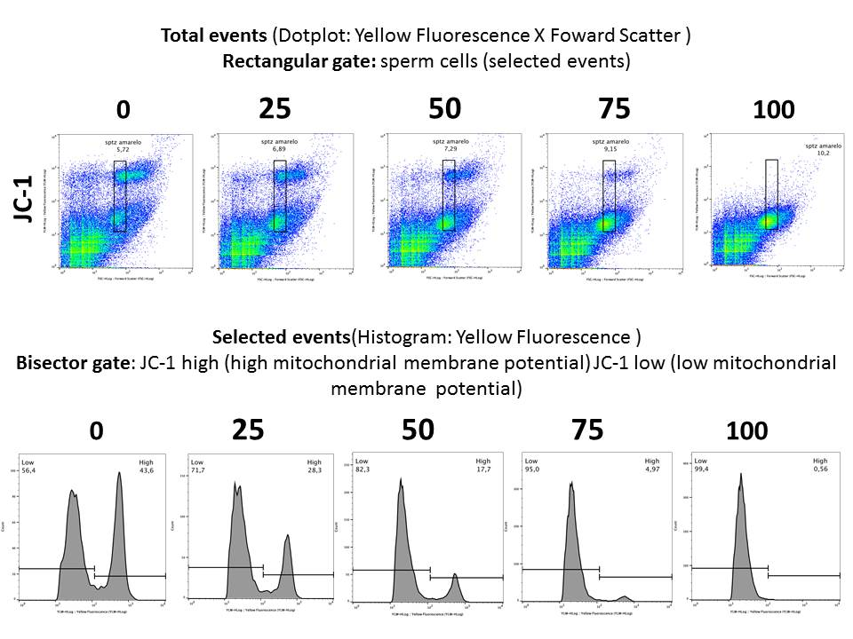
Figure S1 Analysis of sperm samples with 0, 25, 50, 75 and 100% of low mitochondrial membrane potential (FlowJo software v.10.7) used for JC-1 (tetraethylbenzimidazolycarbocyanine iodide) probe validation.

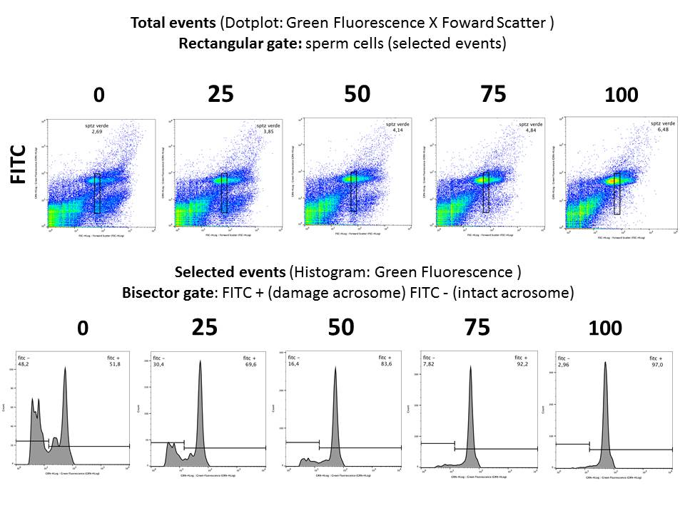
Figure S2 Analysis of sperm samples with 0, 25, 50, 75 and 100% of damage acrosome (FlowJo software v.10.7) used for FITC–PSA (fluorescein-conjugated Pisum sativum) probe validation.

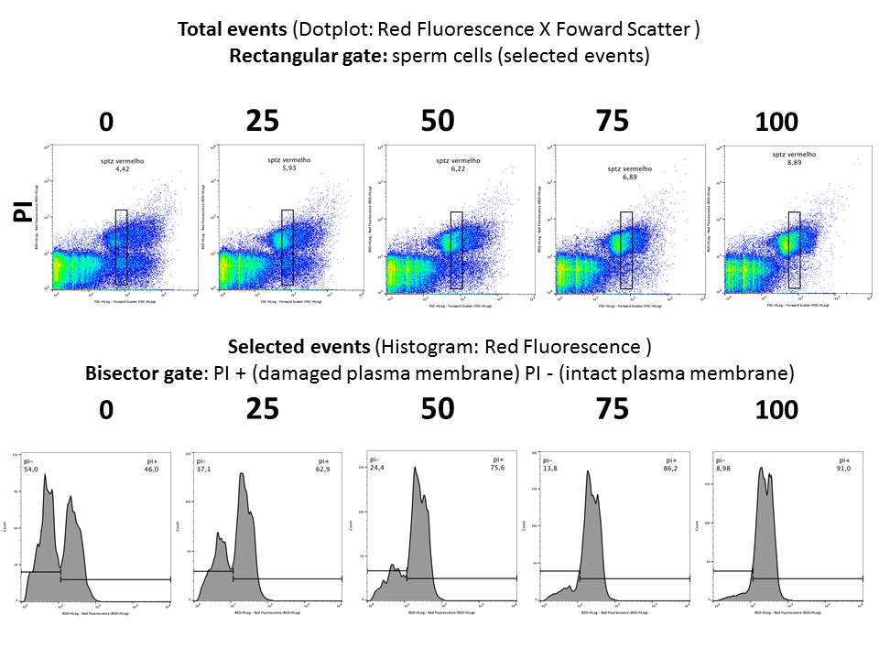
Figure S3 Analysis of sperm samples with 0, 25, 50, 75 and 100% of damaged plasma membrane (FlowJo software v.10.7) used for propidium iodine (PI) probe validation.

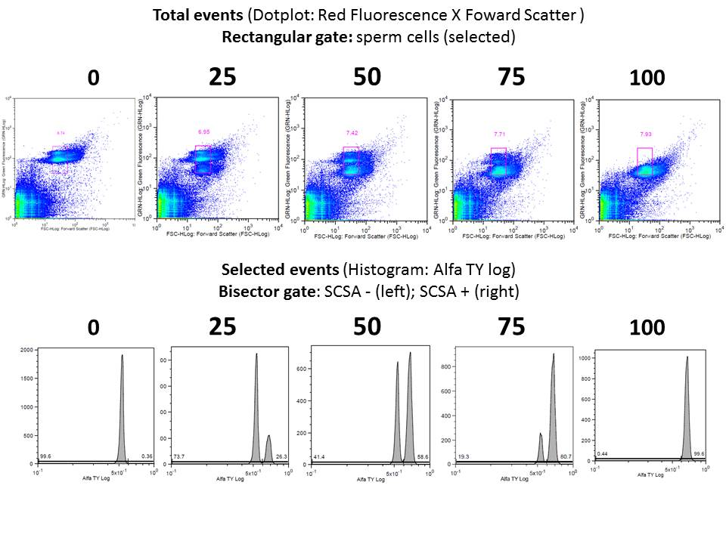
Figure S4 Analysis of sperm samples with 0, 25, 50, 75 and 100% of chromatin susceptible to damage (FlowJo software v.10.7) used for validation chromatin structure status (SCSA) with acridine orange probe.

