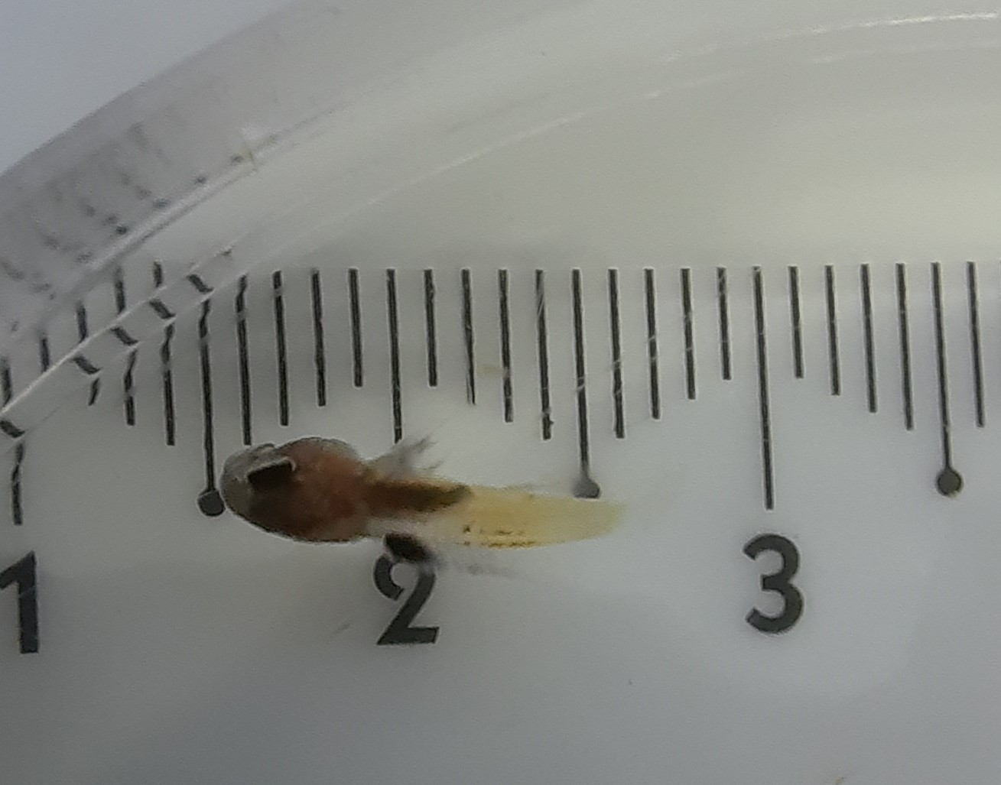

Supplementary File “25 DAH Gramma brailiensis”

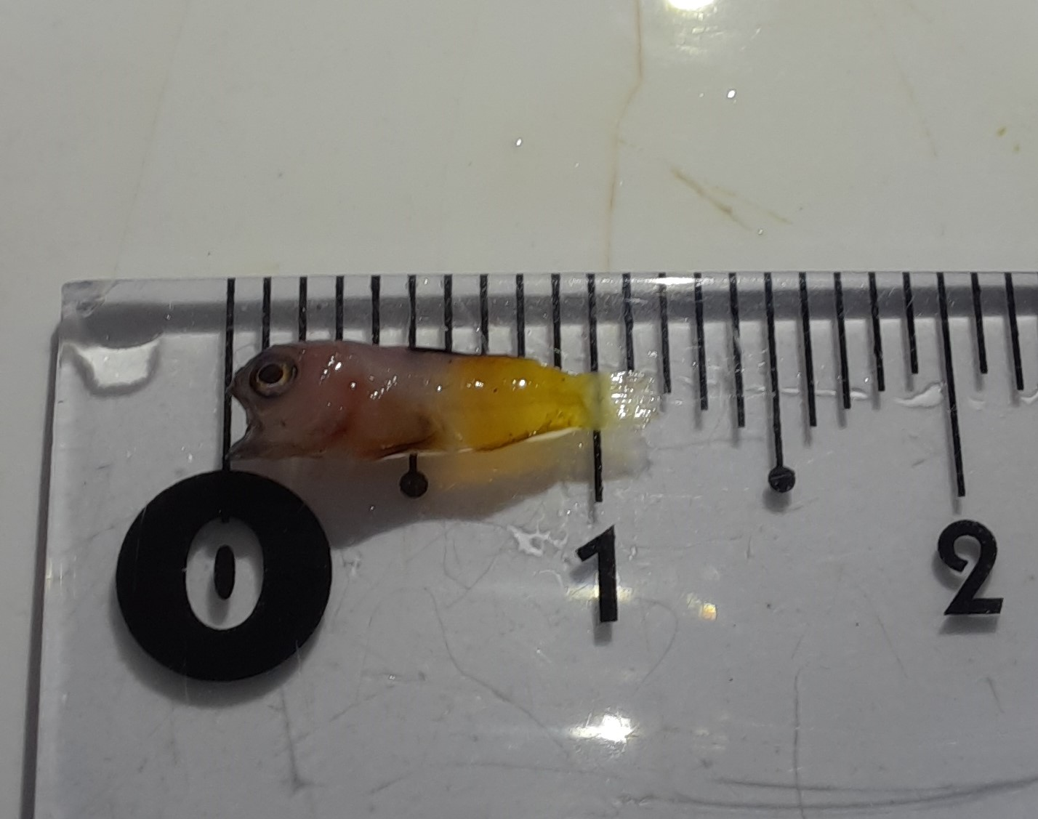

Supplementary File “33 DAH Gramma brailiensis”

