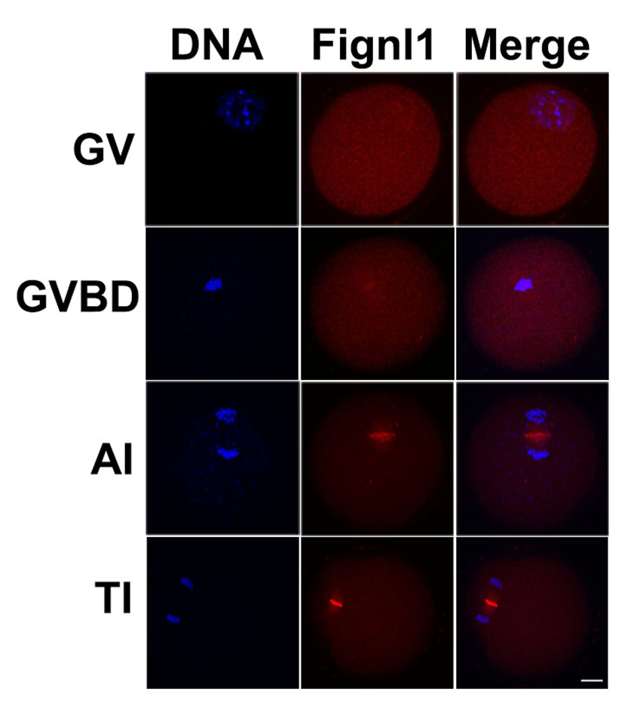
Figure S1. FIGNL1 has different localization characteristics in oocytes of different stages. FIGNL1 has no specific distribution in GV oocytes. It begins to gather around chromosomes in GVBD oocytes. However, in the oocytes at the AI and TI stages, it concentrates on the cytokinesis ring. Fignl, fidgetin-like. Three independent experiments were performed for each result.

