Supporting information
- In vitro maturation of buffalo oocytes
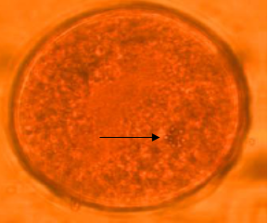
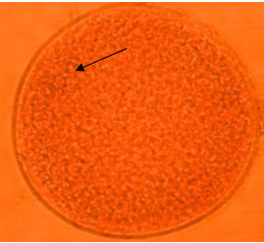
Figure S1-1 Germinal vesicle Figure S1-2 Diakinesis (DK)

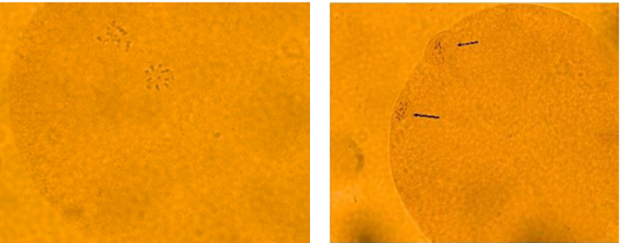
Figure S1-3 Telophase Figure S1-4 Metaphase II

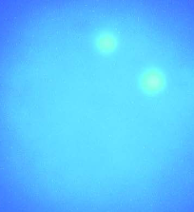
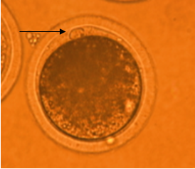

Figure S1-5 Extrusion of PBI Figure S1-6 Pronuclear formation

- In vitro fertilization of buffalo oocytes
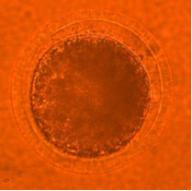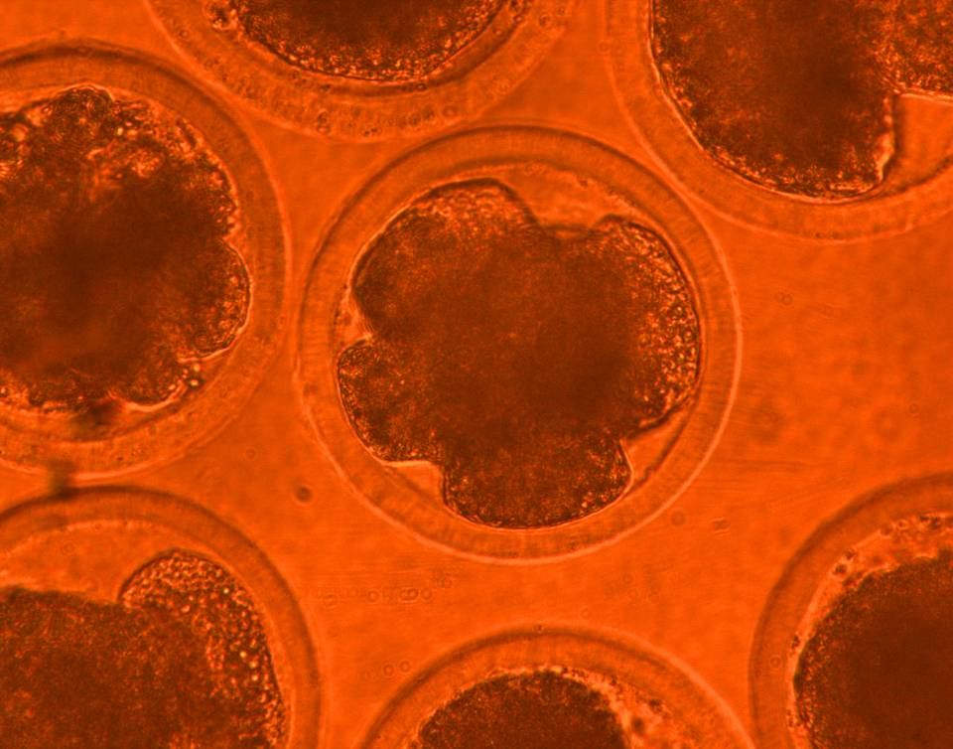
Figure S2-1 Fertilized oocyte (arrow) Figure S2-2 Cleavage-stage embryos

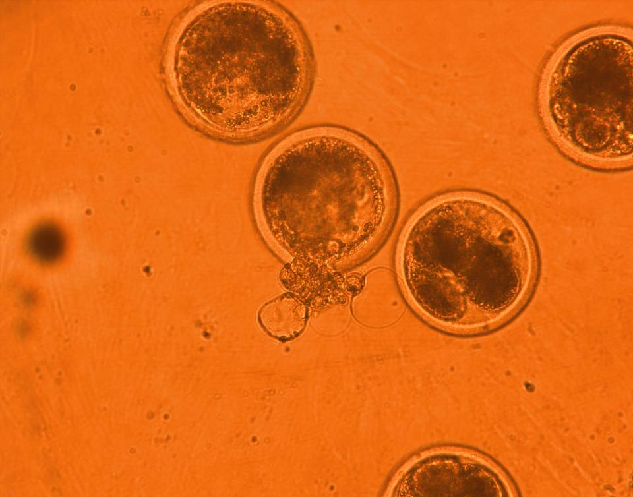
2
1
Figure S2-3 cavitated blastocyst (1) and hatched blastocyst (2)

