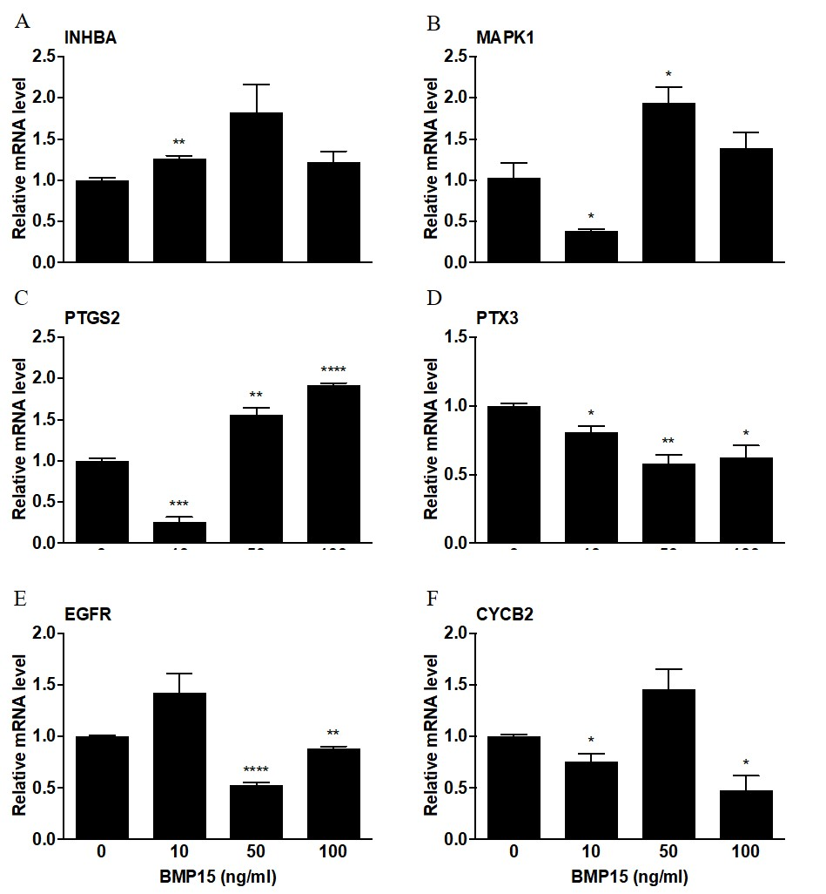Figure S1. Effect of BMP15 administration during IVM on expression of INHBA (A), MAPK1 (B), PTGS2 (C), PTX3 (D), EGFR (E) and CYCB2 (F) in cumulus cells. The expression level of β-ACTIN was used as an internal control. Data are compared to BMP15 0 ng/ml and shown as mean ± SEM (one-way ANOVA; Tukey’s post-hoc test; n = 3; small letters indicate P < 0.05; capital letter P < 0.01).
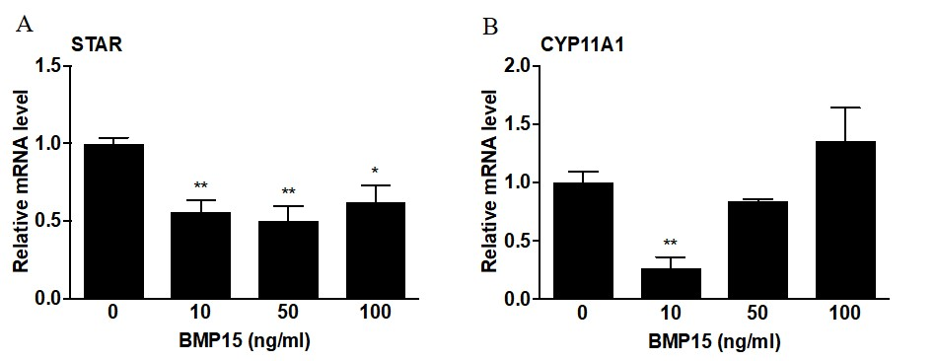
Figure S2. Effect of BMP15 administration during IVM on expression of STAR (A) and CYP11A1 (B) mRNA in cumulus cells. The expression level of β-ACTIN was used as internal control for mRNA expression analysis. Data are compared to BMP15 0 ng/ml and shown as mean ± SEM (one-way ANOVA; Tukey’s post-hoc test; n = 3; small letters indicate P < 0.05; capital letter P < 0.01).
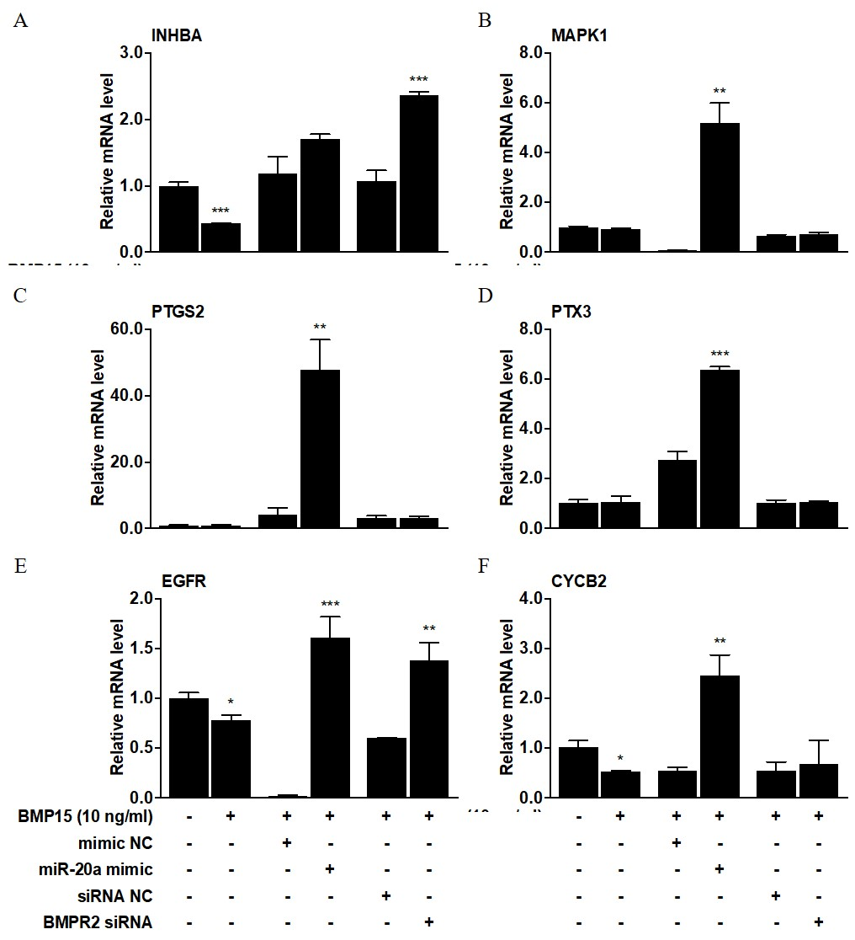
Figure S3. Effect of miR-20a mimic and BMPR2 siRNA transfection during IVM on expression of INHBA (A), MAPK1 (B), PTGS2 (C), PTX3 (D), EGFR (E) and CYCB2 (F) in cumulus cells. The expression level of β-ACTIN was used as an internal control. Data are compared to their corresponding controls and shown as mean ± SEM (two-tailed t-test; n = 3; *P < 0.05; **P < 0.01; ***P < 0.001).
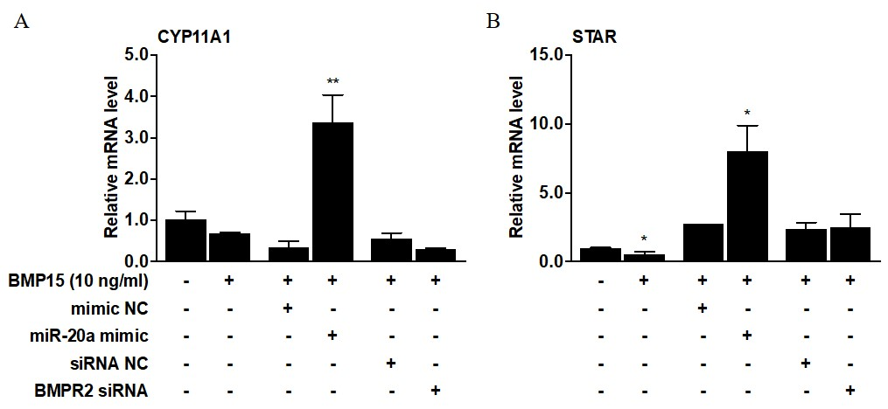
Figure S4. Effect of miR-20a mimic and BMPR2 siRNA transfection during IVM on expression of CYP11A1 (A) and STAR mRNA level (B) in cumulus cells. The expression level of β-ACTIN was used as internal control for mRNA expression analysis. Data are compared to their corresponding controls and shown as mean ± SEM (two-tailed t-test; n = 3; *P < 0.05; **P < 0.01).

