SUPPLEMENTARY MATERIAL FOR ONLINE ONLY PUBLICATION
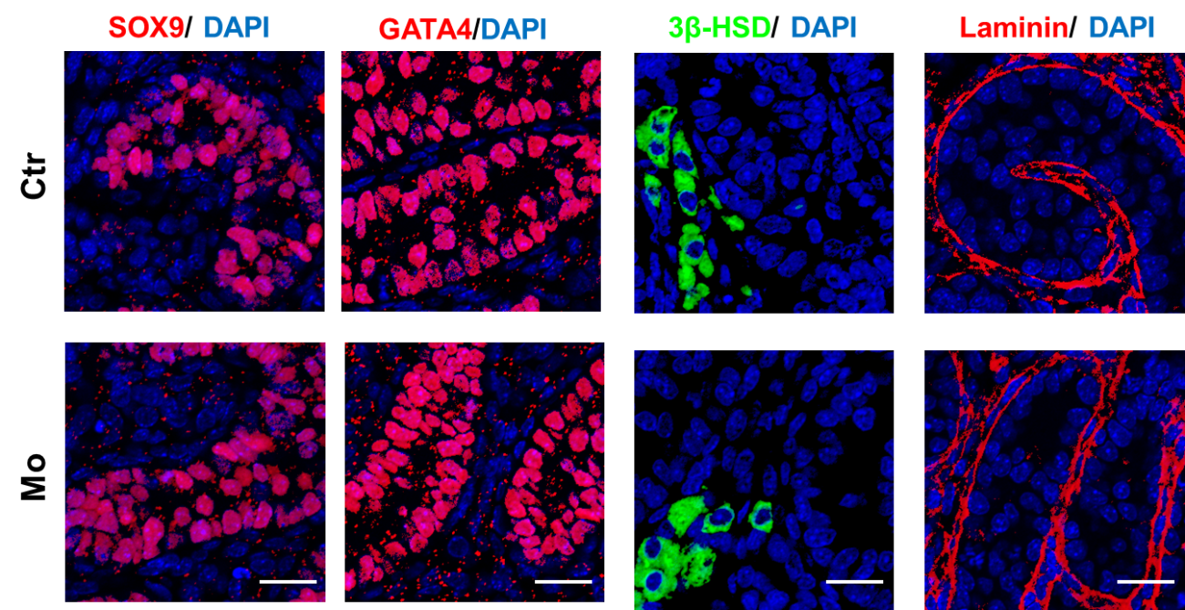
Figure S1. TFRC knockdown does not affect the integrity of seminiferous lumens and somatic cells. Representative images of SOX9 (Sertoli marker, red), GATA4 (Sertoli marker, red), 3β-HSD (Leydig marker, green) and laminin immunostaining in Ctr and Mo testes. There were no differences in somatic cells and no changes in basal membrane of tubules between the two groups. Scale bars: 20 μm. Ctr: negative control; Mo: morpholino-treatment. SOX9: SRY‑box 9; GATA4: GATA binding protein 4; 3β-HSD: 3 beta‑hydroxysteroid dehydrogenase. DAPI: 4’,6‑diamidino‑2‑phenylindole.

Table S1 Antibodies information

Antibody | Source | Colony | Cat no. | Company
TFRC | Mouse | McAb | 13-6800 | Thermo scientific
SYCP1 | Rabbit | PcAb | NB300-229 | Novus Biologicals
SYCP3 | Mouse | McAb | ab97672 | Abcam
γ-H2AX | Rabbit | McAb | ab81299 | Abcam
ACTIN | Mouse | McAb | MAB1501 | Millipore
α-TUBLIN | Rabbit | PcAb | AF0001 | Beyotime
Cleaved-Caspase3 | Rabbit | McAb | 9664S | Cell Signaling Technology
SOX9 | Rabbit | McAb | 82630S | Cell Signaling Technology
GATA4 | Rabbit | McAb | 36966S | Cell Signaling Technology
3β-HSD | Mouse | McAb | SC-515120 | Santa Cruz Biotechnology
Laminin | Mouse | McAb | SC-74531 | Santa Cruz Biotechnology
3β-HSD: 3 beta‑hydroxysteroid dehydrogenase; γ-H2AX: gamma H2A.X variant histone; GATA4: GATA binding protein 4; SYCP1: synaptonemal complex protein 1; SYCP3: synaptonemal complex protein 3; SOX9: SRY‑box 9; TFRC: Transferrin receptor.

