Supporting Information

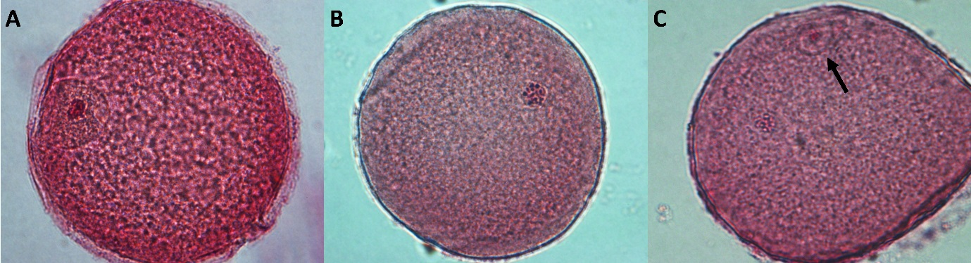

Figure S1 Nuclear maturation stage of bovine oocytes, stained with 2% acetic orcein. The immature oocytes represented by vesicular germ stage (A) are characterized by the presence of a membrane around the chromosomes. After 12–15 h of cultivation there is a de-condensation of the group of chromosomes, which are distributed as small dots that together have a circular shape, characterizing metaphase I (B). Finally, in metaphase II (C), which in bovines can be observed after 18–24 h of cultivation, the chromosomes are also de-condensed, but the presence of polar body (black arrow) can be seen.

