Supporting Information
Figure S1 Ultrastructural images of the cortical region of metaphase I oocytes. (A, B) The oocyte separates from the zona pellucida (ZP) by the perivitelline space (pvs), which contains the oocyte microvilli (mv). Cortical vesicles (CV) form a more-or-less uniform row under the oolemma, with this region presenting coated-vesicles (small circles). Vesicles containing granular materials (large circles) apparently merging (arrows) with the oolemma, expelling their contents (black arrowhead) to the perivitelline space, keeping their roundish form. These contents seemed to interact (white arrowhead) with the inner region of the ZP. In the ooplasm, it can be observed mitochondria (Mi) and smooth endoplasmic reticulum tubules (IT) and small vesicles (SV).

Figure S2 Ultrastructural images of metaphase I oocytes. (A) Metaphase I plate. The chromosome spindle is located near the surface, extending from the cortex towards the inner regions of the oocyte. Note the chromosomes (Chr), the spindle microtubules (arrows) and the absence of centrosomes at the spindle poles (*). (B) Between the zona pellucida (ZP) and the oocyte lies the perivitelline space (pvs), which contains the oocyte microvilli (mv). Under the oolemma, there are the cortical vesicles (CV). In the cortical regions, the ooplasm evidences the presence of smooth endoplasmic reticulum tubular aggregates (*) in association with mitochondria (Mi). (C) Inner region of the oocytes with presence of smooth endoplasmic reticulum tubular aggregates (*) in association with mitochondria (Mi) and numerous smooth endoplasmic reticulum isolated tubules (IT) and small vesicles (SV). (D, E) Note the absence of smooth endoplasmic reticulum large vesicles (LV) in the subcortex (D) compared with the inner ooplasm (E). In both regions, the ooplasm is rich in mitochondria (Mi) and smooth endoplasmic reticulum isolated tubules (IT) and small (SV) and medium (MV) vesicles. Note the presence of lysosomes (Ly).

Figure S3 Ultrastructural images of metaphase I oocytes. (A, C) Small dictyosomes (circles) in the cortical (A) and inner (C) oocyte regions. These dictyosomes (Di) are shown at high magnifications in (B) and (D), respectively. In the ooplasm, it can be observed cortical vesicles (CV), mitochondria (Mi) and lysosomes (Ly). In (C), the image depicts an area devoid of major organelles (*).

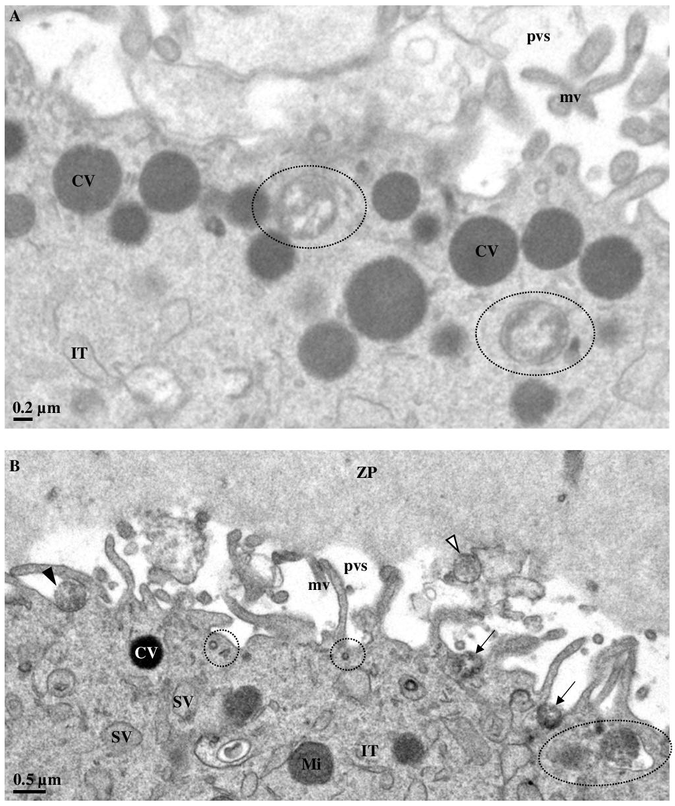
Figure S1.

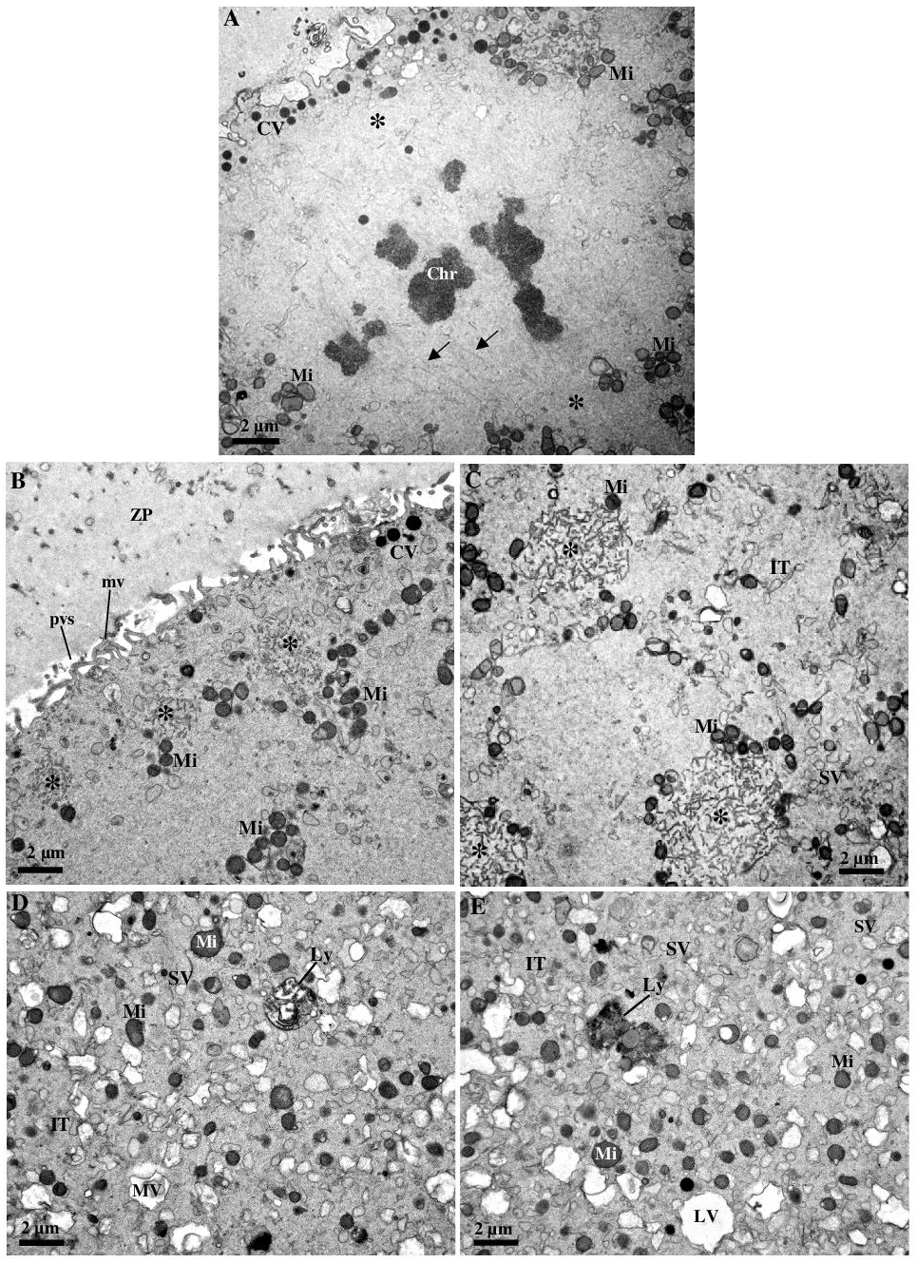
Figure S2.

Figure S3.

