Supporting Information
Table S1 Effect of the donkey donor (stallion) on refrigerated (+4°C) sperm kinetics, bioenergetics, and oxidative status

Stallion |  | J1 | J2 | J3
Tot Mot | % | 48.0 ± 1.2^{A} | 32.8 ± 1.2^{B} | 18.7 ± 1.7^{C}
Prog Mot | % | 15.9 ± 0.6^{A} | 7.7 ± 0.4^{B} | 3.2 ± 0.6^{C}
VCL | µm/s | 87.6 ± 1.6^{A} | 76.1 ± 1.1^{B} | 74.1 ± 1.8^{B}
VSL | µm/s | 43.0 ± 0.9^{A} | 32.4 ± 0.6^{B} | 31.3 ± 1.0^{B}
VAP | µm/s | 59.1 ± 1.3^{A} | 49.3 ± 0.9^{B} | 49.0 ± 1.5^{B}
ALH | µm | 3.59 ± 0.10 ^{A} | 3.04 ± 0.07^{B} | 2.85 ± 0.12^{B}
BCF | Hz | 8.87 ± 0.27 ^{A} | 7.60 ± 0.19^{B} | 6.43 ± 0.31^{C}
MMP | F₀B/F₀A | 35.8 ± 1.4^{A} | 43.0 ± 1.1^{B} | 63.2 ± 2.2^{C}
LPO | (F₀A)/(F₀A+ F₀B) × 100 | 20.5 ± 0.5^{A} | 22.7 ± 0.3^{B} | 22.6 ± 0.5^{B}
Anti-LPO | (F₀B)/(F₀A+ F₀B) × 100 | 60.5 ± 0.6^{A} | 63.2 ± 0.4^{B} | 63.2 ± 0.6^{B}
NBT | Formazan µg | 9.6 ± 0.3ª | 8.8 ± 0.2^{b} | 9.4 ± 0.3

Data (mean ± SE) have been covariated by time of incubation, extender and sperm concentration. Different capital and small letters on the same row indicate statistically significant differences (P < 0.01 and P < 0.05, respectively).

Table S2 Correlation coefficients (R) and probability values (P) among the evaluated parameters of sperm functionality over all the treatments (n = 4 extenders and n = 3 sperm concentrations), stallion (n = 3) and time of incubation (n = 5)

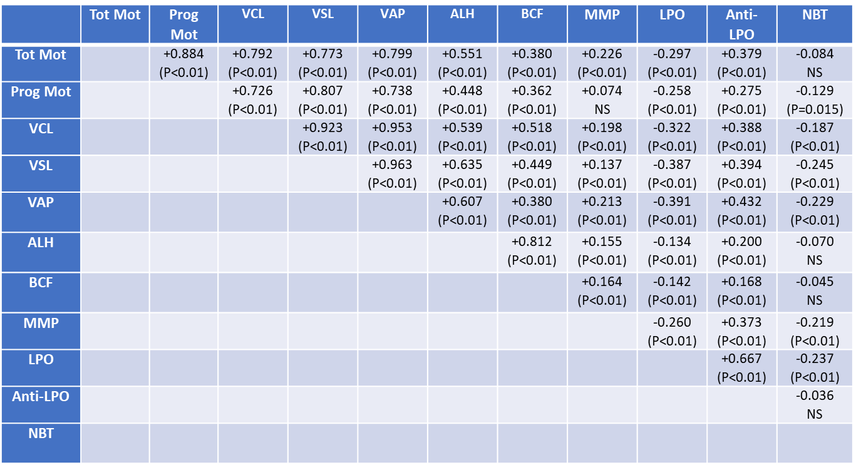
NS, not statistically significant.

