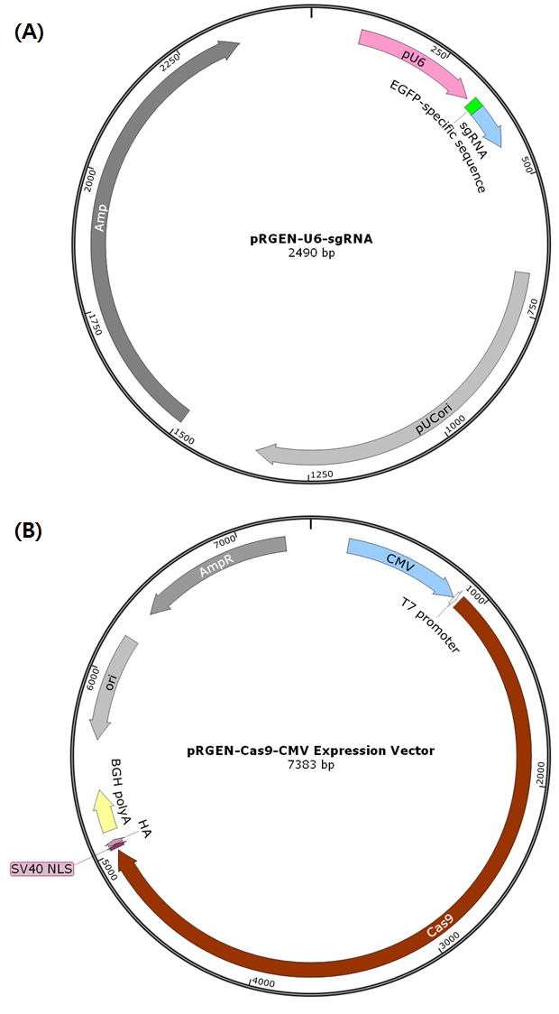
Supplementary Figure. Schematic maps of expression vectors for EGFP sgRNA (A) and cas9 protein (B). (A) sgRNA with target sequence from EGFP gene are expressed by U6 promoter. (B) A human codon-optimized Cas9 gene is expressed by CMV promoter. Note that Cas9 gene is transnationally fused with a SV40 nuclear localization signal and an HA epitope.

