Supplementary materials. Supplementary Figure 1.

Characterization and diversity of seed endophytic bacteria of the endemic holoparasitic plant species Cistanche armena (Orobanchaceae) from a semi-desert area in Armenia

Kristine Petrosyan^{1,3*}, Sofie Thijs³, Renata Piwowarczyk², Karolina Ruraż², Jaco Vangronsveld^{3,4} and Wiesław Kaca¹
¹Department of Microbiology, Institute of Biology, Jan Kochanowski University, Uniwersytecka 7, 25-406 Kielce, Poland
²Center for Research and Conservation of Biodiversity, Department of Environmental Biology, Institute of Biology, Jan Kochanowski University, Uniwersytecka 7, 25-406 Kielce, Poland
³Centre for Environmental Sciences, Environmental Biology Research Group, Hasselt University, Agoralaan building D, 3590 Diepenbeek, Belgium
⁴Institute of Biological Sciences, Department of Plant Physiology and Biophysics, Faculty of Biology and Biotechnology, Maria Curie-Skłodowska University, 19 Akademicka, 20–033 Lublin, Poland
* Correspondence:
Corresponding Author
Department of Microbiology, Institute of Biology, Jan Kochanowski University, Uniwersytecka 7, 25-406 Kielce, Poland,
Tel: (48) 735046235
e-mail: kristine.petrosyan@phd.ujk.edu.pl
kristine.petrosyan@uhasselt.be

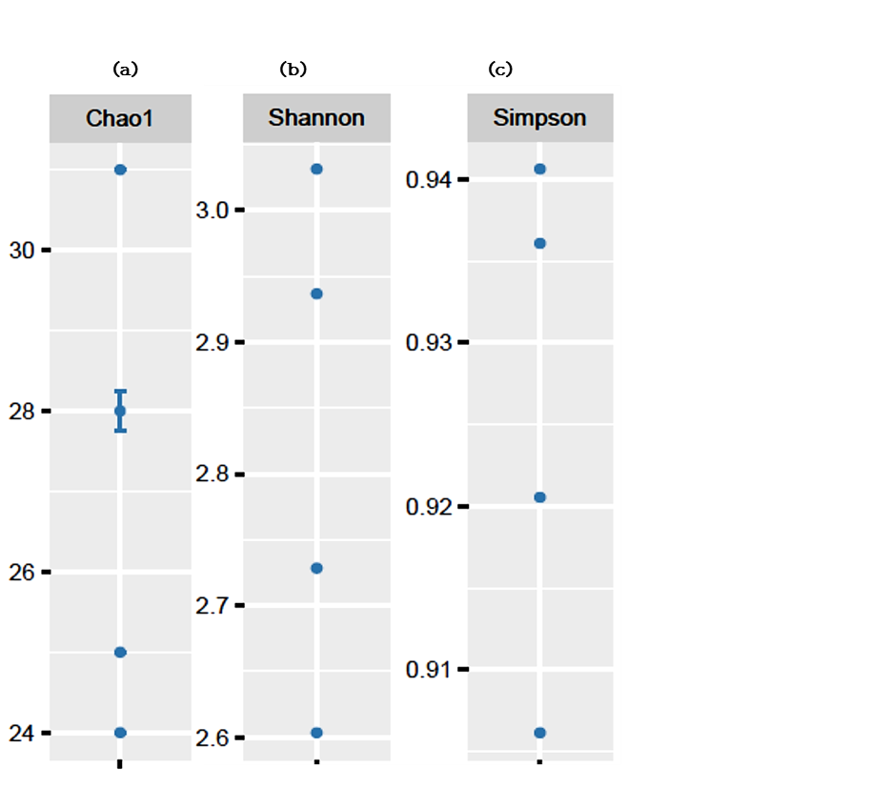
Supplementary Figure. 1. The values of reads of Cistanche armena seed-endophytes after filtering (a) Chao1 index was 27, (b) Shannon-Wiener biodiversity index was 2.82, (c) Simpson index 13.9 for total 75 different OTUs. P-value: 0.05.

