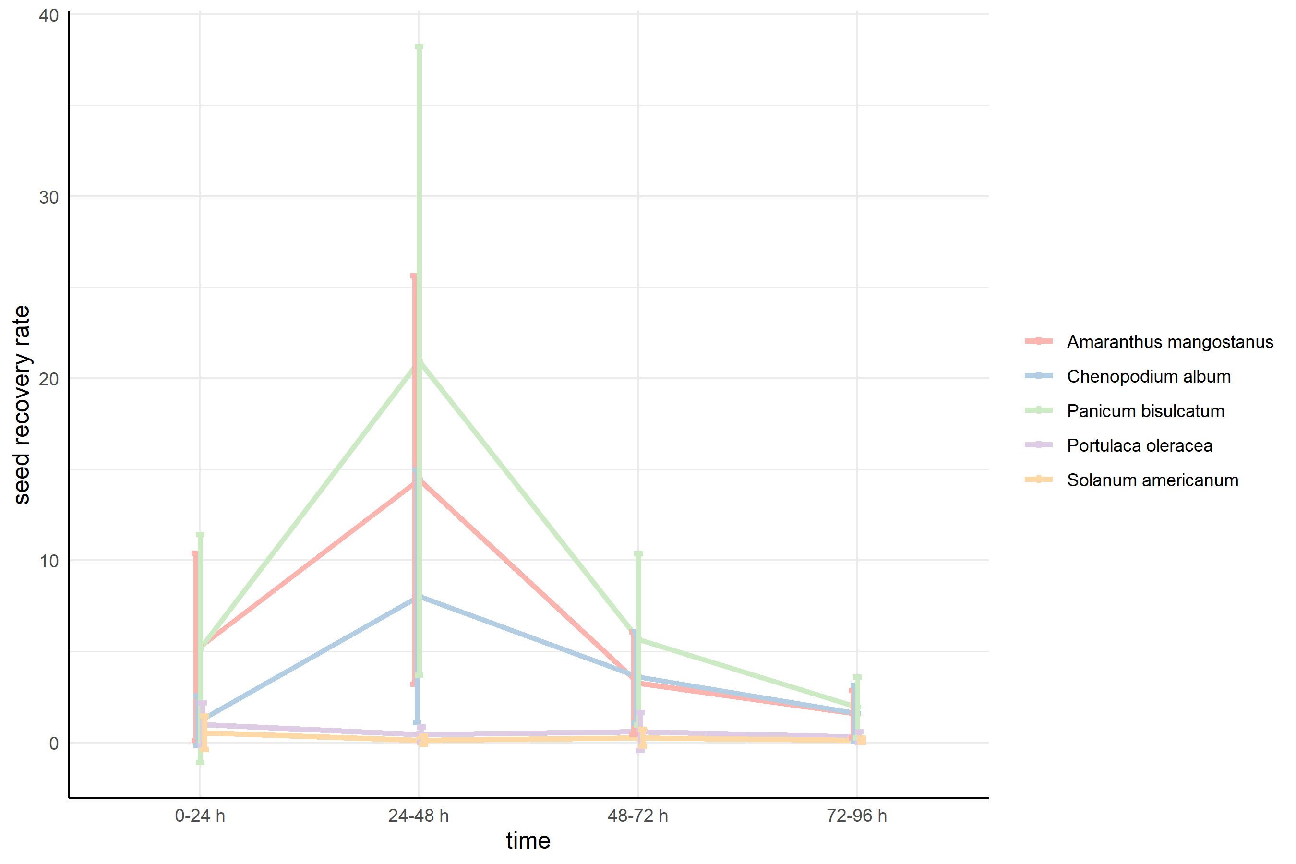
Fig. S1 Seed recovery rate of each species at each time interval. For each time interval, 0–24h, 24–4 h, 48–72h and 72–96h denote the hours after feeding. The data are expressed as mean ± SD.

