Supplemental information

Fig. S1. Germination of B. parachinensis seeds imbibed in water or different concentrations of coumarin.

Fig. S2. Germination of B. parachinensis seeds imbibed in water or different concentrations of GA₃.

Fig. S3. Germination of B. parachinensis seeds imbibed in water or different concentrations of GA₄₊₇.

Fig. S4. Germination of B. parachinensis seeds imbibed in water or different concentrations of PC.

Fig. S5. Germination of B. parachinensis seeds imbibed in water or different concentrations of fluridone.

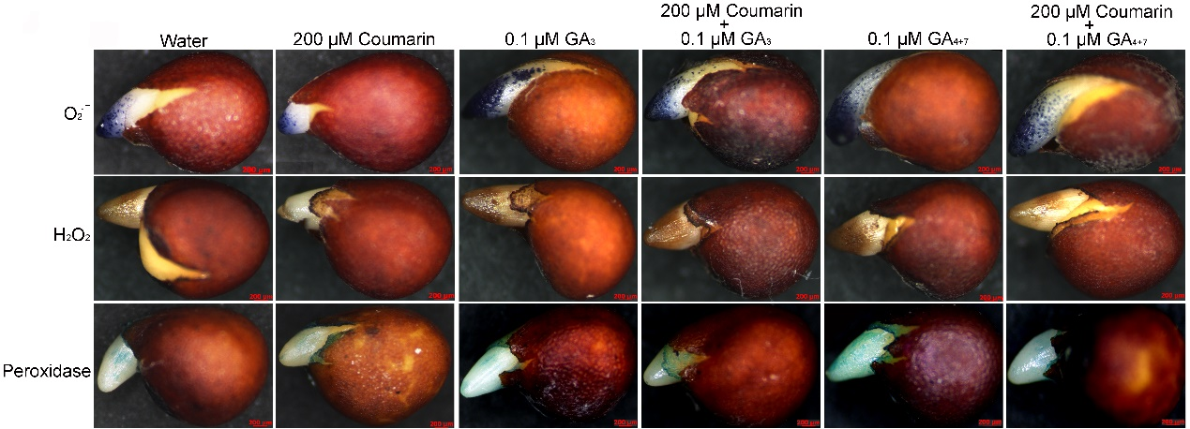

Fig. S6. Accumulation of ROS in B. parachinensis seeds with testa at 10 h when imbibed in water with or without coumarin, GA₃, or GA₄₊₇.

