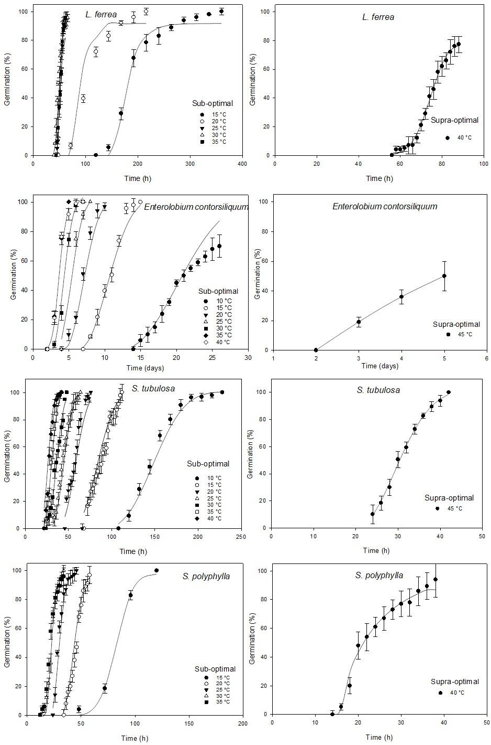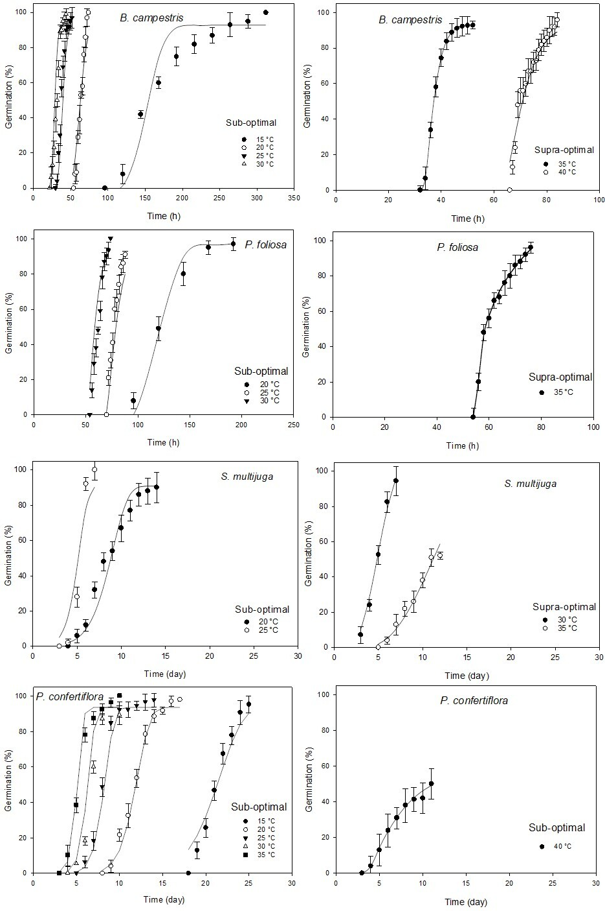
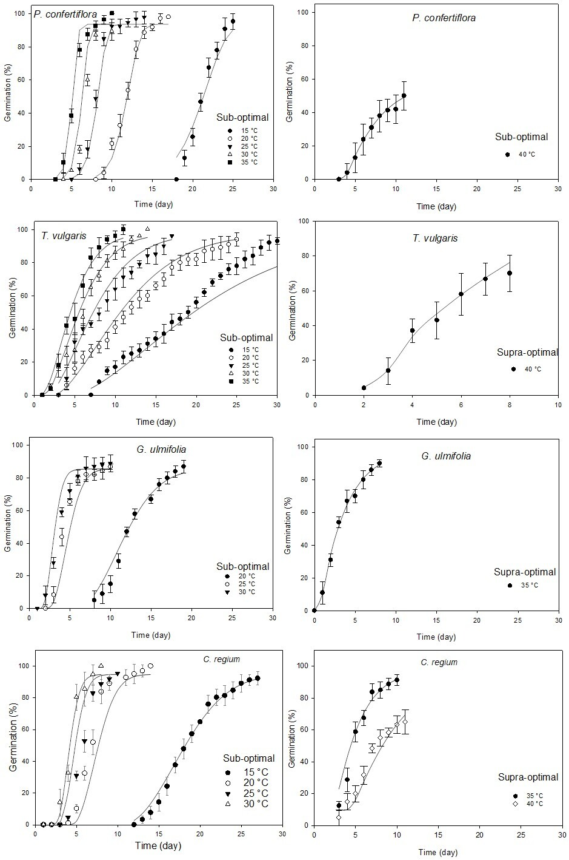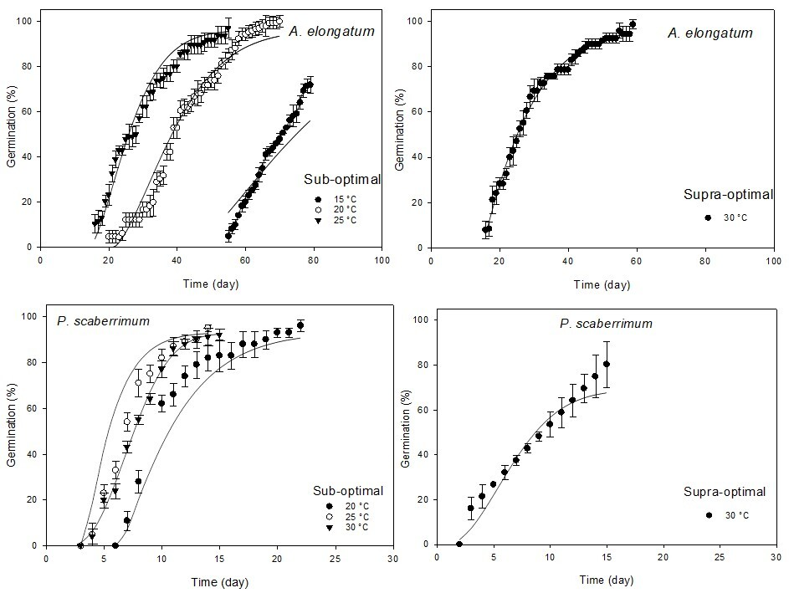
Figure 3. Observed values (symbols) and predicted (lines) by thermal time models of the seed germination curve of species occurring in the Cerrado at constant temperatures. Error bars represent standard deviations.

