Data S2. Funnel traps construction guidelines (Funnel_trap.csv).
Use a PVC pipe measuring 11.4 cm high × 15.0 cm wide (top) × 10 cm long, originally designed for cheese production. This cylindrical plastic structure should have holes, 1 cm in diameter, on the sides and bottom to allow drainage. Attach a conical PVC plastic funnel, 15 cm in diameter, to the top end of the cylindrical plastic structure (approximately 0.0177 m² in area). At the bottom of the funnel, the seeds are caught in a disposable polypropylene bag, with pores smaller than 0.1 mm, fixed with an elastic band to the base of the funnel. This polypropylene bag is originally produced as a disposable hygienic hair cap, and it retains its integrity over the period of exposure in the field, independent of weather conditions (TALGE, Santa Catarina, Brazil).

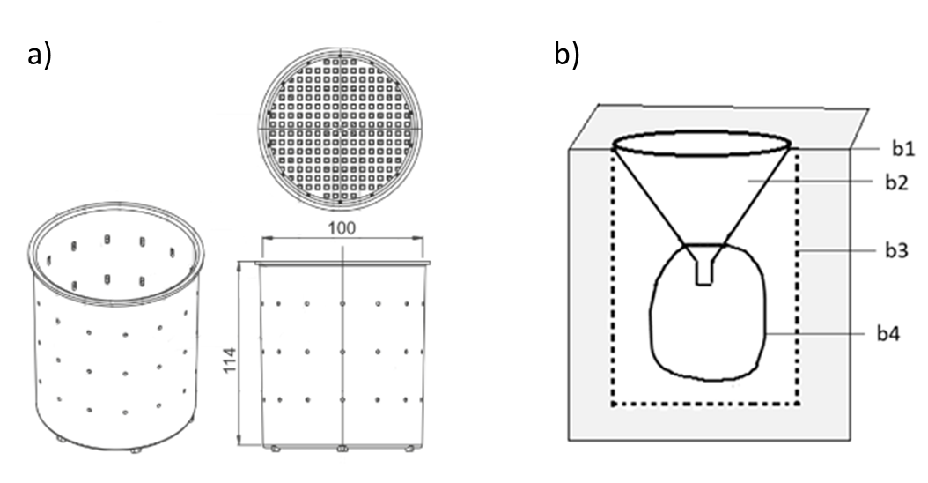
Appendix S2: a) External structure of the funnel trap before PVC funnel installation b) Internal structure of the funnel trap installed in the field; b1: ground level; b2: PVC plastic funnel (15 cm² upper end area); b3: PVC pipe with bore holes 1 cm diameter; b4: bag of < 0.1mm mesh size.

