Data S1. Sticky traps construction guidelines (Sticky_trap.csv).
Use a plastic gardening pot of 10.5 cm high, 14.5 cm wide at top, 11 cm wide at base, with a volume of 1,160 liters. Make two wooden poles from weather-resistant wood: one measuring 3 cm wide × 3 cm thick × 20 cm long; and the other, 3 cm wide × 3 cm thick × 32.5 cm long. Place the 32.5-cm wooden pole in the bottom of the plastic pot, and fill the plastic pot with concrete (1/3 of cement, 1/3 of sand and 1/3 of gravel), fixing the wooden pole at the center and aligned at a 90° angle to the bottom of the pot (Fig. supp. 1). The upper end of this wooden pole should be approximately 22 cm above the ground. Next, using a drill and screws, attach the 20-cm wooden pole to the top of the 32.5-cm pole that is fixed inside the plastic pot. The 20-cm pole should be centralized, and its upper face should form a 45° angle with the ground. Then, using a drill and screws, fix the Plexiglas® plate (0.0225 m²) to the 20-cm pole, in a centralized position. The Plexiglas® plate should be located 25 cm above ground, facing the main wind direction and sloping at a 45°angle (Fig. supp. 1). Cover the Plexiglas® plate with a thin plastic film to allow sample collection, and recover with a new the plastic film after each collection. Coat the Plexiglas® plate with a clear sticky Isobutene/Butene Polymer gel over the thin plastic film. This Polymer gel is originally produced to deter birds and bats from roofs (ROGAMA, São Paulo, Brazil), and it retains its adhesive qualities over the period of exposure in the field, independent of weather conditions.
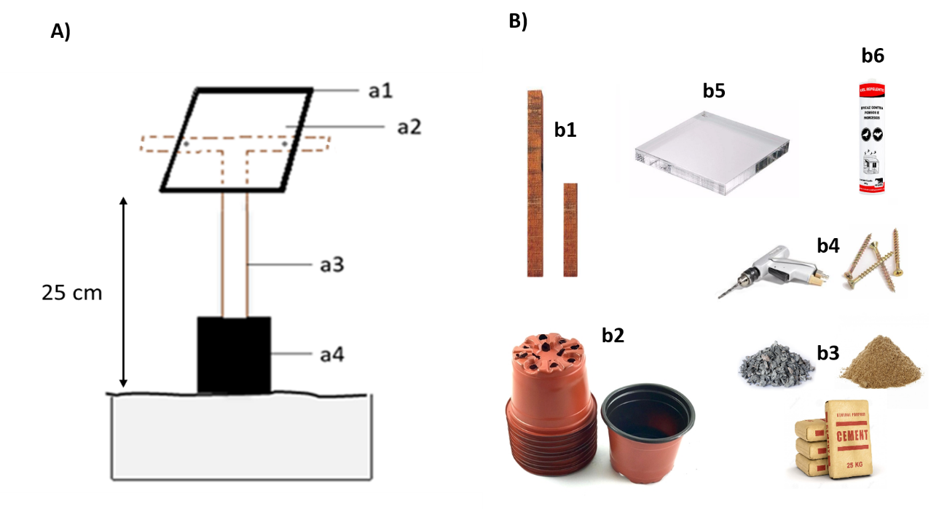
Appendix S1: A) Sticky trap. a1: clear Plexiglas plate (0.0225 m²); a2: sticky gel over a thin plastic film placed over the Plexiglas® plate; a3: wooden pole; a4: plastic pot filled with concrete. B) Material needed to build a Sticky trap. b1: two wooden pole; b2: plastic pot (1,16 liters) ; b3: concrete (cement, sand and gravel) ; b4: drill and screws for wood; b5: Plexiglas plate (0.0225 m²) ; b6: Isobutene/Butene Polymer gel.

