SUPPORTING INFORMATION

Seed priming stimulates spatiotemporal reprograming of the Arabidopsis seed germination program

Jack Mitchell, Nur K. Mukhtar, George W. Bassel

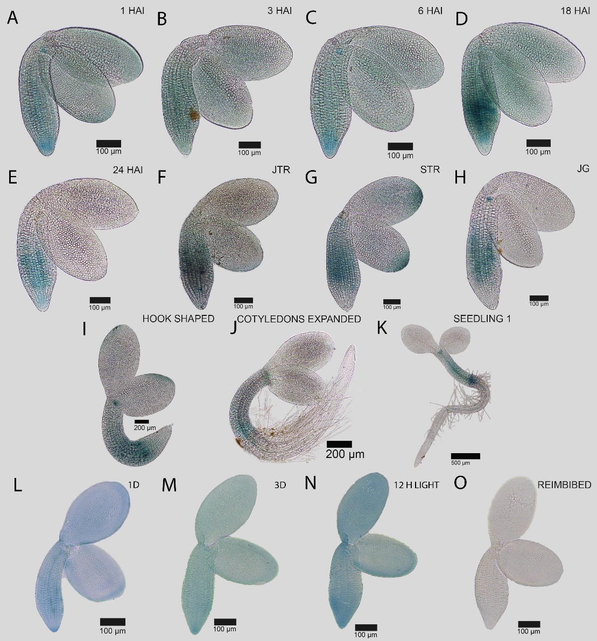
Fig. S1. Spatial and temporal dynamics of the GIBBERELLIN 3 β-HYDROXYLASE 1 (GA3ox1) GA3ox1::GUS reporter during the seed to seedling transition in Arabidopsis. Promoter activity in the germinating embryo at (A) 1 HAI, (B) 3 HAI, (C) 6 HAI, (D) 18 HAI, (E) 24 HAI, (F) early testa rupture, (G) late testa rupture, and germinated seedlings just after the completion of germination (H), (I) hook stage seedling, (J) recently expanded cotyledons and (K) a fully established seedling. Pattern of GA3ox1::GUS promoter activity in an embryo following (L) 1 day and (M) 3 days of priming treatment at 4 ºC in the dark (N) 12 h at 22 ºC in the light, and (O) following reimbibition for 12 h. Black bars indicate the scale in each image.

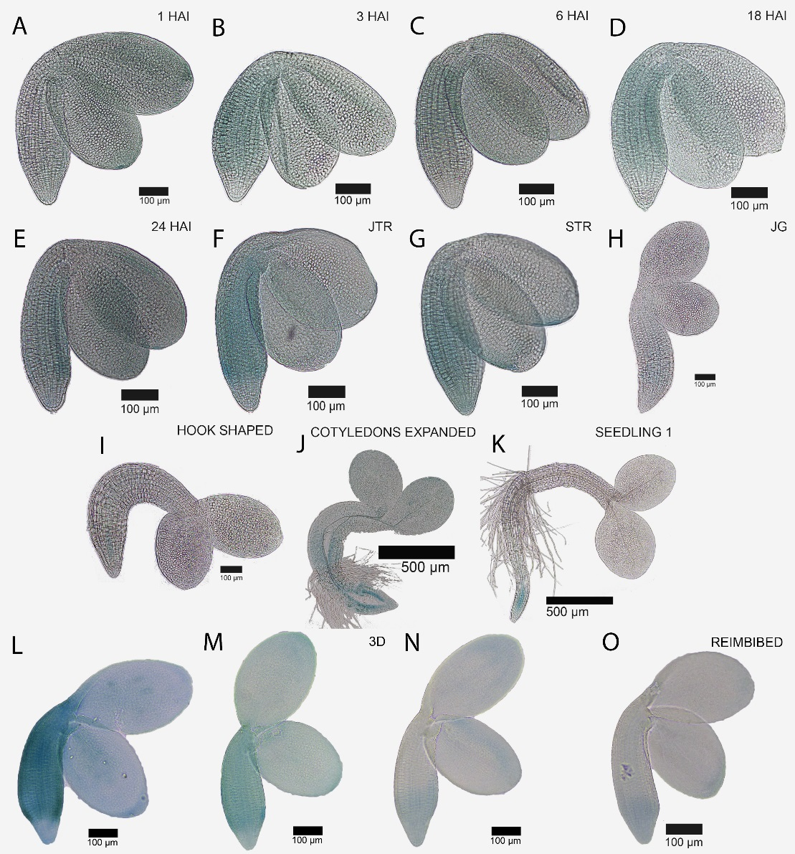
Fig. S2. Spatial and temporal dynamics of the EXPA15::GUS reporter during the seed to seedling transition in Arabidopsis. Promoter activity in the germinating embryo at (A) 1 HAI, (B) 3 HAI, (C) 6 HAI, (D) 18 HAI, (E) 24 HAI, (F) early testa rupture, (G) late testa rupture, and germinated seedlings just after the completion of germination (H), (I) hook stage seedling, (J) recently expanded cotyledons and (K) a fully established seedling. Pattern of EXPA15::GUS promoter activity in an embryo following (L) 1 day and (M) 3 days of priming treatment at 4 ºC in the dark (N) 12 h at 22 ºC in the light, and (O) following reimbibition for 12 h. Black bars indicate the scale in each image.

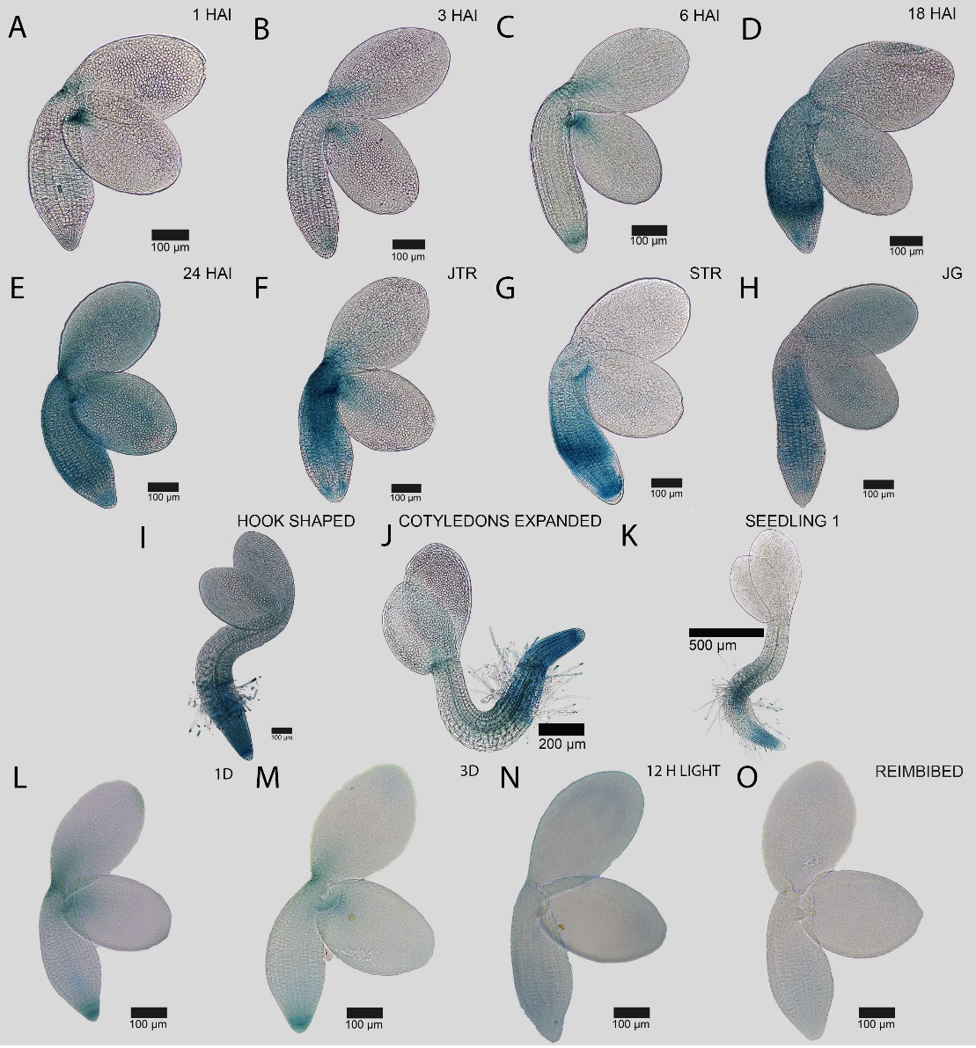
Fig. S3. Spatial and temporal dynamics of the XTH19::GUS reporter during the seed to seedling transition in Arabidopsis. Promoter activity in the germinating embryo at (A) 1 HAI, (B) 3 HAI, (C) 6 HAI, (D) 18 HAI, (E) 24 HAI, (F) early testa rupture, (G) late testa rupture, and germinated seedlings just after the completion of germination (H), (I) hook stage seedling, (J) recently expanded cotyledons and (K) a fully established seedling. Pattern of XTH19::GUS promoter activity in an embryo following (L) 1 day and (M) 3 days of priming treatment at 4 ºC in the dark (N) 12 h at 22 ºC in the light, and (O) following reimbibition for 12 h. Black bars indicate the scale in each image.

