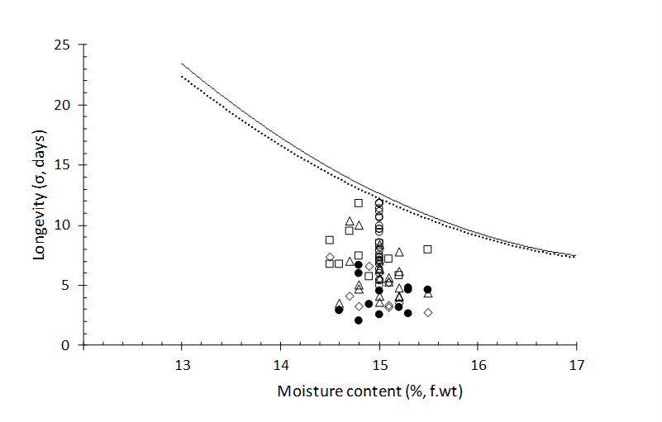
Supplementary Figure 1. Observed and predicted seed longevity. The two curves present the previously-reported negative logarithmic relation between the standard deviation of the frequency distribution of seed deaths in time (σ, days) and seed storage moisture content for rice (Oryza sativa L.) at 40℃ : these curves are derived from the seed viability equation (Ellis and Roberts, 1980) and the estimates of the viability constants K_{E}, C_{W}, C_{H} and C_{Q} for rice provided by Ellis and Hong (2007), where the broken curve is with constant values constrained to a common temperature term for all 12 crops they investigated and the continuous curve with the temperature term derived for rice alone. The symbols denote estimates for σ from the current study for all 80 rice seed lots produced in 2015-2017 and stored hermetically at 40℃ with the moisture contents shown: open symbols are for Japonica rice cv. Gleva (○, Experiment 1; ∆ , Experiment 2; □, Experiment 3; ◊, Experiment 4) and solid symbols for Indica rice cv. Aeron 1 (•, Experiment 4).

