Supplementary information

The impact of genetic and environment on the polar fraction
metabolome of commercial Brassica napus seeds: A Multisite study

Bennouna Djawed¹, Avice Jean-Christophe², Rosique Clément¹, Svilar Ljubica^{1,6}, Pontet Célia³, Trouverie Jacques², Fine Frédéric³, Pinochet Xavier³, Fraser Karl^{4, 5}, Martin Jean-Charles^{1*}.

Author affiliations :
¹Aix Marseille Univ, INSERM, INRA, C2VN, BioMeT, Marseille, France.
²Normandie Univ, UNICAEN, INRA, SFR Normandie Végétal (FED4277), UMR 950 Ecophysiologie Végétale et Agronomie, F-14032 Caen, France
³Terres Inovia, Paris, France.
⁴Food Nutrition & Health Team, Food & Bio-Based Products Group, AgResearch Grasslands Research Centre, Palmerston North, New Zealand.
⁵Riddet Institute, Massey University, Palmerston North 4442, New Zealand
⁶CriBioM, Criblage Biologique Marseille, Faculté de Médecine de la Timone, Marseille, France

*Corresponding author :
C2VN, INRA, INSERM, Aix Marseille Univ, Marseille, France.
jean-charles.martin@univ-amu.fr, Phone: +33695910155

The supplementary informations provid additional details regarding the geografical locations illustrated by Figure S1. In addition, Figure S-, Figure S3 and Figure S4 illustrate the quality of the analysis. Figure S5 illustrates the Principal component analysis of all the samples according to the 1st and the 2nd component, to the 2nd and 3rd component and to the 7th and 8th component. Figure S6 illustrates the correlation network of the samples metabolom. Figure S7 illustrates the box-plot representing the relative abundance of the impacted molecules. Table S1 summurizes the climate and soil caracteristics. Table S2 summurizes the list of the samples used in this study.

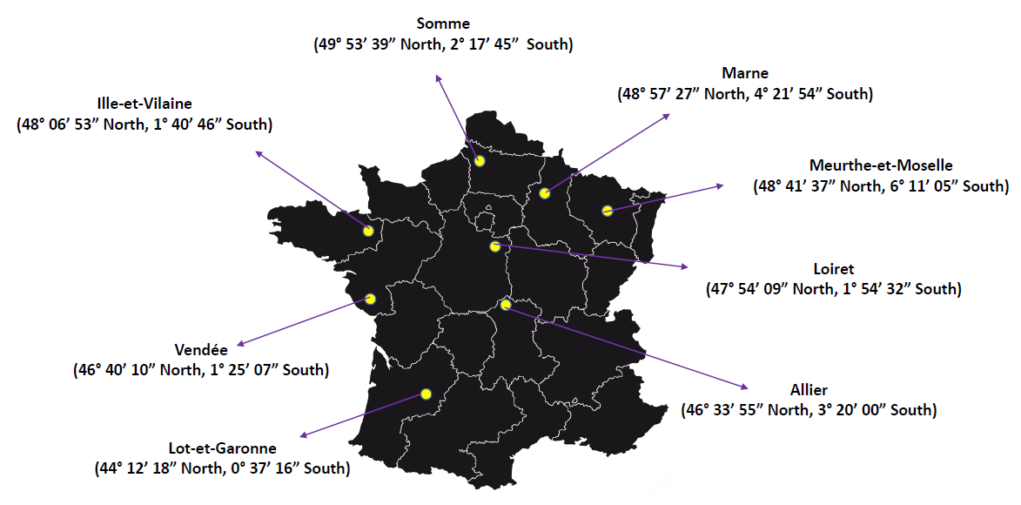
Figure S1. Geographical coordinates of the locations where all the studied varieties were cultivated
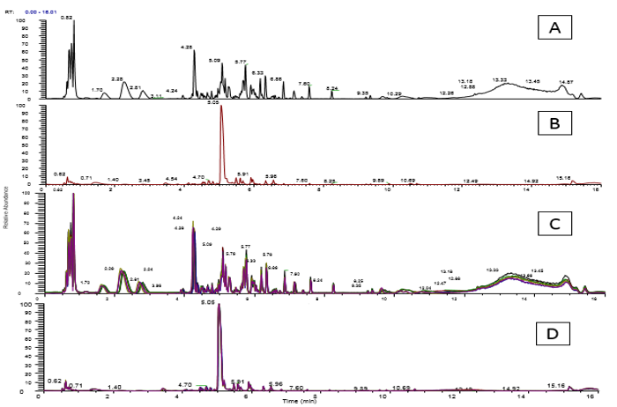
Figure S2. (A). Chromatogram in negative mode. (B). Chromatogram in positive mode. (C) and (D). Overlay of the quality control samples analyzed during the 3 batches in negative and positive mode respectively.
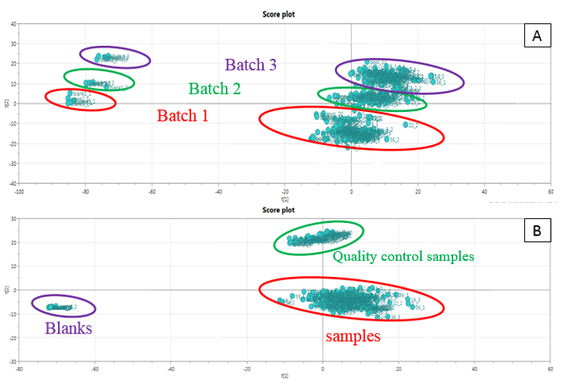
Figure S3. (A). PCA performed on raw data before any filtration. All the samples were analyzed in three batches to avoid blocking the mass spectrometer source. Each batch represents a set of samples that were analyzed by LC-MS on the same analytical system. (B). PCA on filtered data (after removal of blank signals and false chromatographic peaks).

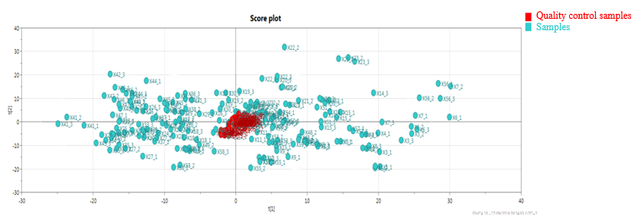
Figure S4. PCA performed on all samples (in triplicates) after application of all filtrations (Normalization and elimination of signals with a coefficient of variation greater than 30%)

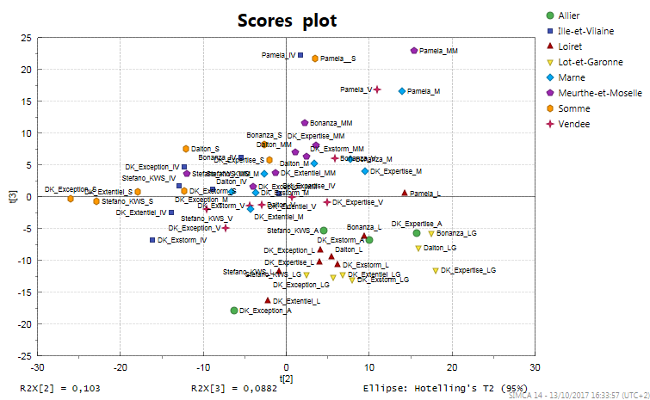
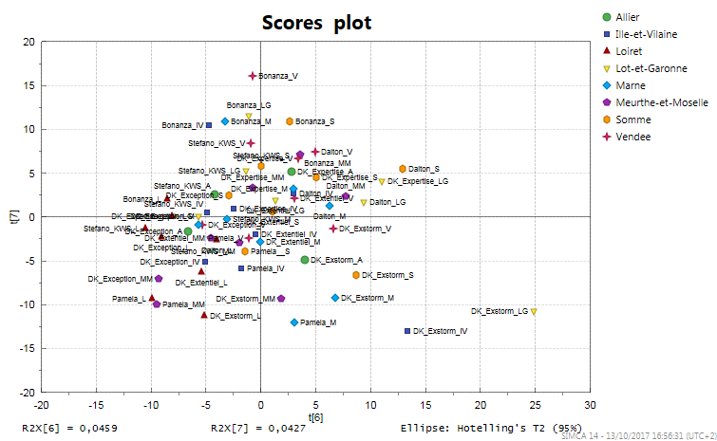
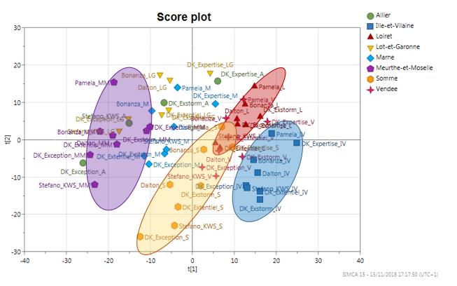
b
c
a

Figure S5. a) Principal component analysis of all the samples according to the 1st and the 2nd components. b) Principal component analysis of all the samples according to the 2nd and the 3rd components. C) Principal component analysis of all the samples according to the 7th and the 8th components

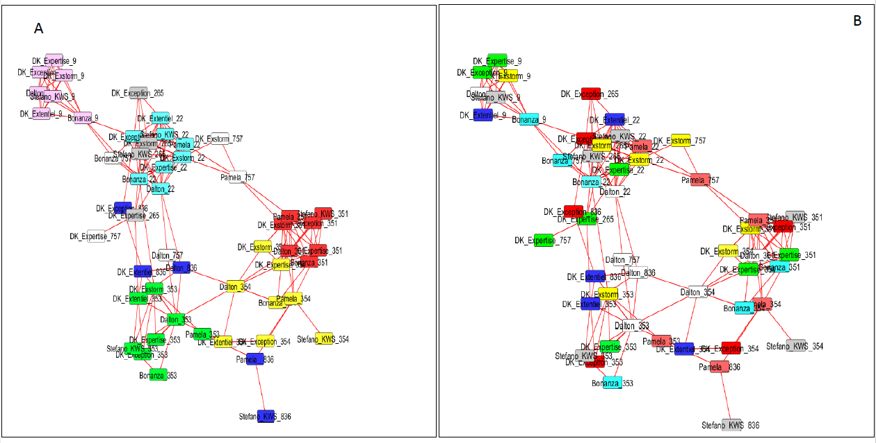
Figure S6. Metabolomes of the analyzed samples display in a partial correlation network. (A) Strong environmental effect, (B) Slight genetic effect. Regions codes are presented according to the code 2 of Table 1

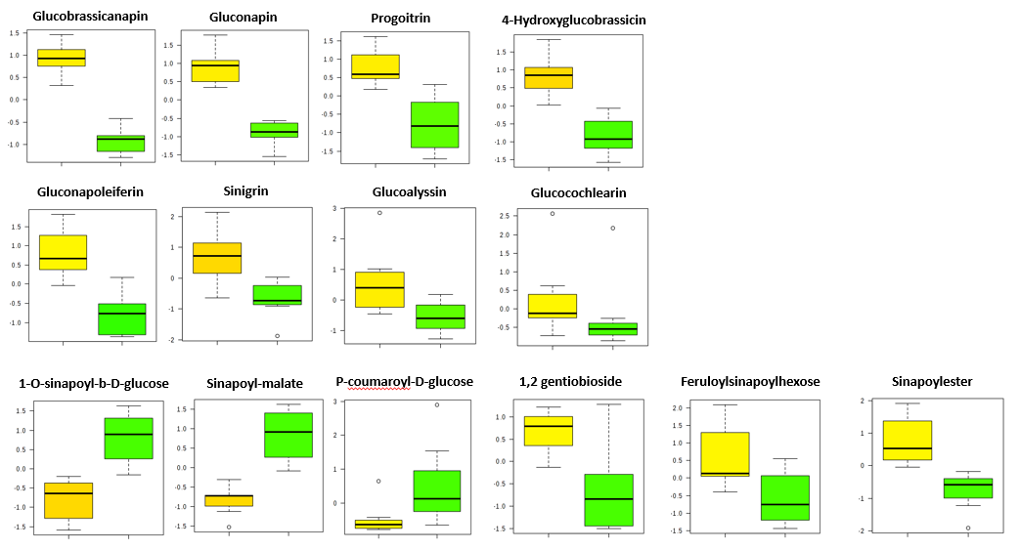
Figure S7. Box-plot representing the relative abundance (normalized concentration values) of the impacted molecules in Loiret (yellow box on the left) and Meurthe-et-Moselle region (green box on the right). Positive infinite numbers are represented as 999999, and negative infinite numbers -999999

Table S1. Geolocalization, soil characteristics and climatic data (observed between flowering and seed harvest stages) corresponding to the eight locations where all the studied genotypes were cultivated (2014 to 2015).
Location | Code | Latitude | Longitude | Soil characteristics | Cumul of  mean daily temperature (°C) | Cumul of precipitation (mm) | Cumul of daily incident photosynthetically active radiation (MJ.m⁻²)
Allier | A | 46.64 | 3.41 | Loamy sand | 1484.85 | 170.3 | 45128.7
Ille-et-Vilaine | IV | 48.1 | -1.8 | Clay loam | 1439.9 | 170.1 | 46004.2
Loiret | L | 48.0 | 2.97 | Flinty loam | 1396.5 | 138.6 | 43215.4
Lot-et-Garonne | LG | 44.32 | 0.83 | Clay loam | 1562.6 | 122 | 46107.6
Marne | M | 48.85 | 4.2 | Flinty chalk | 1592.7 | 97.6 | 49666.6
Meurthe-et-Moselle | MM | 48.8 | 5.93 | Calcareous clay | 1338.9 | 117.3 | 40590.5
Somme | S | 49.88 | 3.01 | Loam | 1201.85 | 94 | 41896
Vendée | V | 46.48 | -1.1 | Calcareous clay | 1552.4 | 188.9 | 46755.9

Table S2. List of samples of Brassica napus
Varieties | specie | Regions | Codes 1* | Code 2*
Bonanza | Brassica napus | Meurthe-et-Moselle | MM | 22
Bonanza | Brassica napus | Lot-et-Garonne | LG | 9
Bonanza | Brassica napus | Somme | S | 836
Bonanza | Brassica napus | Vendée | V | 353
Bonanza | Brassica napus | Loiret | L | 351
Bonanza | Brassica napus | Ille-et-Vilaine | IV | 354
Bonanza | Brassica napus | Marne | M | 757
Dalton | Brassica napus | Meurthe-et-Moselle | MM | 22
Dalton | Brassica napus | Lot-et-Garonne | LG | 9
Dalton | Brassica napus | Somme | S | 836
Dalton | Brassica napus | Vendée | V | 353
Dalton | Brassica napus | Loiret | L | 351
Dalton | Brassica napus | Ille-et-Vilaine | IV | 354
Dalton | Brassica napus | Marne | M | 757
DK Exception | Brassica napus | Meurthe-et-Moselle | MM | 22
DK Exception | Brassica napus | Lot-et-Garonne | LG | 9
DK Exception | Brassica napus | Somme | S | 836
DK Exception | Brassica napus | Vendée | V | 353
DK Exception | Brassica napus | Loiret | L | 351
DK Exception | Brassica napus | Ille-et-Vilaine | IV | 354
DK Exception | Brassica napus | Marne | M | 757
DK Exception | Brassica napus | Allier | A | 265
DK Expertise | Brassica napus | Meurthe-et-Moselle | MM | 22
DK Expertise | Brassica napus | Lot-et-Garonne | LG | 9
DK Expertise | Brassica napus | Somme | S | 836
DK Expertise | Brassica napus | Vendée | V | 353
DK Expertise | Brassica napus | Loiret | L | 351
DK Expertise | Brassica napus | Ille-et-Vilaine | IV | 354
DK Expertise | Brassica napus | Marne | M | 757
DK Expertise | Brassica napus | Allier | A | 265
DK Exstorm | Brassica napus | Meurthe-et-Moselle | MM | 22
DK Exstorm | Brassica napus | Lot-et-Garonne | LG | 9
DK Exstorm | Brassica napus | Somme | S | 836
DK Exstorm | Brassica napus | Vendée | V | 353
DK Exstorm | Brassica napus | Loiret | L | 351
DK Exstorm | Brassica napus | Ille-et-Vilaine | IV | 354
DK Exstorm | Brassica napus | Marne | M | 757
DK Exstorm | Brassica napus | Allier | A | 265
DK Extentiel | Brassica napus | Meurthe-et-Moselle | MM | 22
DK Extentiel | Brassica napus | Lot-et-Garonne | LG | 9
DK Extentiel | Brassica napus | Somme | S | 836
DK Extentiel | Brassica napus | Vendée | V | 353
DK Extentiel | Brassica napus | Loiret | L | 351
DK Extentiel | Brassica napus | Ille-et-Vilaine | IV | 354
DK Extentiel | Brassica napus | Marne | M | 757
Pamela | Brassica napus | Meurthe-et-Moselle | MM | 22
Pamela | Brassica napus | Somme | S | 836
Pamela | Brassica napus | Vendée | V | 353
Pamela | Brassica napus | Loiret | L | 351
Pamela | Brassica napus | Ille-et-Vilaine | IV | 354
Pamela | Brassica napus | Marne | M | 757
Stefano KWS | Brassica napus | Meurthe-et-Moselle | MM | 22
Stefano KWS | Brassica napus | Lot-et-Garonne | LG | 9
Stefano KWS | Brassica napus | Somme | S | 836
Stefano KWS | Brassica napus | Vendée | V | 353
Stefano KWS | Brassica napus | Loiret | L | 351
Stefano KWS | Brassica napus | Ille-et-Vilaine | IV | 354
Stefano KWS | Brassica napus | Marne | M | 757
Stefano KWS | Brassica napus | Allier | A | 265
*Codes used in figures S.

