Supporting information
In Fig. S1 we show all the A_{N} spectra of Neuwedia that were obtained for five, four and five independent sets of seeds of the, respectively, young (y), near-mature (nm) and mature (m) states. Each single spectrum is acquired for several seeds placed near the centre of the ATR crystal. They are brought into close contact with its surface by the pressure device, and it was adjusted to obtain an equal pressure from sample to sample. The spectra presented in the main article are averages of several spectra of such independent sets that were obtained from the same developmental stage. This figure shows the high reproducibility and chemical homogeneity that characterize seeds from the same state (DAP). The growth of characteristic C-lignin bands, e.g. in the interval 800–900 cm^{‒1}, appears uniform across sets of seeds.
A necessary condition of obtaining difference ΔA_{N} spectra that reveal meaningful information is that the spectral differences, i.e. growth and depression of bands, are expressed in a scale that supersedes the spectral variation within spectra obtained for the reference state. In Fig. S2 this is exemplified by the ΔA_{N} spectra characterizing the nm-to-m spectral changes, i.e. the nm state is here the reference state. The spectral variation within the reference state is expressed by the difference spectra ΔA_{N}(nm) = nm-<nm>, where <nm> is the average of the four nm spectra. The ΔA_{N}(m) spectra obtained relative to the same <nm> average are plotted with a constant vertical displacement to facilitate observation.
The variation of optical and sample effects in relation to the ATR technique is relatively small, as the magnitude of spectral features observed for the ΔA_{N}(m) spectra clearly supersedes those of the ΔA_{N}(nm) spectra. The nm-to-m chemical changes are systematic, consistent and reproducible, and cannot be explained by the smaller variations within samples of the same stage. The observation of characteristic bands assigned to lipids and lignins is thus justified, but low-level and larger width spectral changes must be approached with caution, e.g. those observed in the 950–1000 cm^{‒1} interval.
In order to better observe the details and narrow width bands that characterize the nm-to-m development a close-up of Fig. S2 is shown in Fig. S3. These many narrow bands all show up consistently, and cannot be explained by the broader variation of the ΔA_{N}(nm) spectra seen in Fig. S2. Thus for all orchid species studied in the present work the difference spectra are obtained from averages, e.g. ΔA_{N}(m) = <m-<nm>> = <m>-<nm>, and these are little affected by the variations that have been studied in this supporting information.

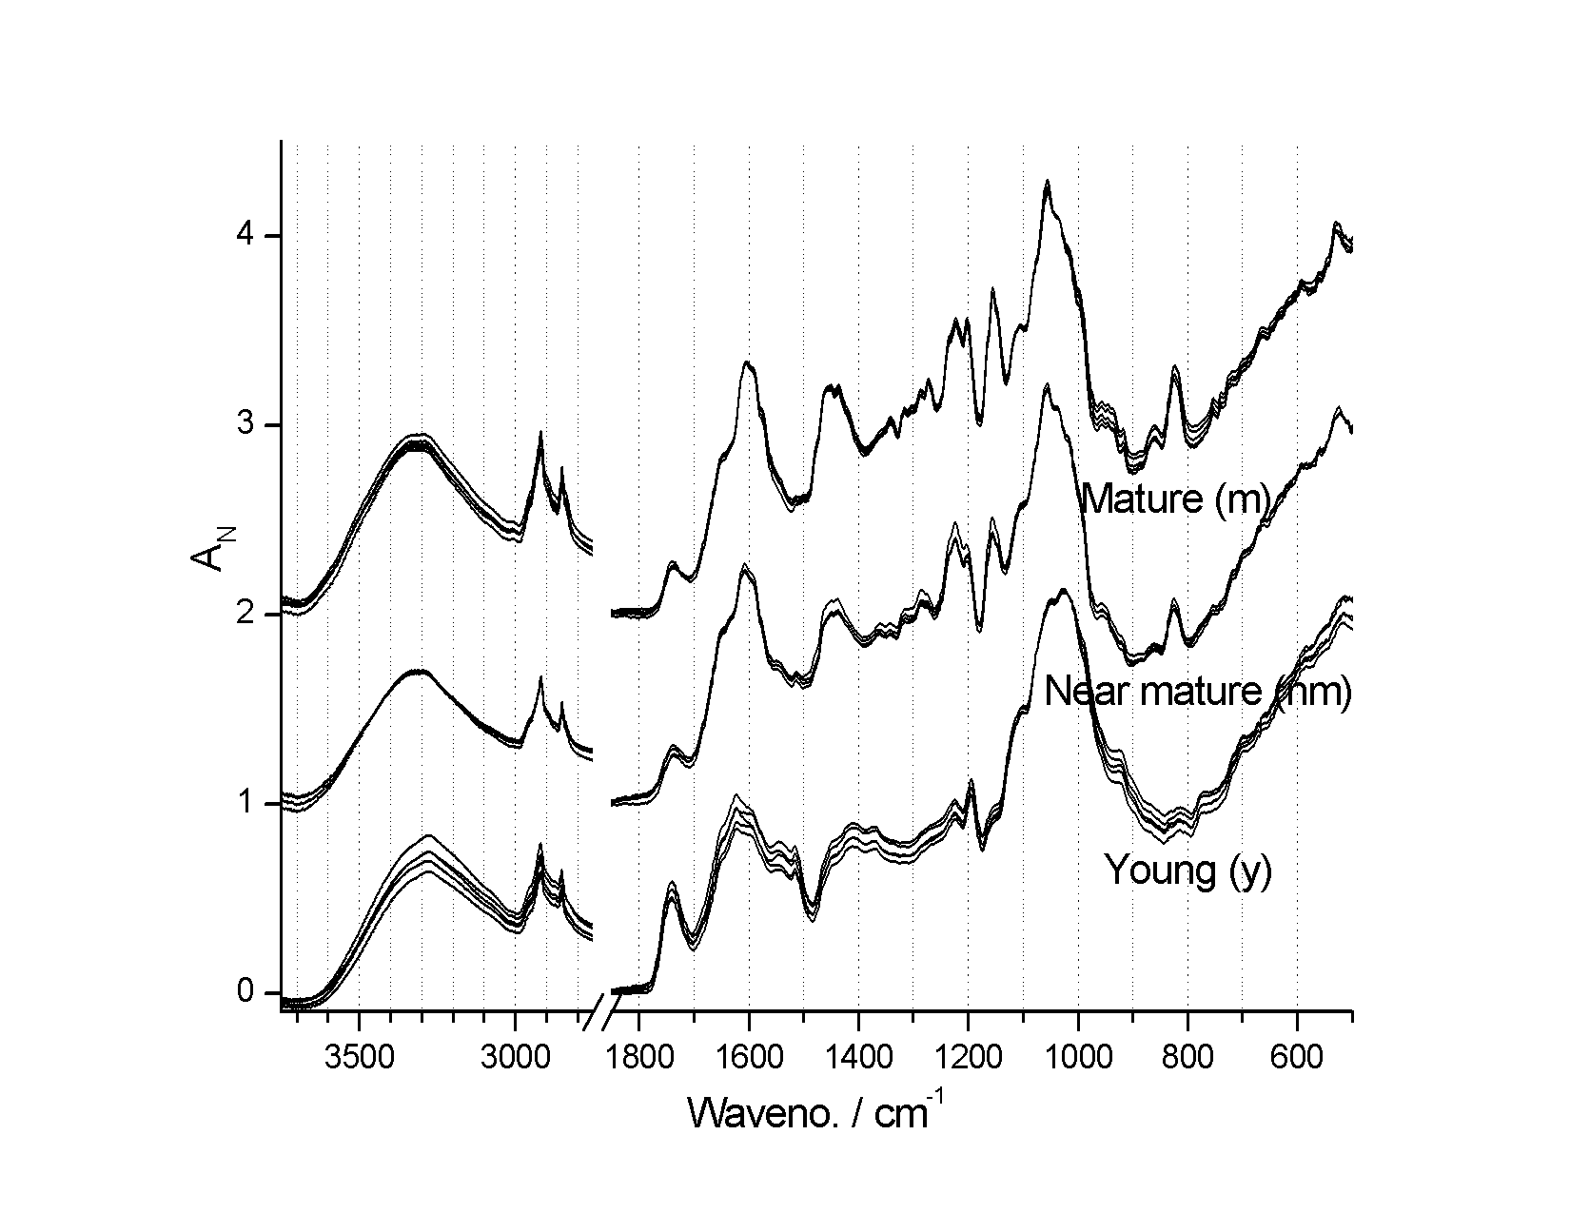
Figure S1.
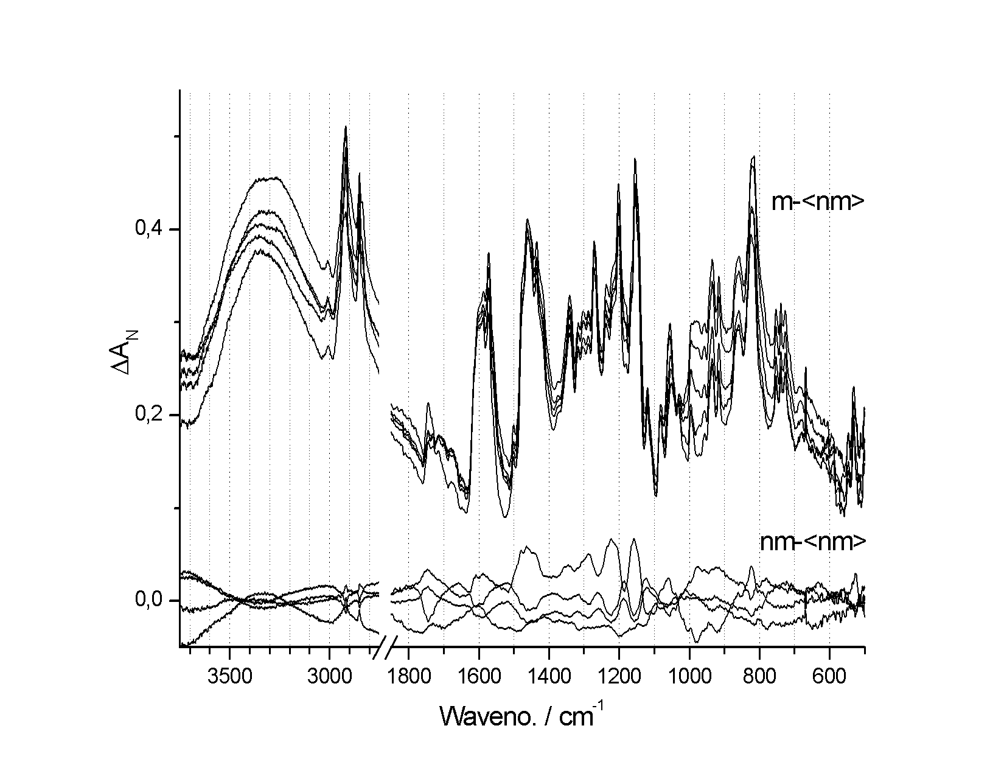
Figure S2.
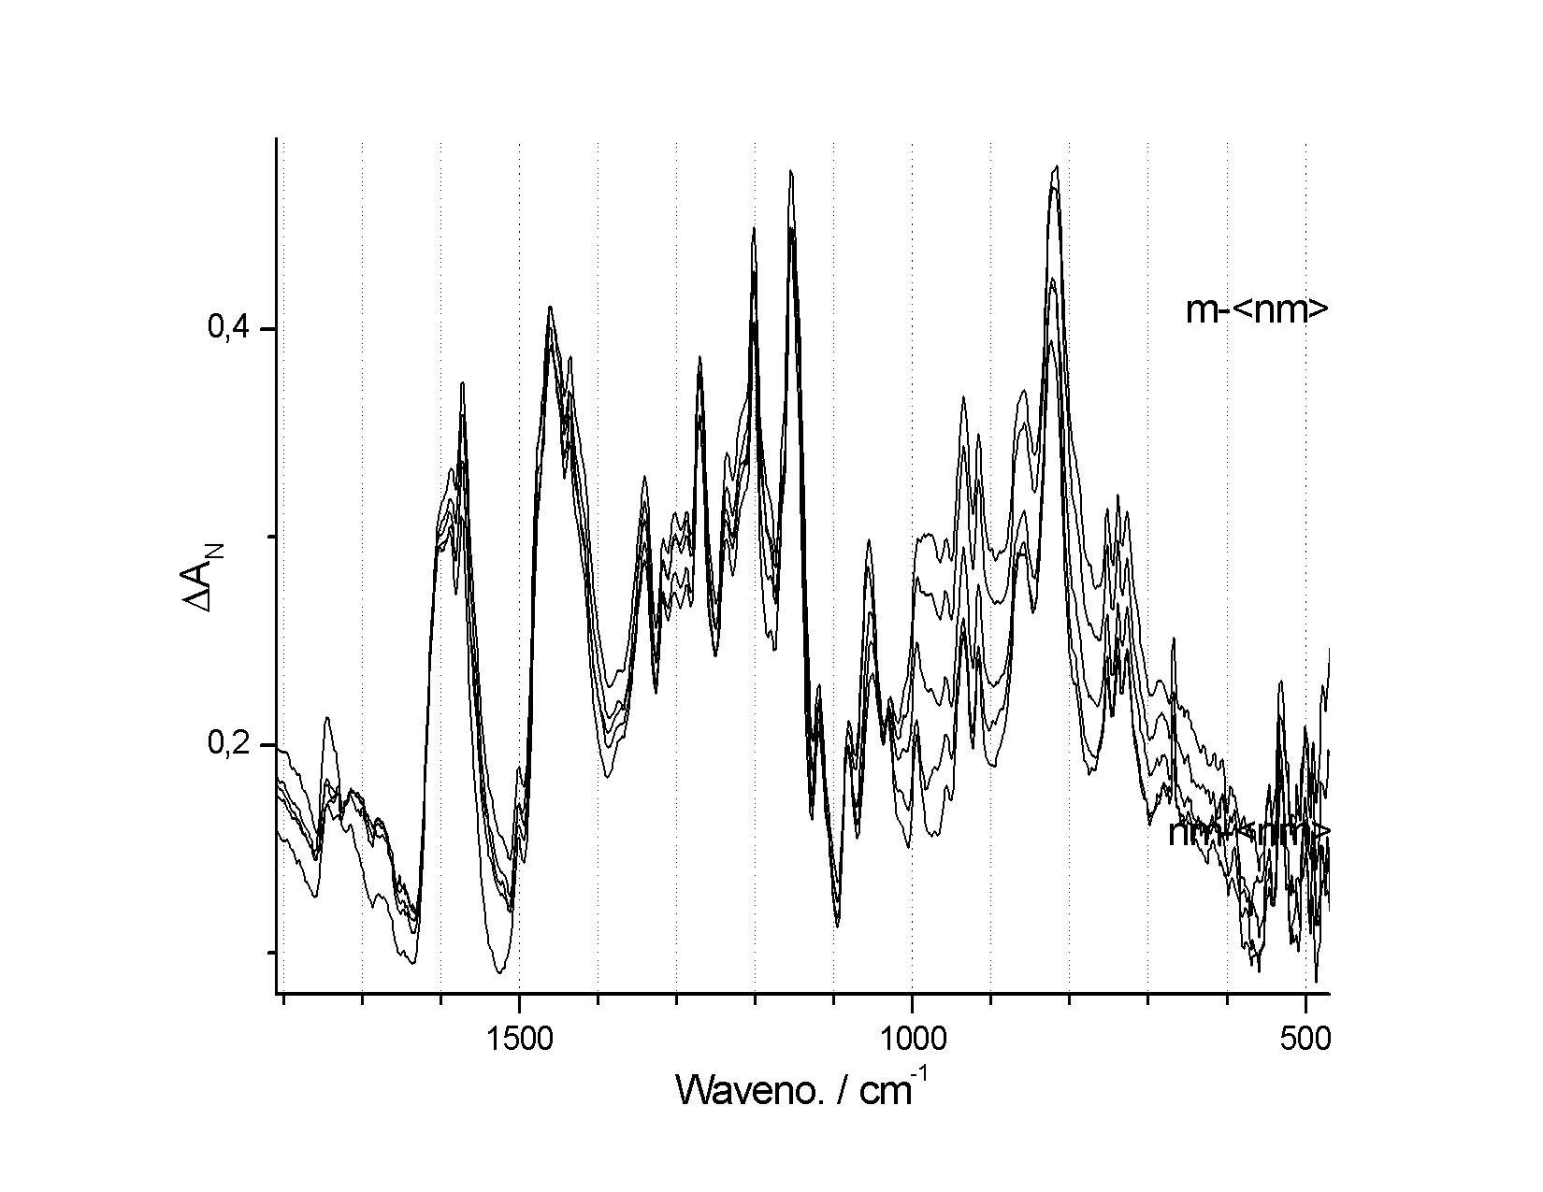
Figure S3.

