Supplementary information S1: drawing and photographs of the five seed germination phenological stages used for Robinia pseudoacacia, adapted from Minost (1997) and Cierjacks et al. (2013). © XP Bouteiller, AJ Porté

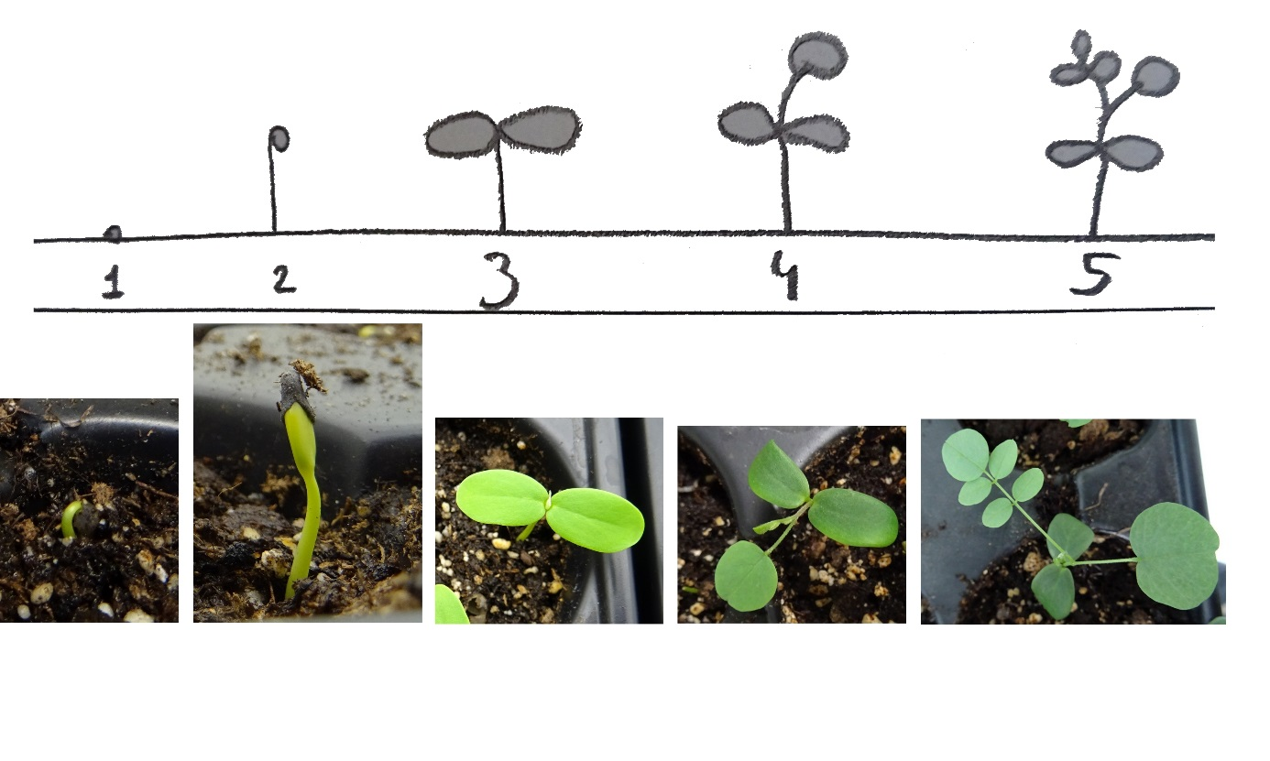

Supplementary information S2: photographs of the seeds for each species
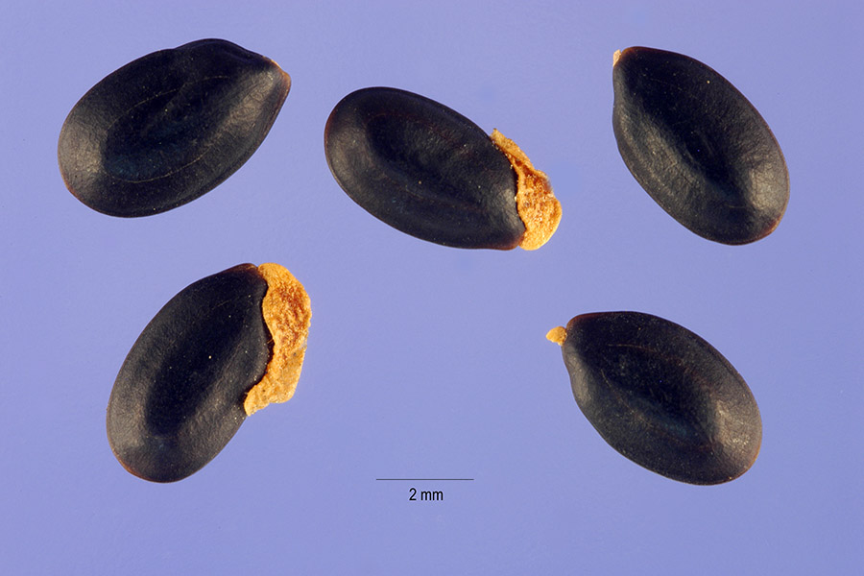
Acacia dealbata, Steve Hurst, hosted by the USDA-NRCS PLANTS Database
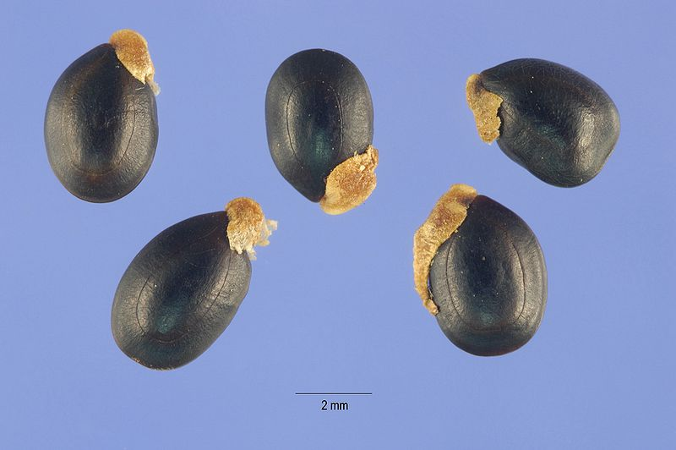
Acacia mearnsii, Steve Hurst, hosted by the USDA-NRCS PLANTS Database

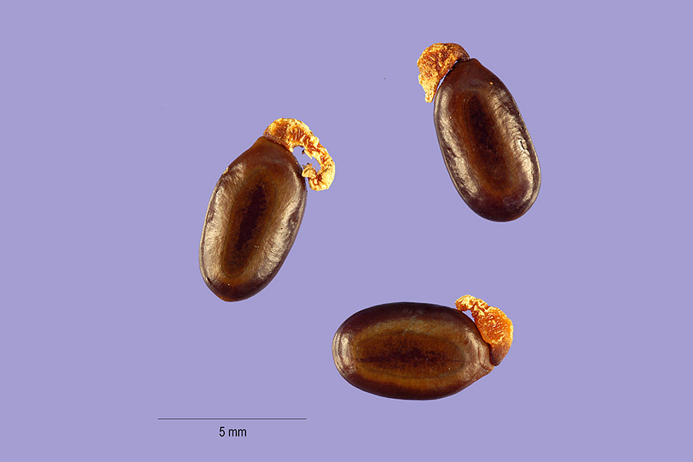
Acacia saligna, Tracey Slotta, hosted by the USDA-NRCS PLANTS Database
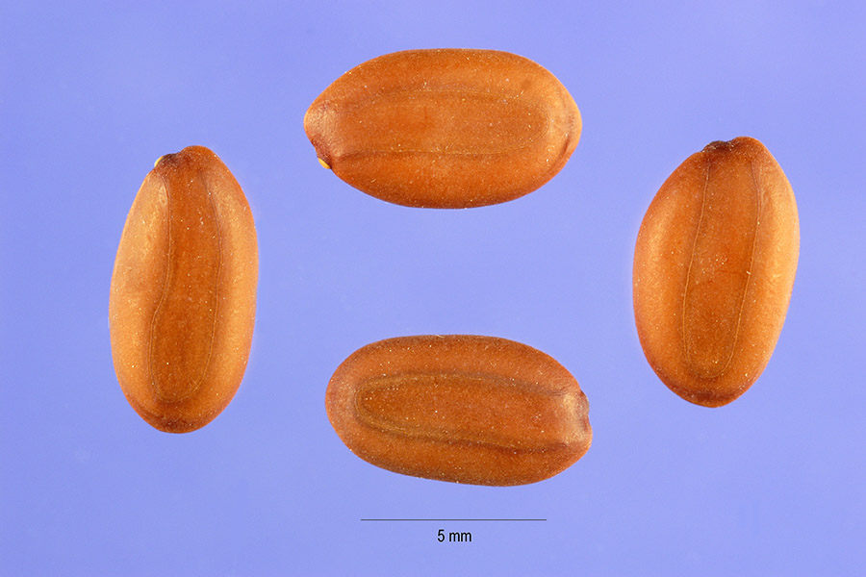
Albizia julibrissin, Steve Hurst, hosted by the USDA-NRCS PLANTS Database
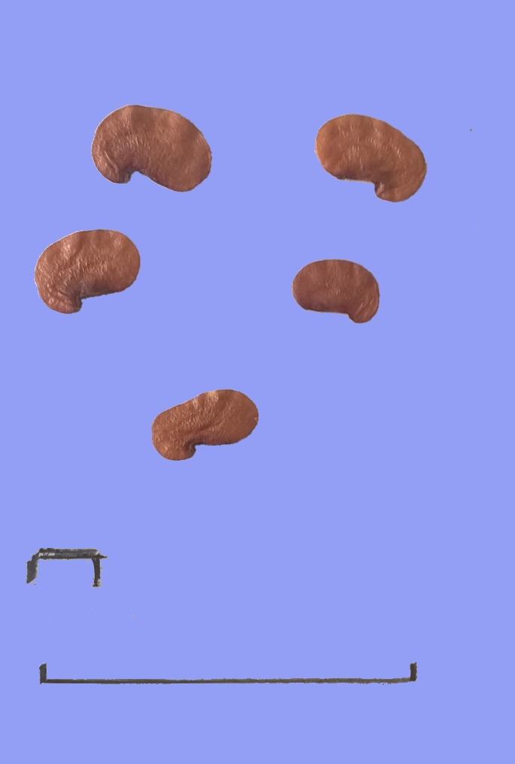
5 mm
Dalbergia sissoo, Annabel J. Porté
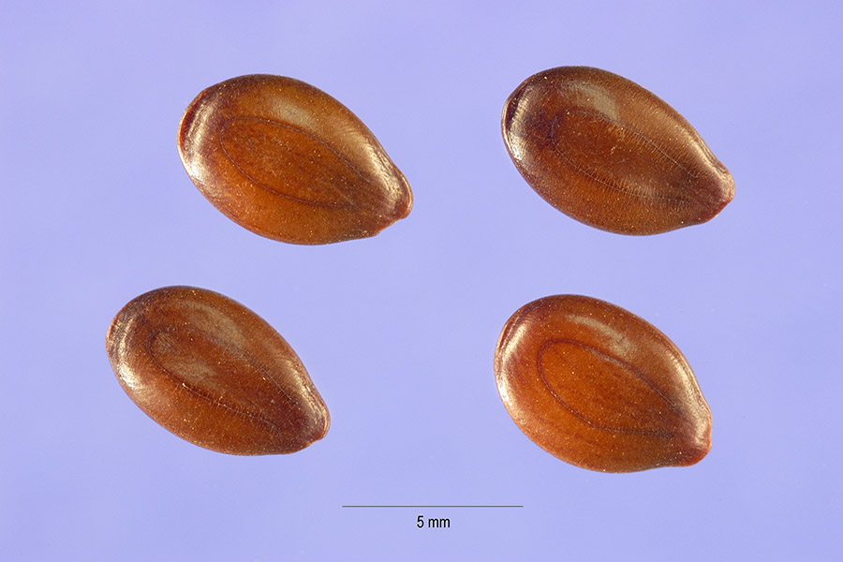
Leucaeana leucocephala, Steve Hurst, hosted by the USDA-NRCS PLANTS Database

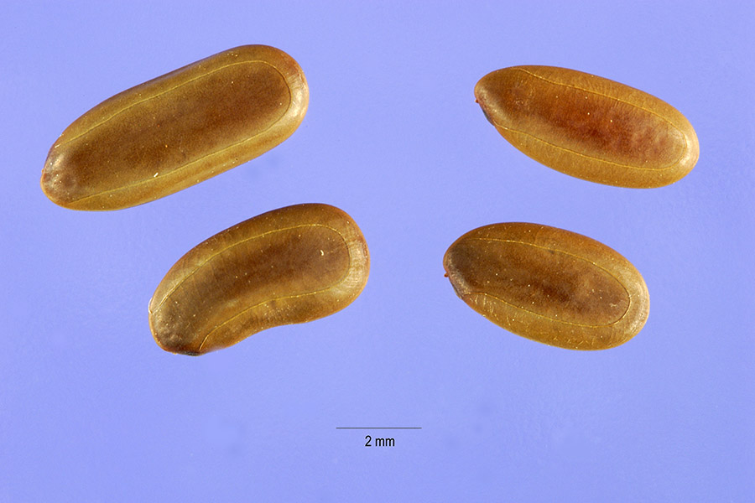
Mimosa pigra, Steve Hurst, hosted by the USDA-NRCS PLANTS Database
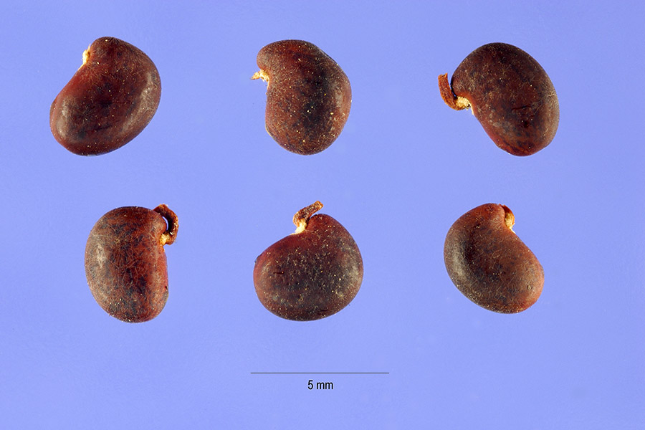
Robinia pseudoacacia, Steve Hurst, hosted by the USDA-NRCS PLANTS Database
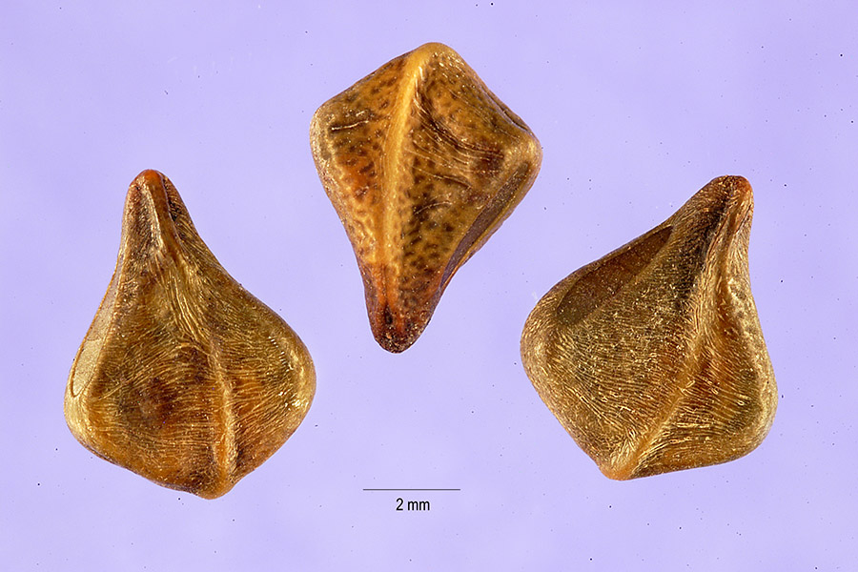
Senna alata, Tracey Slotta, hosted by the USDA-NRCS PLANTS Database
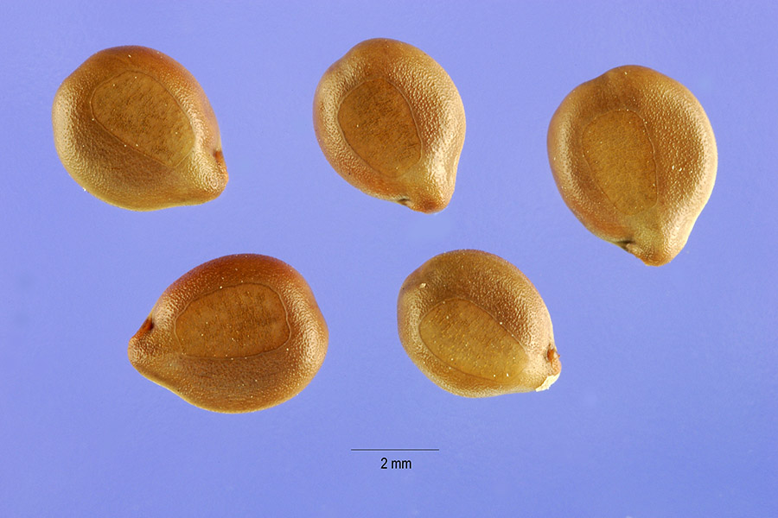
Senna occidentalis, Steve Hurst, hosted by the USDA-NRCS PLANTS Database

Reference:
All photographs are free of use. Except for Dalbergia sissoo, all photographs were extracted from the Image database of the Plant database from the USDA.
USDA, NRCS. 2017. The PLANTS Database (http://plants.usda.gov, 11 January 2017). National Plant Data Team, Greensboro, NC 27401-4901 USA.

