77 DAF

49 DAF

42 DAF

63 DAF

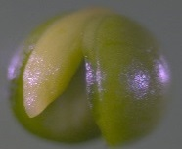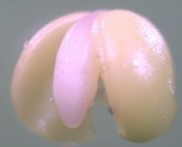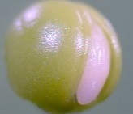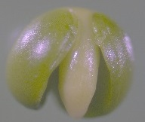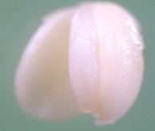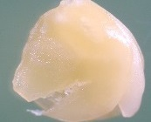

35 DAF

56 DAF

**1 mm**

**Supplementary Figure S2.** Stages of embryo development of oilseed rape (variety Smart) between flowering (beginning of May) and harvest in 2010; DAF: days after flowering.