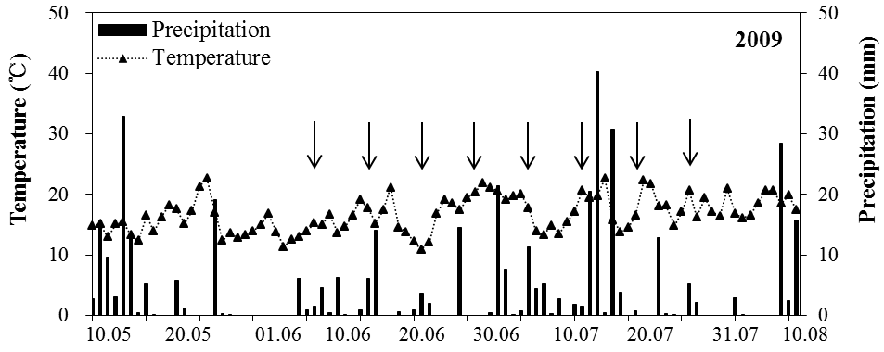
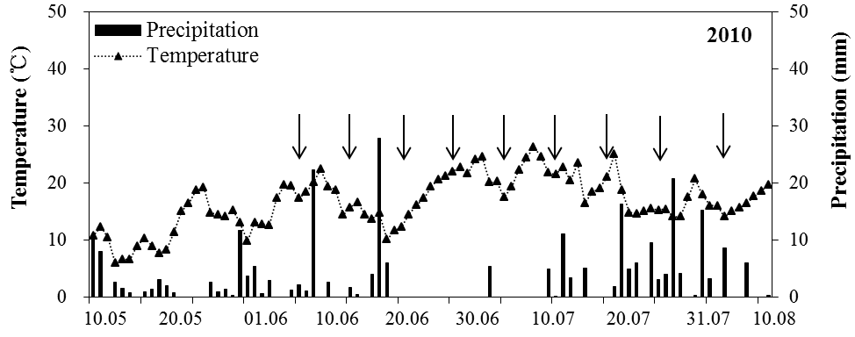
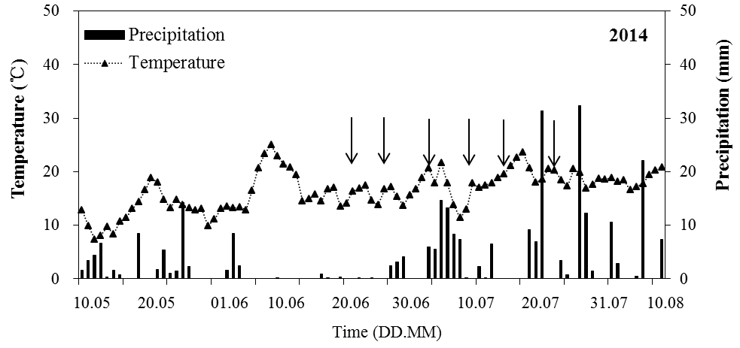
Supplementary Fig. S1. Daily temperature (at 2m above ground) and precipitation from beginning of flowering to last harvest of oilseed rape at experimental station Ihinger Hof in the years 2009, 2010, and 2014. Arrows: harvest date.

