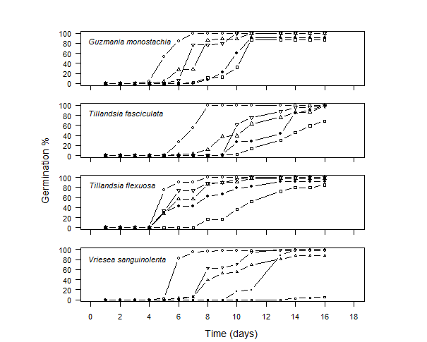

Figure S1. Cumulative germination in response to different wet–dry periods for the species Guzmania monostachia, Tillandsia fasciculata, Tillandsia flexuosa, Vriesea sanguinolenta. Symbols represent the different dry/wet periods in hours: open circles: control treatment (continuous moisture), squares: 12/12, solid circle: 24/24, triangle point-up: 36/36, triangle point-down: 48/48.

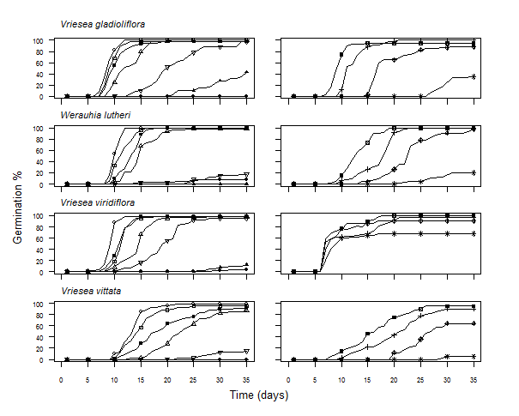

Figure S2. Cumulative germination response of four bromeliads at different water potentials (left side) and different treatments with intermittent drought (right side). Water potentials were 0 (open circle), -0.10 (open square), -0.25 (solid square), -0.50 (open triangle point-up), -1.0 (open triangle point-down), -1.50 (solid triangle), and -2.0MPa (solid circle). The different drought treatments are D0 (square cross), D1 (plus), D2 (diamond plus) and D3 (star).

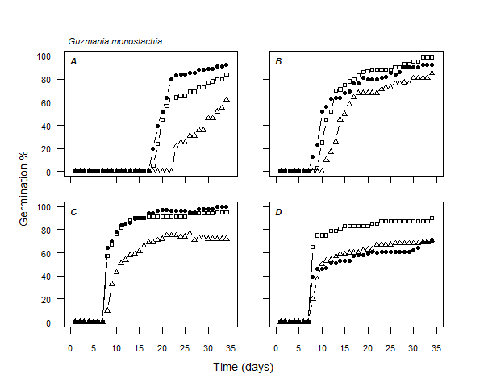
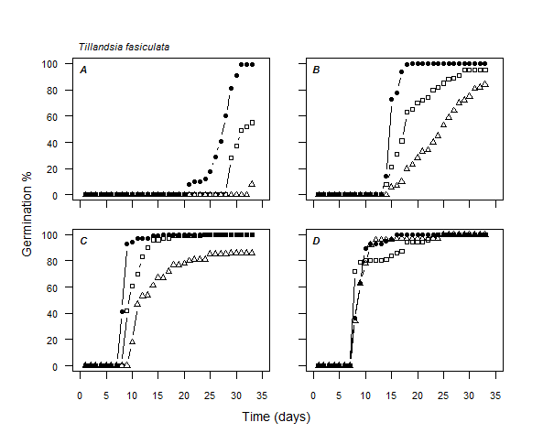
Figure S3 (part 1). Cumulative germination in response to different temperature and water combined treatments for the species Guzmania monostachia and Tillandsia fasciculata. A: 15°C, B: 20°C, C: 25C, D: 32.5°C. Symbols in lines represent the different water treatments: solid circles: continuous moisture, squares: 2 hours dry period, triangle point-up: 6 hours dry period.
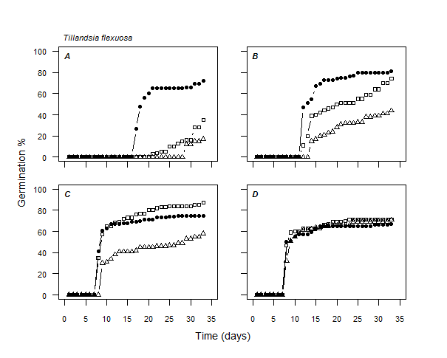
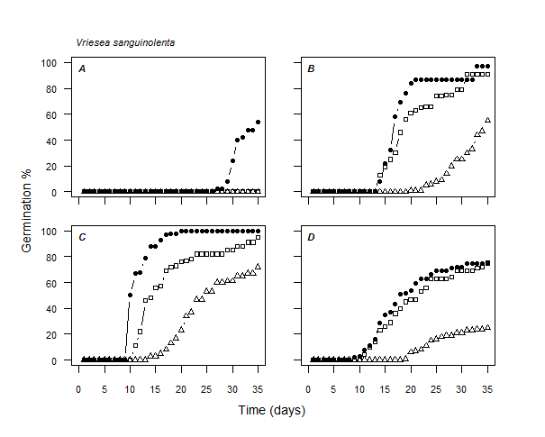
Figure S3 (part 2). Cumulative germination in response to different temperature and water combined treatments for the species Tillandsia flexuosa and Vriesea sanguinolenta. A: 15°C, B: 20°C, C: 25°C, D: 32.5°C. Symbols in lines represent the different water treatments: solid circles: continuous moisture, squares: 2 hours dry period, triangle point-up: 6 hours dry period.

