Supporting Information for

Title: Visible Wealth in Past Societies: A Case Study of Domestic Architecture from the Hawaiian Islands

Authors: Mark D. McCoy, Joseph L. Panuska

Correspondence to: mark.mccoy@fsu.edu

This PDF file includes:

Supplementary Text
Figs. S1 to S2
Tables S1 to S10

Supplementary Text

Summary of Results
We have constructed an archaeological database from over 50 years of field survey, comprised of 2,005 stone foundations from 20 locations across the Hawaiian Islands. It is difficult to say how many domestic compounds this represents. Hommon (2013) suggests an average compound will be comprised of 3 structures. However, since smaller architecture overlaps with the size range of structures that are interpretated to have been used on a temporary basis, we eliminate the smallest quartile, and estimate our database represents about 500 households (1,500 features / 3 features per compound). We do not make any claims regarding total population or population density other than to suggest the very high density areas (more than 500 domestic features per km²) are on par with what has been classified as urban elsewhere in the world.

Metadata for Geospatial Data
We created two GIS layers: 1) points representing domestic features, and 2) polygons representing case study area boundaries. Metadata is divided into information common to both layers and information relevant to Case Studies.

Common Metadata
Layers were created in ESRI’s ArcPro 2.4.1. Coordinate system: UTM, Zone 4N. Created by: M. D. McCoy and J. L. Panuska. Date created: 30 June 2021. Contact: M. D. McCoy, Department of Anthropology, Florida State University, Tallahassee, Florida, USA 32303. mark.mccoy@fsu.edu. Fields: Case_Study: identification number of field survey area created for this study. Location_Name: name used for location of field survey, derived from community names. The two diacritical markings used in Hawaiian were removed to avoid data transcription errors. See below for correct placenames. Site: identification number used by State of Hawai‘i to inventory archaeology or study-specific identification system. Feature: studyspecific identification system for individual features, not all studies provide consistent feature identifications. Form: the physical form of stone, or stone and earth, architecture as described by field survey report. Size: the external, or basal, area of features in m² rounded to nearest decimeter.
Data available at the Digital Archaeological Record (tDAR).

Case Study 1. Manukā, Hawai‘i Source reference:
McCoy, M.D., Codlin, M.C. 2016. The Influence of Religious Authority in Everyday Life: A landscape scale study of domestic architecture and religious law in ancient Hawai‘i. World Archaeology. DOI: 10.1080/00438243.2016.1164073.
Description: 23 domestic features recorded by GPS for a detailed study of architecture. GIS layers from survey are available on the Digital Archaeological Record (tDAR id: 402021).

Case Study 2. Ka‘awaloa, Hawai‘i Source reference:
Hommon, R.J. 1969. An intensive survey of the northern portion of Kaawaloa, Kona, Hawaii.
Mimeographed report in Library, Bernice P. Bishop Museum. Honolulu.
Description: 94 domestic features on survey map marked as TP (terraced platform) and PP (paved platform). Area was estimated by geo-rectifying the map and tracing platforms.

Case Study 3. Kanakau to Mā‘ihi, Hawai‘i Source reference:
Tomonari-Tuggle, M. J. and H. D. Tuggle, 1999. Hokuli‘a: An integrated archaeological mitigation plan. Honolulu: International Archaeological Research Institute, Inc.
Description: 70 domestic features, sites shown on survey map, area of features given in report. Survey map had to be geo-rectified.

Case Study 4. Koloko, Hawai‘i Source reference:
Cordy, R.H. 1981. A Study of Prehistoric Social Change: The Development of Complex Societies in the Hawaiian Islands. New York: Academic Press.
Description: 31 domestic features, sites shown on survey map, area of features given in report. Survey map had to be geo-rectified.

Case Study 5. Kohanaiki to Kalaoa 4, Hawai‘i Source reference:
Cordy, R.H. 1981. A Study of Prehistoric Social Change: The Development of Complex Societies in the Hawaiian Islands. New York: Academic Press.
Description: 57 domestic features, sites shown on survey map, area of features given in report. Survey map had to be geo-rectified.

Case Study 6. Maniniowali to Kukio 1, Hawai‘i Source reference:
Cordy, R.H. 1981. A Study of Prehistoric Social Change: The Development of Complex Societies in the Hawaiian Islands. New York: Academic Press.
Description: 43 domestic features, sites shown on survey map, area of features given in report. Survey map had to be geo-rectified.

Case Study 7. Anaehoomalu and Kalāhuipua‘a, Hawai‘i Source reference:
Kirch, P.V. 1979. Marine exploitation in Prehistoric Hawai‘i: Archaeological Excavations at Kalāhuipua‘a, Hawai‘i Island. Pacific Anthropological Records 29. Honolulu: Bernice P. Bishop Museum.
Description: 29 domestic features, sites shown on survey map, area of features given in report. Survey map had to be geo-rectified. Caves and rock shelters were excluded from sample.

Case Study 8. Waikā and Kahuā 2, Hawai‘i Source reference:
Graves, D.K., and Franklin, L.J. 1998. Archaeological Inventory Survey Kahua Makai/Kahua Shores Coastal Parcels, Lands of Kahua 1 and 2 and Waika, North Kohala District, Island of
Hawai‘i. Hilo: Paul H. Rosendahl, Inc.
Description: 36 domestic features, sites shown on survey map, area of features given in report. Survey map had to be geo-rectified.

Case Study 9. Kīpahulu, Maui Source reference:
Carson, M. T. and R. Reeve, 2008. Archaeological inventory survey of portions of the Kīpahulu Unit of Haleakalā National Park, Maui Island, State of Hawai‘i. Honolulu: International Archaeological Research Institute, Inc.
Description: 39 domestic features, UTM locations and area of features given in report.

Case Study 10. Kahikinui, Maui Source reference:
Erkelens, C. 1995. Phase I Archaeological Investigation, Cultural Resources Survey, Hawai‘i Geothermal Project, Makawao and Hana Districts, South Shore of Maui, Hawai‘i. Honolulu: International Archaeological Research Institute, Inc.
Description: 108 domestic features, UTM locations and area of features given in report.

Case Study 11. Kuheia, Kaho‘olawe Source reference:
Hammatt, H.H., Jimenez, J.A., Lee, T.L., Ida, G., and Head, J. 2002. Historic Properties Task
Order Report, UXO Clearance Project Kaho‘olawe Island Reserve, Hawai‘i. Kailua, Hawai‘i:
Cultural Surveys Hawai‘i, Inc.
Description: 79 domestic features, UTM locations and area of features given in report. Incorrect GPS location given for Site 647 Feature D, likely a typo, edited to give position as same as Site 647 Feature C.

Case Study 12. Māmaki, Lanai Source reference:
Dixon, B., Major, M., and Lazzaaro, D. 1992. Kaunolū: An archaeological inventory survey and mapping of State Site 50-40-98-25, Kaunolū and Keāliakapu Ahupua‘a, Lāna‘i, Hawai‘i. Honolulu: Bernice P. Bishop Museum.
Description: 116 domestic features, point locations not available, survey area boundaries digitized from report map. Map indicates additional unmapped features. Feature sizes given in report.

Case Study 13. Kaunolū, Lanai Source reference:
Dixon, B., Major, M., and Lazzaaro, D. 1992. Kaunolū: An archaeological inventory survey and mapping of State Site 50-40-98-25, Kaunolū and Keāliakapu Ahupua‘a, Lāna‘i, Hawai‘i. Honolulu: Bernice P. Bishop Museum.
Description: 322 domestic features, point locations not available, survey area boundaries digitized from report map. Feature sizes given in report.

Case Study 14. Kawela, Moloka‘i Source reference:
Weisler, M., and Kirch, P.V. 1982. The Archaeological Resources of Kawela, Moloka‘i: Their nature, significance, and management. Honolulu: Bernice P. Bishop Museum.
Description: 100 domestic features, site locations given in UTM coordinates, most feature sizes given in report. A small number of feature sizes had to be estimated from reported size ranges in compounds.

Case Study 15. Kaluakoi, Moloka‘i Source reference:
Dixon, B, and Major, M. 1992. Kapukahehu to Pu‘uhakina: An archaeological inventory survey of southwest Moloka‘i, Hawai‘i. Honolulu: Bernice P. Bishop Museum.
Description: 156 domestic features, sites shown on survey map, area of features given in report. Survey map had to be geo-rectified.

Case Study 16. North Halawa, O‘ahu Source reference:
Hartzell, L.L., S.A. Lebo, H.A. Lennstrom, S.P. McPherron, and D.I. Olszewski, 2003. Imu, adzes, and upland agriculture: Inventory survey archaeology in the North Hālawa Valley, O‘ahu. Honolulu: Bernice P. Bishop Museum.
Description: 45 domestic features, sites shown on survey map, area of features given in report. Survey map had to be geo-rectified.

Case Study 17. Ewa, O‘ahu Source reference:
Haun, A. 1991a. An Archaeological Survey of the Naval Air Station, Barber’s Point, O‘ahu,
Hawai‘i. Honolulu: Bernice P. Bishop Museum.
Description: 118 domestic features, sites shown on survey map, area of features given in report. Survey map had to be geo-rectified.

Case Study 18. Lualualei, O‘ahu Source reference:
Haun, A. 1991b. An Archaeological Survey of the Naval Magazine and Naval Communications
Area Transmission Facility Lualualei, O‘ahu, Hawai‘i. Honolulu: Bernice P. Bishop Museum.
Description: 182 domestic features, sites shown on survey map, area of features given in report. Survey map had to be geo-rectified.

Case Study 19. Mākua, Oahu Source reference:
Elbé, F., Cleghorn, P., and Jackson, T.L. 1995. Archaeological Investigations at Proposed MK19 Range Makua Military Reservation Wai‘anae, O‘ahu, Hawai‘i. Kailua, Hawai‘i: Biosystems Analysis, Inc.
Description: 45 domestic features, sites shown on survey map, area of features given in report. Survey map had to be geo-rectified.

Case Study 20. Kīahuna, Kaua‘i Source reference:
Hammatt, H.H., Shideler, D., O’Hare, C.R., Cordy, D., and Folk, W.H. 2004. Kīahuna
Archaeological Inventory Survey and Testing Project Parcels 3, 4, and 5, Kōloa, Ahupua‘a, Kona District, Kaua‘i. Kailua, Hawai‘i: Cultural Surveys Hawai‘i, Inc.
Description: 312 domestic features, point locations not available, survey area boundaries digitized from report map. Feature sizes given in report.

Standard Error and Sample Size
We examined relative Standard Error following Fochesato et al. (2019) and found that even case studies with small sample sizes had little error. The small amount of improvement made with larger sample sizes reaches diminishing returns at n=100.

External vs. Internal Area Measurements
In Case Study 1, where we have the best information on the external (or basal) area and estimated interior (or floor) area, we calculated the Gini coefficient using both techniques.
External area, our preferred method, resulted in a Gini coefficient of 0.467 (Boot=0.441, SE=0.059, Lower=0.321, Upper=0.548) and internal area resulted in a Gini coefficient of 0.504 (Boot=0.474, SE=0.065, Lower=0.332, Upper=0.584).

Statistical Tests to Address the Modifiable Areal Unit Problem
The Modifiable Areal Unit Problem (MAUP) arises from the use of arbitrary boundaries to define samples (43, 44). We examined two potential problems related to study area boundaries: 1) the aggregation of domestic features by study area rather than by compound, and 2) clustering as a proxy for representativeness of settlement patterns.
Due to uneven preservation, and high density of compounds in some areas, as well as other factors, it is impossible to unambiguously assign domestic features to a compound except in rare circumstances. One such circumstance is Case Study 1, a geologically young landscape with very little soil development. Archaeological visibility is extraordinarily high and the area lacks the small temporary shelters that are common among farms. We calculated a Gini coefficient based on features aggregated by study area (i.e., 23 features), our preferred method, and by compound and study area (i.e., the same 23 features collapsed into 5 compounds). Features resulted in a Gini coefficient of 0.467 (Boot=0.441, SE=0.059, Lower=0.321, Upper=0.548) and compounds resulted in a Gini coefficient of 0.442 (Boot=0.380, SE=0.118, Lower=0.150, Upper=0.596). Wide margin of error is due to the small number of compounds. The results of this test confirm our technique of aggregating features by case study area will return a Gini coefficient that mirrors what we would find if we measured individual compounds. We used Ripley’s K-function to test case study areas for clustering since this function is capable of detecting clustering, or dispersion, at different spatial scales. The majority of case study areas where this test could be applied (10 out of 16 cases) show statistically significant clustering. Specifically, nearly all show significantly significant clustering from 0 to 550-meter bands, at which point they cross over to random. Table S4 shows: Location_Type: if point locations are at the feature or site resolution; Nearest_ Neighbor_Index: an index of to classify points as clustered-random-dispersed within a fixed area; Z-score: of the Nearest Neighbor Index; Result: if Nearest Neighbor Index is clustered, random, or dispersed; Observed Mean
Distance: mean distance in meters of points; Significant_Breakpoint_Distance: Ripley’s K shows points are statistically significantly clustered within this distance band and then become random past this distance; Number_of_Points: number of geographic points in calculation;
Error_Warning: the software (ESRI’s ArcPro 2.4.1) give a small sample warning for Ripley’s K calculations under n=30.
We recalculated statistics using only the 10 case studies that appear to have the best representation of the settlement pattern. The result was a mean Gini of 0.507 (se=0.016, bootstrapped Upper= 0.538, Lower=0.475). The results of this test confirm that our database returns a Gini coefficient that is sufficiently similar to a sub-sample of only those surveys most representative of the overall settlement pattern.

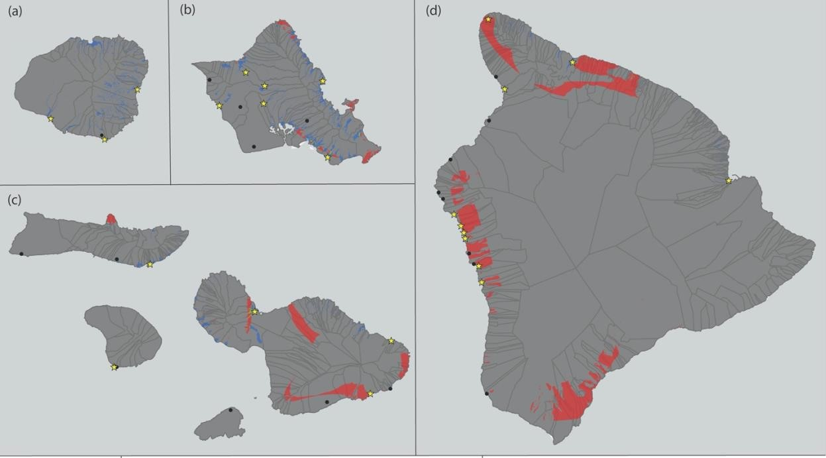
Fig. S1. Map of Agricultural Resources. On the islands of Kaua‘i (a), O‘ahu (b) and Moloka‘i (c) people relied primarily on irrigated farming. In contrast, on Maui (c) and Hawai‘i (d) most food would have come from rainfed (non-irrigated) agriculture.

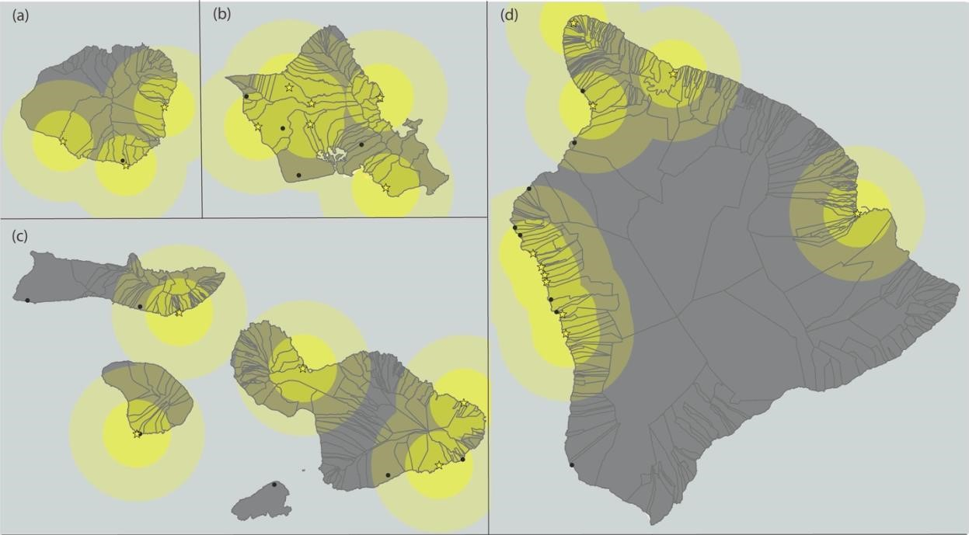
Fig. S2. Map of Distance Bands to Royal Centres. To assess the role of royal centres within the larger settlement pattern we examined settlement density, inequality, and features size within distance bands of 0-10 km from known royal centres, at 10-20 km, and more than 30 km on the islands of Kaua‘i (a), O‘ahu (b) and Moloka‘i (c), Maui (c), and Hawai‘i (d).

Case_Study Gini Boot_Gini Standard_Error Lower Upper
1 | 0.467 | 0.444 | 0.060 | 0.321 | 0.554
2 | 0.500 | 0.492 | 0.033 | 0.426 | 0.555
3 | 0.439 | 0.431 | 0.030 | 0.371 | 0.490
4 | 0.408 | 0.390 | 0.048 | 0.290 | 0.477
5 | 0.390 | 0.380 | 0.041 | 0.299 | 0.458
6 | 0.394 | 0.385 | 0.026 | 0.329 | 0.431
7 | 0.575 | 0.530 | 0.100 | 0.342 | 0.684
8 | 0.643 | 0.618 | 0.047 | 0.501 | 0.686
9 | 0.501 | 0.487 | 0.046 | 0.390 | 0.572
10 | 0.568 | 0.561 | 0.035 | 0.486 | 0.629
11 | 0.489 | 0.481 | 0.033 | 0.412 | 0.542
12 | 0.636 | 0.626 | 0.037 | 0.546 | 0.691
13 | 0.582 | 0.576 | 0.034 | 0.507 | 0.640
14 | 0.520 | 0.513 | 0.025 | 0.458 | 0.557
15 | 0.645 | 0.637 | 0.034 | 0.568 | 0.699
16 | 0.570 | 0.558 | 0.051 | 0.455 | 0.650
17 | 0.521 | 0.515 | 0.036 | 0.442 | 0.582
18 | 0.463 | 0.457 | 0.032 | 0.398 | 0.524
19 | 0.636 | 0.616 | 0.048 | 0.502 | 0.692
20 | 0.624 | 0.621 | 0.024 | 0.572 | 0.670
All 0.579 0.579 0.010 0.560 0.598

Table S1. Results by Study Area: Gini coefficient.

Case_Study Island Location_Name Number_of_Features Study_Area_km2
1 | Hawaii | Manuka | 23 | 0.231
2 | Hawaii | Kaawaloa | 94 | 0.106
3 | Hawaii | Kanakau to Maihi | 70 | 4.522
4 | Hawaii | Koloko | 31 | 0.272
5 | Hawaii | Kohanaiki to Kalaoa 4 | 57 | 2.015
6 | Hawaii | Maniniowali to Kukio 1 | 43 | 0.266
7 | Hawaii | Anaehoomalu and Kalahuipuaa | 29 | 6.766
8 | Hawaii | Waika and Kahua 2 | 36 | 0.178
9 | Maui | Kipahulu | 39 | 0.07
10 | Maui | Kahikinui | 108 | 5.786
11 | Kahoolawe | Kuheia | 79 | 2.73
12 | Lanai | Mamaki | 116 | 0.058
13 | Lanai | Kaunolu | 322 | 0.581
14 | Molokai | Kawela | 100 | 2.678
15 | Molokai | Kaluakoi | 156 | 16.898
16 | Oahu | North Halawa | 45 | 0.371
17 | Oahu | Ewa | 118 | 2.751
18 | Oahu | Lualualei | 182 | 6.46
19 | Oahu | Makua | 45 | 0.522
20 | Kauai | Kaihuna | 312 | 1.493
All - - 2005 54.754

Table S2. Results by Study Area: Field Surveys. Name used for location of field survey were derived from community names. The two diacritical markings used in Hawaiian were removed to avoid data transcription errors. See metadata above for correct spellings.

Average_Feature_Size_m2 SD_Feature_Size_m2
1 | 32.5 | 32.2
2 | 74.6 | 84.8
3 | 51.3 | 46.4
4 | 38 | 32.5
5 | 33.7 | 28.6
6 | 33.3 | 26.3
7 | 39.3 | 68.3
8 | 85.4 | 135.4
9 | 44.7 | 46.8
10 | 35.4 | 45.8
11 | 40.7 | 41.9
12 | 32.4 | 57.2
13 | 31.3 | 60
14 | 25 | 27.5
15 | 27.2 | 50.5
16 | 41.2 | 52.2
17 | 20.7 | 26.9
18 | 54.5 | 64.2
19 | 49.8 | 78.6
20 | 28.4 | 47.2
All 37.3 56.9
Table S3. Results by Study Area: Feature size.

Density_km2 Density_Classification
1 | 100 | high
2 | 887 | very high
3 | 15 | low
4 | 114 | high
5 | 28 | low
6 | 162 | high
7 | 4 | low
8 | 202 | high
9 | 557 | very high
10 | 19 | low
11 | 29 | low
12 | 2000 | very high
13 | 554 | very high
14 | 37 | low
15 | 9 | low
16 | 121 | high
17 | 43 | low
18 | 28 | low
19 | 86 | high
20 | 209 | high

Table S4. Results by Study Area: Density.

Distance_to_Royal_Center_km Agricultural_Resources
1 | 38.8 | None
2 | 0 | Rainfed
3 | 2 | Rainfed
4 | 6.5 | Rainfed
5 | 9.3 | Rainfed
6 | 19 | None
7 | 10.6 | Rainfed
8 | 4.8 | Rainfed
9 | 6.94 | Irrigated
10 | 8.3 | Rainfed
11 | 34.3 | Rainfed
12 | 0 | No data
13 | 0.5 | No data
14 | 10.7 | Irrigated
15 | 42.7 | None
16 | 14.5 | Irrigated
17 | 17.5 | None
18 | 5.9 | Irrigated
19 | 4.8 | Irrigated
20 | 0.98 | Irrigated

Table S5. Results by Study Area: Distance to Royal Centre and Agricultural Resources.

Island Case_Study Gini Boot_Gini Standard_Error Lower Upper
Hawaii | 1 to 8 | 0.519 | 0.516 | 0.022 | 0.472 | 0.557
Maui | 9 and 10 | 0.553 | 0.548 | 0.027 | 0.493 | 0.601
Kahoolawe | 11 | 0.489 | 0.481 | 0.032 | 0.415 | 0.542
Lanai | 12 and 13 | 0.598 | 0.594 | 0.027 | 0.54 | 0.643
Molokai | 14 and 15 | 0.602 | 0.598 | 0.027 | 0.547 | 0.65
Oahu | 16 to 19 | 0.548 | 0.547 | 0.021 | 0.506 | 0.589
Kauai | 20 | 0.624 | 0.621 | 0.024 | 0.572 | 0.669

Table S6. Results by Island: Gini coefficient

Number_of_Featur Average_Feature_Size_ SD_Feature_Size_
Island es m2 m2 Percent_Rainfed_Food
Hawaii | 383 | 52.5 | 69.8 |  | 87%
Maui | 79 | 37.9 | 46.1 |  | 47%
Kahoolawe | 147 | 40.7 | 41.9 | no data
Lanai | 438 | 31.6 | 59.2 | no data
Molokai | 256 | 26.3 | 42.9 |  | 13%
Oahu | 390 | 42.2 | 58 |  | 6%
Kauai | 312 | 28.4 | 47.2 |  | 0

Table S7. Results by Island: Feature Size. Approximate proportion of farmed food from intensive rainfed farming is from Ladefoged et al. (2009).

Agricultural Boot Standar Number of Average Feature SD Feature Resources Gini Gini d Error Lower Upper Features Size m2 Size m2
Irrigated | 0.576 | 0.575 |  | 0.015 | 0.545 | 0.604 | 541 |  | 31.8 |  | 48.6
None | 0.573 | 0.571 |  | 0.023 | 0.525 | 0.618 | 522 |  | 36 |  | 51.5
Rainfed | 0.54 | 0.538 |  | 0.02 | 0.498 | 0.575 | 425 |  | 51.2 |  | 69.4
No Data | - | - | - |  | - | - | 517 | - |  | -

Table S8. Results by Agricultural Resource

Case Location_Type Nearest_Neighbor_Index Z-score Result Observed_Mean_Distance
1 | Feature | 0.348 | -5.984 | clustered | 23.9
2 | Feature | 0.867 | -2.463 | clustered | 17.1
3 | Site | 0.838 | -2.144 | clustered | 146.9
4 | Feature | 0.563 | -4.66 | clustered | 34.9
5 | Feature | 0.262 | -10.66 | clustered | 33.3
6 | Feature | 0.336 | -8.336 | clustered | 17.7
7 | Feature | 0.146 | -8.8 | clustered | 47.2
8 | Site | 1.361 | 3.236 | dispersed | 74.6
9 | Feature | 0.715 | -3.449 | clustered | 17.7
10 | Site | 0.839 | -1.924 | clustered | 196.5
11 | Feature | 0.242 | -12.889 | clustered | 112.8
14 | Feature | 0.025 | -18.66 | clustered | 2.6
15 | Feature | 0.667 | -4.814 | clustered | 215.2
16 | Site | 1.149 | 1.029 | random | 113.1
17 | Site | 0.69 | -2.651 | clustered | 158.4
18 | Site | 0.702 | -5.219 | clustered | 115

Table S9. Spatial Statistics: Nearest Neighbour

Case Significant_Breakpoint_Distance_m Number_of_Points Error_Warning
1 | 100 | 23 | small sample size
2 | 100 | 94 | -
3 | 100 | 48 | -
4 | 100 | 31 | -
5 | 500 | 57 | -
6 | 250 | 43 | -
7 | 1750 | 29 | small sample size
8 | - | 22 | small sample size
9 | 75 | 40 | -
10 | - | 39 | -
11 | 550 | 79 | -
14 | 550 | 100 | -
15 | - | 57 | -
16 | - | 13 | small sample size
17 | - | 20 | small sample size
18 | - | 84 | -

Table S10. Spatial Statistics: Ripley’s K.

References
Fochesato, M., 2019. et al., Comparing ancient inequalities: the challenges of comparability, bias and precision. Antiquity 93, 853–869.
Hommon, R.J. 2013. The Ancient Hawaiian State. Oxford Univ. Press, Oxford.
Ladefoged, T.N., et al., 2009. Opportunities and constraints for intensive agriculture in the Hawaiian archipelago prior to European contact. J. of Archaeo. Sci. 36: 2374-2383.

