Supplementary information
Table S1: All 21 variables initially considered in the model, those with Variance Inflation Factors (VIF) > 10 were excluded from the modelling (Naimi et al. 2014)
Layer | Source and description | VIF
Bio01 | Fick and Hijmans (2017) Wordclim (v2.1) data for Annual mean temperature. | > 10
Bio02 | Fick and Hijmans (2017) Wordclim (v2.1) data for Mean diurnal temperature range (Mean of monthly (maximum temperature – minimum temperature)). | 3.64
Bio03 | Fick and Hijmans (2017) Wordclim (v2.1) data for Isothermally (Bio02/Bio07) (×100). | 6.62
Bio04 | Fick and Hijmans (2017) Wordclim (v2.1) data for Temperature Seasonality (standard deviation ×100). | > 10
Bio05 | Fick and Hijmans (2017) Wordclim (v2.1) data for Maximum temperature of the warmest month. | > 10
Bio06 | Fick and Hijmans (2017) Wordclim (v2.1) data for Minimum temperature of the coldest month. | > 10
Bio07 | Fick and Hijmans (2017) Wordclim (v2.1) data for Annual temperature range (Bio05-Bio06). | > 10
Bio10 | Fick and Hijmans (2017) Wordclim (v2.1) data for Mean temperature of the warmest quarter. | > 10
Bio11 | Fick and Hijmans (2017) Wordclim (v2.1) data for Mean temperature of the coldest quarter. | 7.26
Bio12 | Fick and Hijmans (2017) Wordclim (v2.1) data for Annual precipitation. | > 10
Bio13 | Fick and Hijmans (2017) Wordclim (v2.1) data for Precipitation of the wettest month. | > 10
Bio14 | Fick and Hijmans (2017) Wordclim (v2.1) data for Precipitation of the driest month. | 3.91
Bio15 | Fick and Hijmans (2017) Wordclim (v2.1) data for Precipitation Seasonality (Coefficient of Variation). | 8.38
Bio16 | Fick and Hijmans (2017) Wordclim (v2.1) data for Precipitation of the wettest quarter. | 2.24
Bio17 | Fick and Hijmans (2017) Wordclim (v2.1) data for Precipitation of the driest quarter. | > 10
Forest cover 2021 | Hansen et al (2013). Forest cover as a percentage coverage of each pixel. | 4.07
Forest Landscape Integrity Index | Grantham et al (2020). Combination of a range of observed and inferred human pressures, and forest connectivity. | 2.78
NDVI | Didan (2015). Normalised Difference Vegetation Index, derived from: (Near Infrared band – Red band) / (Near Infrared band + Red band) | > 10
EVI | Didan (2015). Enhanced Vegetation Index calculated from:  2.5 * ((Near Infrared band – Red band) / Near Infrared band + (6 * Red band) – (7.5 * Blue band) + 1) | 2.25
Altitude | Farr et al (2007) Derived from the STRM Digital Elevation Model. | 7.26
Maximum Slope | Derived from the STRM Digital Elevation Model, calculated using QGIS slope plugin. | 1.71

Table S2. Sub-model performance metrics, derived from models built using only 4 cross-validation folds, wi0th fifth fold held out for independent testing
Held-out fold | Number of occupied pixels | Boyce Index | True Skill Statistic | Area Under the receiving operator Curve
1 | 94 | 0.935 | 0.4145 | 0.748
2 | 23 | 0.924 | 0.8337 | 0.9713
3 | 27 | 0.96 | 0.5198 | 0.7854
4 | 32 | 0.915 | 0.7631 | 0.9275
5 | 19 | 0.983 | 0.6272 | 0.8332

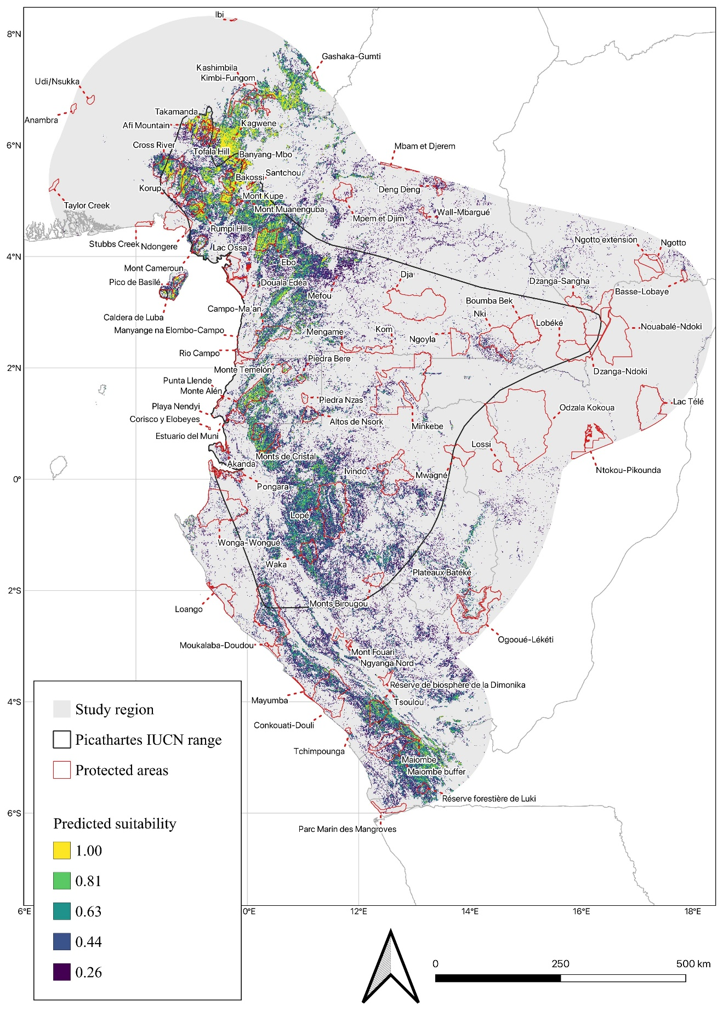
Figure S1: Areas predicted as potentially most suitable for Grey-necked Picathartes nests with Protected Areas highly presented

Figure S2: Weighted map derived from the five sub-models of predicted suitability
