Supplementary Material

Further details on Maxent analyses

Bird distribution modelling
See main text for an explanation of methods and results (Table 1)

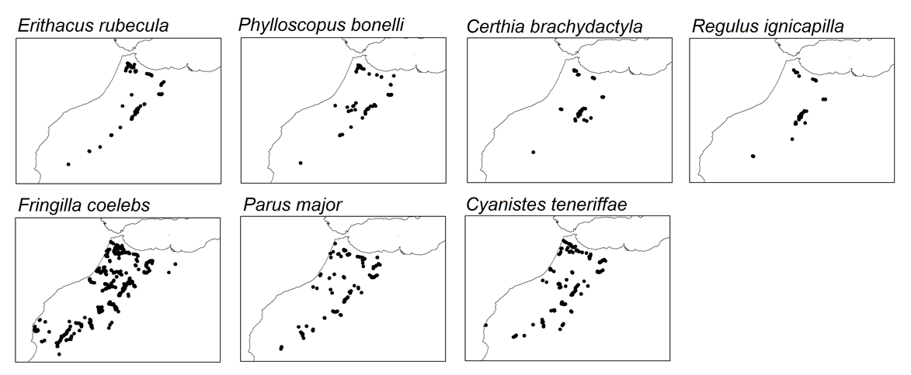 Figure S1. Distribution of the occurrences recorded per species across the sampling area.

Table S1. Pearson's correlation coefficients among the variables used to create the species distribution models for birds.
 | Forest | Bio10 | Bio12 | Bio17
Forest | 1
Bio10 | -0.588 | 1
Bio12 | 0.764 | -0.629 | 1
Bio17 | 0.489 | -0.268 | 0.302 | 1
Forest: Forest cover, Bio10: Mean Temperature of Warmest Quarter, Bio12: Annual Precipitation, Bio17: Precipitation of Driest Quarter.

Table S2. Model parameter settings with best predictive capacity according to KUENM package. Bold numbers indicate the best final models used to project the geographical distribution of habitat suitability for each species. pROC: partial receiver operating characteristic curve, OR: omission rate based on error criterion of 5% during evaluation with independent data. RM: regularization multiplier; F: features (l: linear, q: quadratic, p: product), Akaike information criterion corrected for small samples. ΔAICc: models within 2 AICc units of the minimum value among the candidate models.
Species | model | RM | F | p-value  pROC | OR | AICc | ΔAICc
Erithacus rubecula | 1 | 0.2 | qp | 0.00 | 0.00 | 2055.08 | 0.00
Phylloscopus bonelli | 1 | 0.6 | lq | 0.00 | 0.00 | 1496.71 | 0.00
 | 2 | 0.7 | lq | 0.00 | 0.05 | 1497.06 | 0.35
 | 3 | 0.4 | lqp | 0.00 | 0.05 | 1497.29 | 0.58
 | 4 | 0.4 | qp | 0.00 | 0.05 | 1497.40 | 0.69
 | 5 | 0.8 | lq | 0.00 | 0.05 | 1497.43 | 0.72
 | 6 | 0.4 | lq | 0.00 | 0.05 | 1497.72 | 1.00
 | 7 | 0.9 | lq | 0.00 | 0.05 | 1497.83 | 1.11
 | 8 | 0.5 | lqp | 0.00 | 0.05 | 1498.15 | 1.44
 | 9 | 0.5 | qp | 0.00 | 0.05 | 1498.16 | 1.44
 | 10 | 0.2 | lq | 0.00 | 0.05 | 1498.22 | 1.51
 | 11 | 1 | lq | 0.00 | 0.05 | 1498.26 | 1.55
 | 12 | 0.5 | lq | 0.00 | 0.05 | 1498.71 | 2.00
Certhia brachydactyla | 1 | 0.7 | p | 0.00 | 0.00 | 941.30 | 0.00
 | 2 | 0.8 | p | 0.00 | 0.10 | 941.42 | 0.12
 | 3 | 0.9 | p | 0.00 | 0.10 | 941.54 | 0.23
 | 4 | 1 | p | 0.00 | 0.15 | 941.67 | 0.37
 | 5 | 0.1 | p | 0.00 | 0.10 | 942.61 | 1.30
Regulus ignicapilla | 1 | 0.2 | lq | 0.00 | 0.15 | 907.28 | 0.00
 | 2 | 0.3 | lq | 0.00 | 0.15 | 908.92 | 1.64
 | 3 | 0.1 | lq | 0.00 | 0.15 | 909.03 | 1.75
Fringilla coelebs | 1 | 0.6 | lq | 0.00 | 0.05 | 10794.37 | 0.00
 | 2 | 0.7 | lq | 0.00 | 0.06 | 10795.89 | 1.52
Parus major | 1 | 0.1 | q | 0.00 | 0.07 | 2665.83 | 0.00
 | 2 | 0.2 | q | 0.00 | 0.11 | 2665.83 | 0.01
 | 3 | 0.3 | q | 0.00 | 0.11 | 2665.84 | 0.02
 | 4 | 0.4 | q | 0.00 | 0.11 | 2665.85 | 0.02
 | 5 | 0.5 | q | 0.00 | 0.11 | 2665.86 | 0.03
 | 6 | 0.6 | q | 0.00 | 0.11 | 2665.87 | 0.04
 | 7 | 0.7 | q | 0.00 | 0.11 | 2665.88 | 0.05
 | 8 | 0.8 | q | 0.00 | 0.11 | 2665.89 | 0.06
Cyanistes teneriffae | 1 | 0.5 | lq | 0.00 | 0.04 | 4072.64 | 0.00
 | 2 | 0.6 | lq | 0.00 | 0.07 | 4073.68 | 1.05

Forest distribution modelling
Introduction
We studied the current and future distribution of forest cover to be used as explanatory variables in bird models. As in the case of birds, we used Maxent version 3.4.4 (Phillips et al. 2017) to model the current distribution of forest cover within the study area.

Methods
Maxent requires data on forest occurrences and a set of environmental raster shapes to be used as predictor variables. As in the case of bird modelling, the selected shapes were at 30 arc-second resolutions (~1 km). We generated 1000 randomly selected sampling points within a minimum convex polygon (MCP) covering the forest area in the study area (Fig. 1B). Forest presence records were taken from the Global tree density map dataset (Crowther et al. 2015). Climatic data were obtained from CHELSA (http://chelsa-climate.org/), which has been shown to provide improved climatic estimates in landscapes with complex topography (Karger et al. 2017). We chose four climate variables (Table S5) to represent the effect on tree cover of Mediterranean seasonality and drought on some ecological processes related to distribution, productivity, and phenology (Zuckerberg et al. 2020). In addition, we considered some soil features since they are key factors affecting tree distribution (Wan et al. 2018). This is particularly so in mountainous areas, where forest distribution is inherently sensitive and strongly limited by the variation of soil conditions (Yang et al. 2018). In this context, soil texture and chemical properties strongly affect root development, tree recruitment, drought effects and distribution (Dovčiak et al. 2003, Kooch et al. 2008). Soil data were taken from the ISRIC-World soil information SoilGrids250m database (https://www.isric.org/explore/soilgrids). In this study, we used the data on sand content, silt content, clay content, bulk density, pH (in H2O), soil organic carbon (SOC), cation-exchange capacity (CEC) and nitrogen. We calculated averages according to layer thickness for sand content, silt content, clay content and bulk density over the six layers. For SOC, nitrogen, and CEC, we took the average from the top two layers since most soil organic matter is in these layers. For the pH, all average values were very similar to the first layer value (0-5 cm) since pH was highly correlated among all six layers, thus we used the value of the first layer in our analysis. These data were used to carry out a principal component analysis (PCA) to obtain a reduced number of orthogonal variables. We obtained two components related to nutrient and soil texture (PC1 and PC2 respectively, see Table S4) that were included in the following Maxent analyses to set forest distribution (see Table S5).
As in the case of birds, we used KUENM package in R (Cobos et al. 2019) for choosing an appropriate amount of model complexity (Merow et al. 2014), which selects the best Maxent models of a series of candidates arranged by different combinations of parameter settings. As in birds, we created 119 candidate models by combining the whole set of independent variables, 17 regularization multiplier values (0.1–1.0 at intervals of 0.1, 2–6 at intervals of 1, and 8 and 10), and all seven possible combinations of three feature classes (linear, quadratic, product; see main text). The future distribution of the forest cover was also estimated by projecting the best fitted model (see Table S6) onto future projections of environmental variables (climatic) for two time periods of 2050 (average for 2041–2060) and 2070 (average for 2061–2080) under different emission pathways (see main text). To track changes in suitable habitats, we calculated the percentage of grids that gained or lost habitat suitability for the two RCPs, and for 2050 and 2070, compared to the current area of suitable habitat. To identify suitable grids from unsuitable ones, we first converted model output into binary maps based on the equal training sensitivity and specificity cumulative threshold.

Results
Just one Maxent model was selected by the KUENM package (Table S6) in which forest cover was strongly related to annual precipitation and soil nutrients (Table S7). In addition, climatic predictions suggested a loss of forest cover in some lowlands and an increase in some highlands (Fig. S2).

Table S3. Pearson's correlation coefficients among the soil variables
 | bulk density | CEC | clay | nitrogen | pH | sand | silt | SOC
bulk density | 1
CEC | 0.065 | 1
clay | 0.275 | 0.614 | 1
nitrogen | -0.690 | 0.143 | -0.192 | 1
pH (in H₂O) | 0.565 | -0.452 | -0.309 | -0.599 | 1
sand | -0.250 | -0.604 | -0.851 | 0.161 | 0.212 | 1
silt | 0.048 | 0.193 | 0.064 | -0.007 | 0.076 | -0.578 | 1
SOC | -0.644 | 0.252 | 0.109 | 0.775 | -0.792 | -0.117 | 0.054 | 1
CEC: cation-exchange capacity, SOC: soil organic carbon.

Table S4. Contribution of the soil variables in the first two components in our dataset:
Variables | Components
 | pc1 | pc2
bulk density | -0.684 | -0.544
CEC | 0.493 | -0.652
clay | 0.270 | -0.848
nitrogen | 0.790 | 0.425
pH (in H₂O) | -0.904 | 0.016
sand | -0.273 | 0.922
silt | 0.099 | -0.434
SOC | 0.914 | 0.166
Eigenvalues | 3.144 | 2.687
Variance (%) | 39.30 | 33.58

Table S5. Pearson's correlation coefficients among the variables used to create the species distribution models for forest.
 | Bio04 | Bio10 | Bio12 | Bio17 | soil_pc1 | soil_pc2
Bio04 | 1
Bio10 | 0.093 | 1
Bio12 | -0.273 | -0.347 | 1
Bio17 | 0.527 | -0.351 | 0.301 | 1
PC1 | -0.556 | -0.483 | 0.559 | -0.122 | 1
PC2 | 0.433 | -0.209 | -0.380 | 0.253 | -0.510 | 1
Bio04: Temperature Seasonality (standard deviation ×100), Bio10: Mean Temperature of Warmest Quarter, Bio12: Annual Precipitation, Bio17: Precipitation of Driest Quarter, soil_pc: first principal component, soil_pc2: second principal component.

Table S6. Model parameter settings with best predictive capacity for forest distribution according to KUENM. RM: regularization multiplier; F: features (l: linear, q: quadratic, p: product), pROC: partial receiver operating characteristic curve, OR: omission rate based on error criterion of 5%, AICc: Akaike information criterion corrected for small samples. ΔAICc: models within 2 AICc units of the minimum value among the candidate models.
Forest | RM | FC | p-value  pROC | OR | AICc | Delta  AICc
Model 1 | 0.1 | lqp | 0.00 | 0.00 | 21916.36 | 0.00

Table S7. Estimates of the relative contribution of environmental variable models predicting habitat suitability for the forest cover. The values represent the percent contribution of importance of each variable in the model. Percent contribution indicates the change in regularized gain by adding the corresponding variable. Values are averages and standard deviation over 10 replicate runs. (Symbols in parentheses show the trend of the response curves for the variables: + increase, − decrease, Ω hump-shaped, = no trend).
Variables | Relative contribution
Bio04 | 7.187 ± 1.695 (=)
Bio10 | 9.762 ± 0.979 (Ω)
Bio12 | 37.64 ± 2.038 (+)
Bio17 | 6.186 ± 0.984 (+)
soil_pc1 | 33.37 ± 4.671 (Ω)
soil_pc2 | 2.635 ± 0.690 (Ω)
Bio04: Temperature Seasonality, Bio10: Mean Temperature of Warmest Quarter; Bio12, Annual Precipitation; Bio17, Precipitation of Driest Quarter; soil_pc1 and soil pc2.

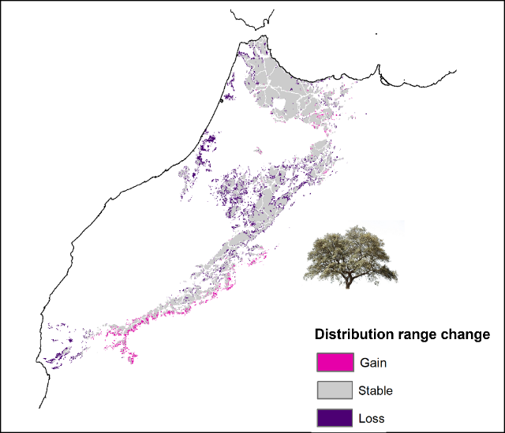
Figure S2. Projected changes in the future habitat suitability for forest cover. Colours reflect the range shifts in terms of surface area; gained (pink), stable (grey) and lost (purple). Suitability map is average calculations of the two periods (2050 and 2070) under two emissions scenarios (RCP 4.5 and RCP 8.5).

References
Cobos, M. E., Peterson, A. T., Barve, N. and Osorio-Olvera, L. (2019) kuenm: an R package for detailed development of ecological niche models using Maxent. PeerJ, 7, e6281.
Crowther, T. W., Glick, H. B., Covey, K. R., Bettigole, C., Maynard, D. S., Thomas, S. M., … Bradford, M. A. (2015) Mapping tree density at a global scale. Nature 525: 201–205.
Dovčiak, M., Reich, P. B. and Frelich, L. E. (2003) Seed rain, safe sites, competing vegetation, and soil resources spatially structure white pine regeneration and recruitment. Can. J. Forest Res.33: 1892–1904.
Karger, D. N., Conrad, O., Böhner, J., Kawohl, T., Kreft, H., Soria-Auza, R. W., … Kessler, M. (2017) Climatologies at high resolution for the earth’s land surface areas. Scientific Data 4: 170122.
Kooch, Y., Jalilvand, H., Bahmanyar, M. A. and Pormajidian, M. R. (2008) The use of principal component analysis in studying physical, chemical and biological soil properties in southern Caspian forests (north of Iran). Pakistan Journal of Biological Sciences 11: 366–372.
Merow, C., Smith, M. J., Edwards Jr, T. C., Guisan, A., McMahon, S. M., Normand, S., … Elith, J. (2014) What do we gain from simplicity versus complexity in species distribution models? Ecography 37: 1267–1281.
Phillips, S. J., Anderson, R. P., Dudík, M., Schapire, R. E. and Blair, M. E. (2017) Opening the black box: an open-source release of Maxent. Ecography, 40: 887–893.
Wan, J.-Z., Li, Q.-F., Li, N., Si, J.-H., Zhang, Z.-X., Wang, C.-J., … Li, Z.-R. (2018) Soil indicators of plant diversity for global ecoregions: Implications for management practices. Global Ecology and Conservation, 14: e00404.
Yang, W., Wang, Y., Webb, A. A., Li, Z., Tian, X., Han, Z., … Yu, P. (2018) Influence of climatic and geographic factors on the spatial distribution of Qinghai spruce forests in the dryland Qilian Mountains of Northwest China. Science of The Total Environment612: 1007–1017.
Zuckerberg, B., Strong, C., LaMontagne, J. M., St. George, S., Betancourt, J. L. and Koenig, W. D. (2020). Climate Dipoles as Continental Drivers of Plant and Animal Populations. Trends in Ecology & Evolution, 35: 440–453.

