Supplementary Materials

A review of the conservation status of Black Stork Ciconia nigra in South Africa, Lesotho and Eswatini

SM Table 1: Maxent response tables for the variables used in predictive models.

The table includes the variable retained for each of the Breeding or Foraging models for Black Stork. * denotes variables derived from the South African National Landcover dataset.
 | Breeding |  | Foraging
Variable | Percent contribution | Permutation importance | Percent contribution | Permutation importance
Slope gradient | 59.1 | 78.3
bio16 Precipitation of Wettest Quarter | 12.8 | 5
bio14 Precipitation of driest month | 9 | 4.5
bio11 Mean Temperature of Coldest quarter | 6.1 | 0.4 | 19.6 | 14.2
bio15 Precipitation Seasonality | 3.3 | 0.3 | 2.1 | 2.6
bio17 Precipitation of Driest Quarter | 3.3 | 1.6
Drainage Lines | 2.4 | 1.4 | 25.6 | 18.9
Digital Elevation Model Data | 2.1 | 1.1 | 1.2 | 13.2
Soil pH | 1.9 | 7.5 | 2 | 2.9
Dams 300m* |  |  | 14 | 2.3
Natural vegetation (1km radius)* |  |  | 3.2 | 3.3
bio1 Annual Mean Temperature |  |  | 6.1 | 0.1
bio4 Temperature Seasonality |  |  | 2.8 | 0.4
bio6 Min Temperature of coldest month |  |  | 3.4 | 12.3
bio5 Max Temperature of warmest month |  |  | 1.7 | 0.7
Normalized Difference Vegetation Index
: winter
Normalized Difference Vegetation Index
: summer
Mountain Aspect Eastness
Mountain Aspect Northness
Soil clay content
Terrain ruggedness
Heat Load Index
Bio:2, 3, 10, 12, 13

SM Figure 1

Supplementary Figure 1: SABAP2 distribution of Black Stork for breeding (Yes) and non-breeding (No) seasons. Colours indicate reporting rate (RR) from pentads where the species was recorded. Black indicates no records, while grey indicates no data. This is also the background ‘presence’ data set used for creating breeding vs non-breeding season distribution maps using random forest predictive modelling.

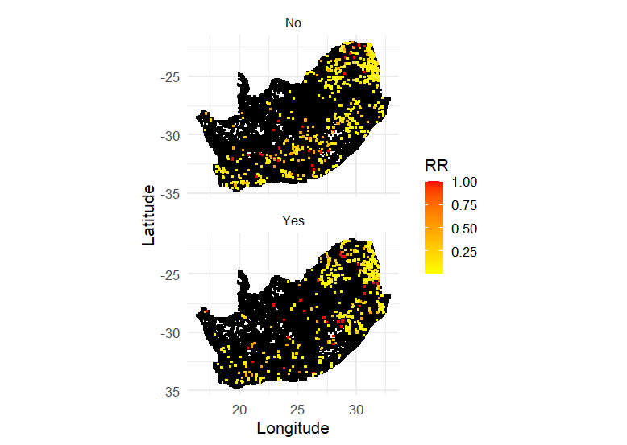

SM Figure 2: Probability surfaces from Maxent models for Breeding range and Foraging range
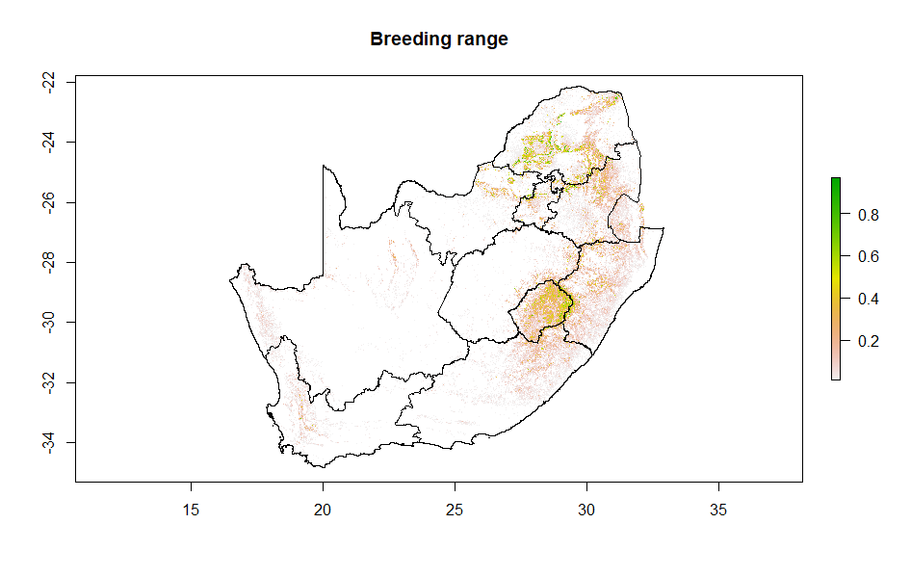
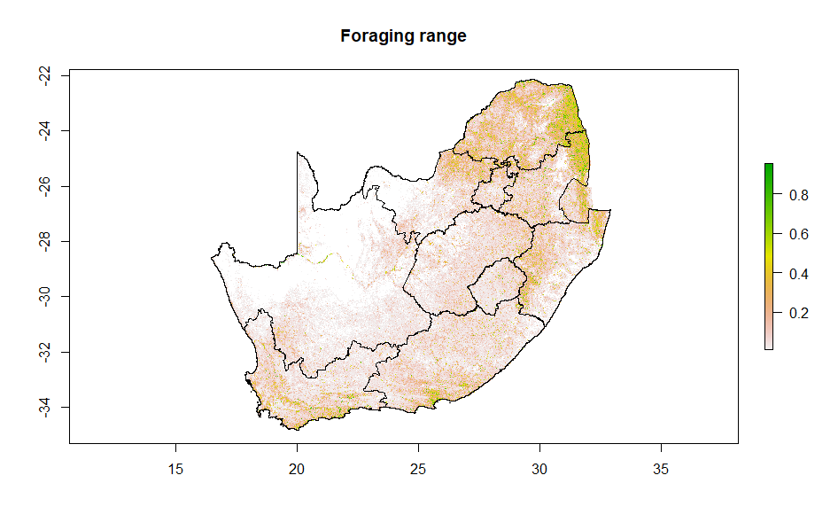

SM Figure 3 The main response curves from Maxent model output (those contributing 9% or more)

Breeding distribution model | Foraging distribution model
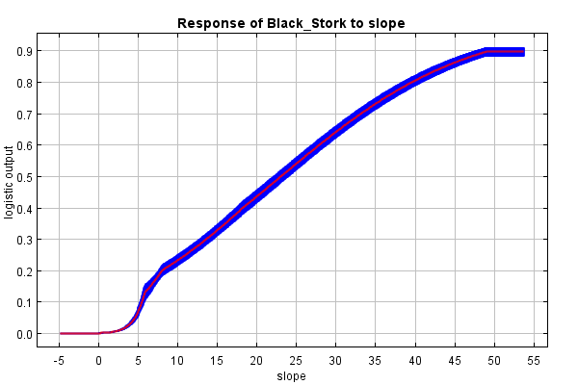 | 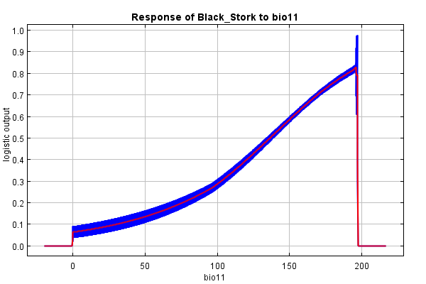
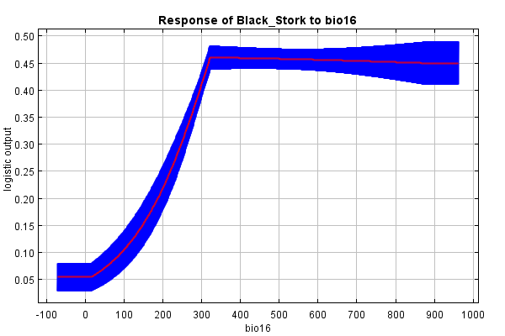 | 