Supplementary materials
Contents
Figure S1. Correlation matrix plot for habitat variables.
Table S1. Results of stepwise model selection with Akaike information criterion (AIC) values.
Table S2. Results of Generalised Liner Model (GLM) testing for the effect of habitat variables on occurrence of Wood Snipe.
Table S3. Checklist of orders for invertebrates sampled at background and foraging sites.
Table S4. Results of Generalised Liner Models (GLMs) testing for the effect of the total length of all soil macroinvertebrates and the total length of earthworms on whether the Wood Snipe foraging at sites during breeding season across the study area.
Table S5. Total length of all the food resources in taxa sampled at sites.

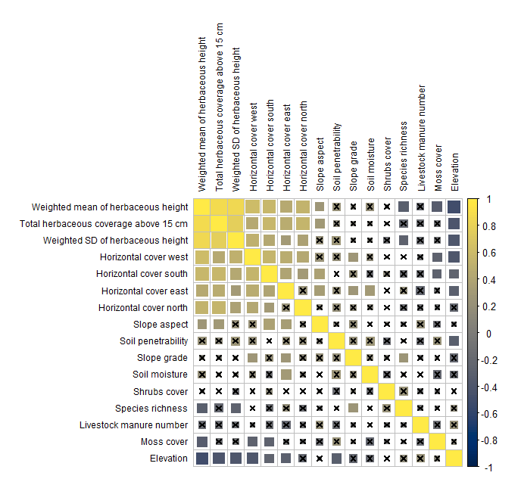
Figure S1. Correlation matrix plot. Colours and sizes of the squares indicates value of Pearson's r, while cross indicates insignificant correlation coefficients with significant level > 0.05.

Table S1. Results of stepwise model selection with Akaike information criterion (AIC) values.
Rank | Model structureª | AIC | Note
1 | ELE + MOI + I(MOI^2) + cover15 | 75 | Best model
2 | ELE + GRA + MOI + I(MOI^2) + cover15 | 76
3 | ELE + GRA + MOI + I(MOI^2) + PEN + cover15 | 77
4 | ELE + GRA + MOI + I(MOI^2) + PEN + log(LVS + 1) + cover15 | 79 | Full model
ª ELE, elevation; GRA, Slope grade; MOI, Soil moisture; PEN, Soil penetrability; LVS, Livestock manure number; cover15, Total herbaceous plant coverage in plot above 15 cm.

Table S2. Results of Generalised Liner Model (GLM) testing for the effect of habitat variables, elevation, soil moisture and total herbaceous plant coverage above 15 cm on occurrence of Wood Snipe during breeding season across all sites of the study area. Significant effects are indicated in bold.
Model term | Estimate | SE | Z-value | P-value
ELE | -0.009 | 0.004 | -2.19 | 0.028
MOI | 7.378 | 3.459 | 2.13 | 0.033
I(MOI^2) | -1.818 | 0.857 | -2.12 | 0.034
cover15 | 0.019 | 0.014 | 1.33 | 0.185

Table S3. Checklist of orders for invertebrates sampled at background and foraging sites. Taxonomic classification based on the Integrated Taxonomic Information System (ITIS)ª.
PHYLUM | CLASS | ORDER
Annelida | Clitellata | Hirudinida
 |  | Opisthopora
Arthropoda | Arachnida | Araneae
 | Chilopoda | Geophilomorpha
 |  | Lithobiomorpha
 | Collembola | Collembola
 | Diplopoda | Polydesmida
 | Insecta | Coleoptera
 |  | Diptera
 |  | Hemiptera
 |  | Hymenoptera
 |  | Lepidoptera
 | Malacostraca | Isopoda
Mollusca | Gastropoda | Stylommatophora
ª Retrieved [November 7th, 2022], from the Integrated Taxonomic Information System (ITIS) on-line database, www.itis.gov, CC0
https://doi.org/10.5066/F7KH0KBK

Table S4. Results of Generalised Liner Models (GLMs) testing for the effect of the total length of all soil macroinvertebrates and the total length of earthworms on whether the Wood Snipe foraging at sites during breeding season across the study area. Significant effects are indicated in bold.
Model term | Estimate | SE | Z-value | P-value
Total length of all soil macroinvertebrates
Total length | 0.005 | 0.002 | 2.15 | 0.031
Total length of earthworms
Total length | 0.002 | 0.004 | 0.54 | 0.590

Table S5. Total length (in millimetre) of all the food resources in taxa sampled at sites. The name of quadrats indicates background sites (with initial B) and foraging sites (with initial W).
Quadrat | Araneae | Hirudinida | Coleoptera | Collembola | Diptera | Geophilomorpha | Opisthopora | Hemiptera | Hymenoptera | Isopoda | Lepidoptera | Lithobiomorpha | Polydesmida | Stylommatophora
B1 | 5 |  | 45 |  | 5 |  | 255 |  |  |  |  | 10
B2 |  |  | 8 |  | 8 |  | 205 | 3 |  | 8 |  | 10
B3 |  |  | 10 |  | 174 |  | 220 | 3 | 20 |  |  | 10
B4 |  |  | 7 |  |  |  | 95 |  |  |  | 20
B5 |  |  |  |  | 12 |  | 20 | 3
B6 |  |  | 12 |  | 10 |  | 140
B7 |  |  | 10 | 5 |  |  | 70
B8 |  |  | 3 |  |  |  | 25
B9 |  |  | 20 |  | 3 |  | 40
B10 |  |  | 23 |  | 10 |  | 30
B11 |  |  |  |  | 5 |  | 40 |  |  |  | 100
B12 |  | 60 | 15 |  | 10 |  | 65 |  | 15 |  |  | 13
B13 | 11 |  |  |  | 16 | 5 |  |  |  |  |  |  |  | 7
B14 |  |  | 14 |  | 8 |  | 80 |  |  |  |  |  |  | 20
B15 | 12 |  |  |  | 22 |  | 28 |  | 15 |  |  | 7
B16 |  |  | 10 |  |  |  | 8
B17 |  |  |  |  | 10 | 10 | 108 |  |  |  | 60 |  |  | 18
B18 |  |  | 56 |  | 15 | 55 | 239 |  | 5 |  |  | 7
B19 |  |  | 10 |  | 8 |  | 50 |  | 4
B20 |  | 50 | 15 |  | 10 |  | 40 | 3
B21 | 7 |  | 10 |  | 12 |  | 55
B22 |  | 50 |  |  |  |  | 20 | 3
B23 | 10 |  |  |  | 34 |  | 350 |  |  |  | 45
B24 |  | 35 | 75 |  | 12 |  | 80
W1 | 4 | 15 | 59 |  | 32 | 55 | 177 | 3 |  |  | 20
W2 |  |  | 11 |  |  |  | 235 |  |  |  |  | 13
W3 |  |  | 54 |  | 466 |  | 80
W4 |  |  | 34 |  | 686 |  | 76 |  | 5
W5 |  |  | 14 |  |  | 15 | 80 |  | 5 |  |  | 8
W6 |  |  | 35 |  |  | 30 | 130 |  | 5 |  |  |  |  | 10
W7 |  |  | 10
W8 |  |  | 43 |  | 20 | 50 | 215 | 5
W9 | 10 |  | 22 |  |  |  | 110 |  | 20 |  |  |  | 15
W10 |  | 30 | 20 |  |  |  | 20 |  |  |  | 15
W11 | 6 |  | 25 | 5 | 20 | 30 | 239 |  |  |  |  | 10
W12 | 4 |  | 24 |  | 40 | 62 |  |  | 5 |  | 20 | 15
W13 |  |  | 27 |  | 86 | 27 | 140 | 9 | 40 |  |  | 56
W14 |  |  | 15 |  | 3 | 10 | 135
W15 |  |  | 50 | 3 |  |  |  |  | 5
W16 |  |  | 35 | 3 | 308 | 20 | 90 |  |  |  |  | 12
W17 | 10 |  | 15 |  | 18 | 55 | 123 |  |  |  | 20

