SUPPLEMENTARY MATERIALS
S1.1 - Methods
To explore relationship between the number of lethal equivalents (LE) and the mean stochastic growth rate the LE was increased in increments of 1.25, starting from 0 to 12.5 based on Frankham’s (2010) recommendation that the Vortex 10 default value of 6.29 underestimates the deleterious consequences of inbreeding and should be doubled. The total genetic load that is due to recessive lethal alleles was left at the default value of 50% (Miller & Lacy 2005). The proportion of residents/non-migrants was set to 15% as this was an intermediate value between the 11% and 17% residents making up some populations reported in German and Swiss populations respectively (Rotics et al., 2017; Schaub et al., 2004). Furthermore, when exploring the impact of non-migratory birds on population growth rate, 15% resulted in a small positive growth rate which we believe would better demonstrate the impact of increasing the number of lethal equivalents within the population. These models were run for 100 years as the long-lived nature of the white stork would mean that genetic impacts may not be visible in the short term.
S1.2 - Results
Table S1: Population viability model results from Vortex10 modelling different numbers of lethal equivalent in the British white stork (Ciconia ciconia). Det. r = deterministic growth rate. Stoch. r = stochastic growth rate. Exc. supp. years = excluding years where population supplementation occurred. N = population size. PE = probability of extinction of the population in 100 years. SE = standard error
Lethal Equivalent | Det. r | Stoch. r | N (extent) after 100 years ± SE | PE (%)
0 | 0.0211 | 0.0099±0.0003 | 719.56±25.53 | 0.9
1.25 | 0.0211 | 0.0065±0.0003 | 583.25±24.16 | 2
2.5 | 0.0211 | 0.0037±0.0003 | 482.44±19.00 | 2.2
3.75 | 0.0211 | 0.0009±0.0003 | 407.18±16.88 | 4.1
5 | 0.0211 | -0.0016±0.0003 | 340.97±14.03 | 5.9
6.25 | 0.0211 | -0.0051±0.0003 | 269.16±12.41 | 8.3
7.5 | 0.0211 | -0.0078±0.0004 | 250.32±12.75 | 11.7
8.75 | 0.0211 | -0.0105±0.0004 | 210.45±10.73 | 14.9
10 | 0.0211 | -0.0136±0.0004 | 191.76±11.25 | 17.7
11.25 | 0.0211 | -0.0153±0.0004 | 168.37±11.36 | 20.1
12.5 | 0.0211 | -0.0178±0.0004 | 149.01±9.67 | 25.7

There was a negative correlation between the number of lethal equivalents and stochastic population growth (Fig. S1). Within a population that contains 15% non-migratory birds, negative population growth was observed when the number of lethal equivalents reached 5 (r = -0.0016; Fig S1) when the model is run over 100 years. The population’s probability of extinction also increased with the number of lethal equivalents, with over a quarter (25.7%; Table S1) of iterations going extinct at the highest value of 12.5
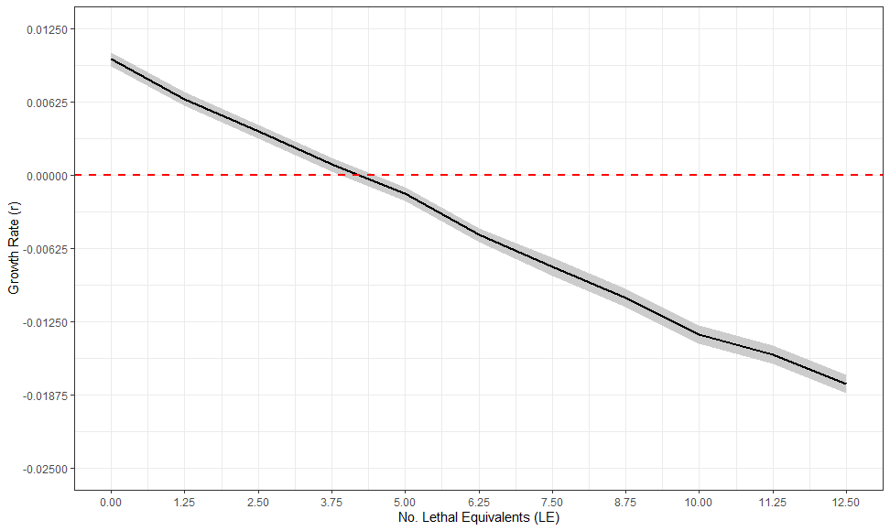
Figure S1: The relationship between the number of lethal equivalents (LE) and the mean stochastic growth rate of the British white stork (Ciconia ciconia) population where 15% of the population were residents. Models were produced using Vortex10 and were run for 100 years and 1000 iterations. Initial population size was set to 155 with a carrying capacity of 12,600. The grey shading represents 95% CI from the distribution of values from all iterations.

S2 – The exact mortality rates entered into Vortex10 based on the percentage of non-migratory individuals with the population.
Table S2: The mortality rates of each age class entered into Vortex10 based on the percentage of non-migratory individuals within the population being modelled
Non-migratory (%) | 0-1 | 1-2 | 2-3 | 3
0 | 65.1 | 22.16 | 22.16 | 22.16
1 | 65.1 | 22.12 | 22.05 | 21.99
2 | 65.1 | 22.07 | 21.95 | 21.82
3 | 65.1 | 22.03 | 21.84 | 21.66
4 | 65.1 | 21.98 | 21.74 | 21.49
5 | 65.1 | 21.94 | 21.63 | 21.32
6 | 65.1 | 21.89 | 21.52 | 21.15
7 | 65.1 | 21.85 | 21.42 | 20.99
8 | 65.1 | 21.80 | 21.31 | 20.82
9 | 65.1 | 21.76 | 21.21 | 20.65
10 | 65.1 | 21.71 | 21.10 | 20.48
11 | 65.1 | 21.67 | 20.99 | 20.32
12 | 65.1 | 21.62 | 20.89 | 20.15
13 | 65.1 | 21.58 | 20.78 | 19.98
14 | 65.1 | 21.54 | 20.67 | 19.81
15 | 65.1 | 21.49 | 20.57 | 19.65
20 | 65.1 | 21.27 | 20.04 | 18.81
25 | 65.1 | 21.05 | 19.51 | 17.97
30 | 65.1 | 20.82 | 18.98 | 17.13
35 | 65.1 | 20.60 | 18.45 | 16.29
40 | 65.1 | 20.38 | 17.92 | 15.46
45 | 65.1 | 20.15 | 17.39 | 14.62
50 | 65.1 | 19.93 | 16.86 | 13.78

