Supplementary Material

Another emerging threat to birds: avian mortality estimates from roadside transparent noise barrier collisions in South Korea

Hae-Min Seo, Young-Jun Kim, Eun-Jae Lee, Su-Gil Lee, Woo-Shin Lee4, and Chang-Yong Choi

Contents
Figure S1. Examples of various transparent structures in urban environments.
Table S1. List of observed species and the number of carcasses killed by collision with transparent noise barriers in the surveys.
Table S2. Observed bird mortality caused by collision with transparent noise barriers, documented in this study.
Table S3. Searcher detection rate collected from carcass detection experiments in this study.

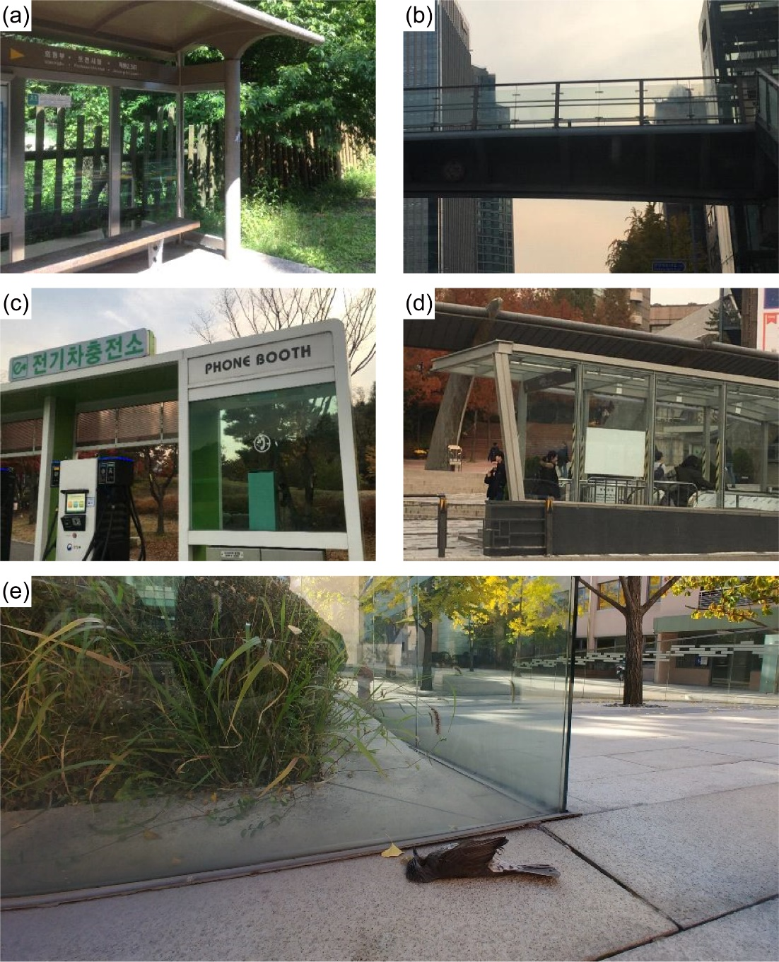
Figure S1. Examples of various transparent structures in urban environments. (a): A bus stop made of glass panels; (b): an overhead bridge with transparent fences; (c): a phone booth; (d): a subway entrance; (e): glass garden fences with a collided Brown-eared Bulbul Hypsipetes amaurotis.

Table S1. List of observed species and the number of carcasses killed by collision with transparent noise barriers in the surveys. LC and NT in the International Union for Conservation of Nature (IUCN) Red List status denote the least concerning and near-threatened species. In the column of protected species, EII indicates the Class II Endangered Species protected by the Wildlife Protection and Management Act, while NM denotes species designated as the Natural Monument according to the Cultural Heritage Protection Act.
Common name | Scientific name | IUCN status  (2021) | Protected Species in ROK | No. of carcasses | Proportion (%)
Ring-necked Pheasant | Phasianus colchicus | LC |  | 1 | 0.3
Grey Heron | Ardea cinerea | LC |  | 1 | 0.3
Common Kestrel | Falco tinnunculus | LC | NM | 1 | 0.3
Oriental Turtle Dove | Streptopelia orientalis | LC |  | 71 | 23.5
Common Cuckoo | Cuculus canorus | LC |  | 1 | 0.3
Oriental Scops Owl | Otus sunia | LC | NM | 1 | 0.3
Northern Boobook | Ninox japonica | LC | NM | 1 | 0.3
Common Kingfisher | Alcedo atthis | LC |  | 4 | 1.3
Pygmy Woodpecker | Dendrocopos kizuki | LC |  | 4 | 1.3
White-backed Woodpecker | Dendrocopos leucotos | LC |  | 1 | 0.3
Great Spotted Woodpecker | Dendrocopos major | LC |  | 4 | 1.3
Grey-faced Woodpecker | Picus canus | LC |  | 2 | 0.7
Black Paradise Flycatcher | Terpsiphone atrocaudata | NT | NM/EII | 1 | 0.3
Eurasian Jay | Garrulus glandarius | LC |  | 2 | 0.7
Asian Azure-winged Magpie | Cyanopica cyanus | LC |  | 16 | 5.3
Eurasian Magpie | Pica pica | LC |  | 10 | 3.3
Oriental Tit | Parus minor | LC |  | 13 | 4.3
Coal Tit | Parus ater | LC |  | 5 | 1.7
Varied Tit | Sittiparus varius | LC |  | 2 | 0.7
Brown-eared Bulbul | Hypsipetes amaurotis | LC |  | 39 | 12.9
Korean Bush Warbler | Horornis canturians | LC |  | 1 | 0.3
Japanese leaf warbler | Phylloscopus xanthodryas | LC |  | 1 | 0.3
Eastern Crowned Warbler | Phylloscopus coronatus | LC |  | 2 | 0.7
Vinous-throated Parrotbill | Paradoxornis webbianus | LC |  | 10 | 3.3
Goldcrest | Regulus regulus | LC |  | 5 | 1.7
Eurasian Nuthatch | Sitta europaea | LC |  | 1 | 0.3
White’s Thrush | Zoothera aurea | LC |  | 6 | 2.0
Grey-backed Thrush | Turdus hortulorum | LC |  | 5 | 1.7
Pale Thrush | Turdus pallidus | LC |  | 2 | 0.7
Orange-flanked Bush-robin | Tarsiger cyanurus | LC |  | 1 | 0.3
Daurian Redstart | Phoenicurus auroreus | LC |  | 2 | 0.7
Tree Sparrow | Passer montanus | LC |  | 38 | 12.6
Olive-backed Pipit | Anthus hodgsoni | LC |  | 7 | 2.3
Brambling | Fringilla montifringilla | LC |  | 1 | 0.3
Eurasian Siskin | Carduelis spinus | LC |  | 5 | 1.7
Chinese Grosbeak | Eophona migratoria | LC |  | 4 | 1.3
Tristram's Bunting | Emberiza tristrami | LC |  | 1 | 0.3
Yellow-throated Bunting | Emberiza elegans | LC |  | 6 | 2.0

Table S2. Observed bird mortality caused by collision with transparent noise barriers (TNBs), which includes transparent parts of partially transparent noise barriers (tPNB), documented in this study.
Locality | Type of road | Length of observed  TNB (km) | Observed mortality  (bird/day/km)
Chungbuk Province | local road | 0.09 | 0.00
Chungnam Province | local road | 1.53 | 0.15
Chungnam Province | local road | 0.89 | 0.27
Chungnam Province | local road | 1.14 | 0.00
Daejeon Metropolitan City | local road | 0.47 | 2.54
Gangwon Province | expressway | 3.17 | 0.04
Gyeonggi/Gangwon Province | expressway | 2.38 | 0.05
Gyeonggi Province | expressway | 0.59 | 0.14
Gyeonggi Province | local road | 2.55 | 0.03
Gyeonggi Province | local road | 0.12 | 0.00
Gyeonggi Province | local road | 0.71 | 0.18
Gyeonggi Province | local road | 0.32 | 0.31
Gyeonggi Province | local road | 0.27 | 0.00
Incheon Metropolitan City | local road | 0.09 | 0.00
Jeonbuk Province | local road | 1.67 | 0.35
Jeonbuk Province | local road | 0.71 | 0.14
Jeonnam Province | expressway | 0.14 | 0.70
Seoul Metropolitan City | expressway | 3.55 | 0.03
Seoul Metropolitan City | expressway | 0.99 | 0.00
Seoul Metropolitan City | local road | 0.09 | 0.00
Seoul Metropolitan City | local road | 0.29 | 0.00
Seoul Metropolitan City | local road | 0.87 | 0.31
Seoul Metropolitan City | local road | 0.13 | 0.00
Seoul Metropolitan City | local road | 0.61 | 0.00
Seoul Metropolitan City | local road | 2.42 | 0.00
Mean ± Standard deviation |  | 1.03 ± 1.03 | 0.21 ± 0.51

Table S3. Searcher detection rate (DR) collected from carcass detection experiments in this study (n = 12).
Experiment | Total number of the placed carcasses | Total number of the detected carcasses | Searcher detection rate  (detected/placed)
1 | 6 | 4 | 0.67
2 | 9 | 3 | 0.33
3 | 8 | 2 | 0.25
4 | 6 | 1 | 0.17
5 | 8 | 1 | 0.13
6 | 5 | 2 | 0.40
7 | 8 | 7 | 0.88
8 | 10 | 1 | 0.10
9 | 10 | 1 | 0.10
10 | 10 | 2 | 0.20
11 | 54 | 6 | 0.11
12 | 20 | 14 | 0.70
Minimum |  |  | 0.10
Maximum |  |  | 0.88

