Supplementary Material

Habitat selection and ontogeny of habitat use by juvenile Eurasian Spoonbills Platalea leucorodia revealed by GPS tracking

MANUELA S. RODRIGUES, PEDRO M. ARAÚJO, JOÃO P. SILVA, JOSÉ M. ABAD-GÓMEZ, PEDRO C. RODRIGUES, JAIME A. RAMOS and JOSÉ A. ALVES

Contents
Appendix S1. Exploratory analysis of radius to use in revisitation analysis.

Appendix S1. Exploratory analysis of radius to use in revisitation analysis
Revisitation analysis calculates how many times the trajectory of one individual enters a circular area centred in in each position of the trajectory, that is, how many times one individual revisits the same location (Bracis et al. 2018). Because we did not have any a priori consideration of the radius value to use we did an exploratory analysis to establish such value. First, we tested values of radii between 10 and 1000m (in increments of 100m). We calculated the mean number of revisits to all locations using each radius value. Then we plotted the results for each spoonbill (Fig. S1) and identified a common asymptote value across individuals, as after such value increasing the radius would not change the results. We used the “changepoint” package in R (Killick & Eckley 2014) to detect where change points were located, which was on average at 113 ± 14.7 m (Table S1). In addition, we also plotted the variance of the log of revisitations for the same test radii and found that in all cases most of the variance occurs in radii smaller than 100 m (Fig. S2), implying that larger radii would consider all areas as having the same revisitations. Therefore, 100m was the selected radius. Nonetheless, we used a sensitivity analysis to ensure that changing the selected radius by ± 50% would not affect the results, and this was indeed the case (Fig. S3).

Table S1: Value of radius identified as change point for each juvenile spoonbill
Juvenile spoonbill | Change point (radius value)
Ascella | 80
Atlas | 120
Australis | 110
Azha | 150
Castor | No change detected
Dalim | 30
Hadar | No change detected
Mira | 120
Mizar | 190
Nembus | 80
Polaris | 50
Rigel | 160
Sirius | 70
Tabit | 110
Vega | 210

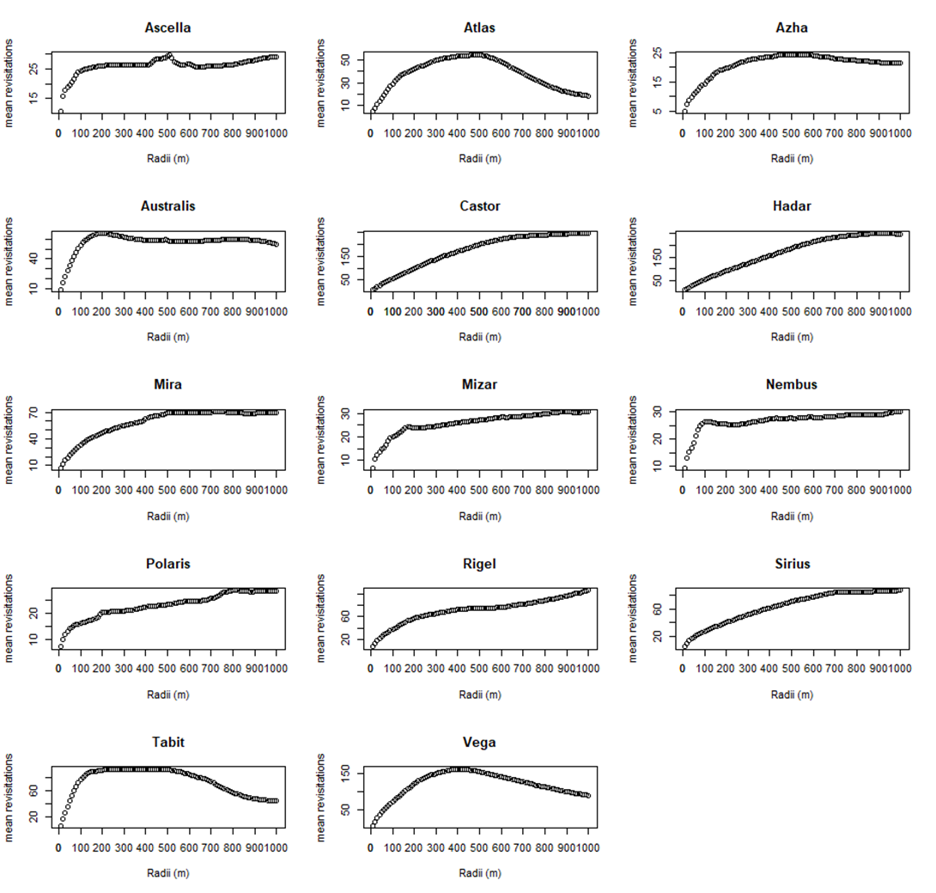
Figure S1: Mean number of revisitations made by juvenile spoonbills to each location for each radius tested.

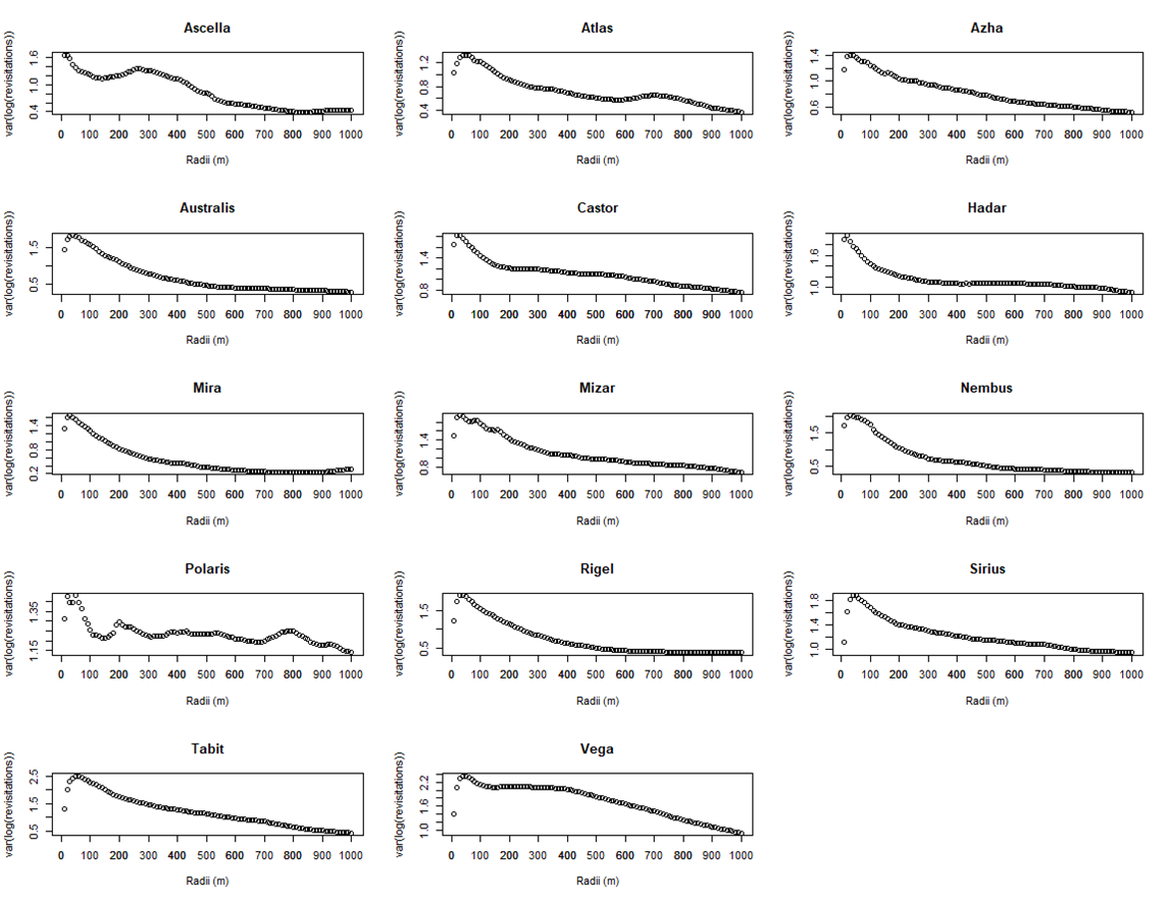
Figure S2: Variation on the log of revisitations made by juvenile spoonbills to each location for each radius tested.

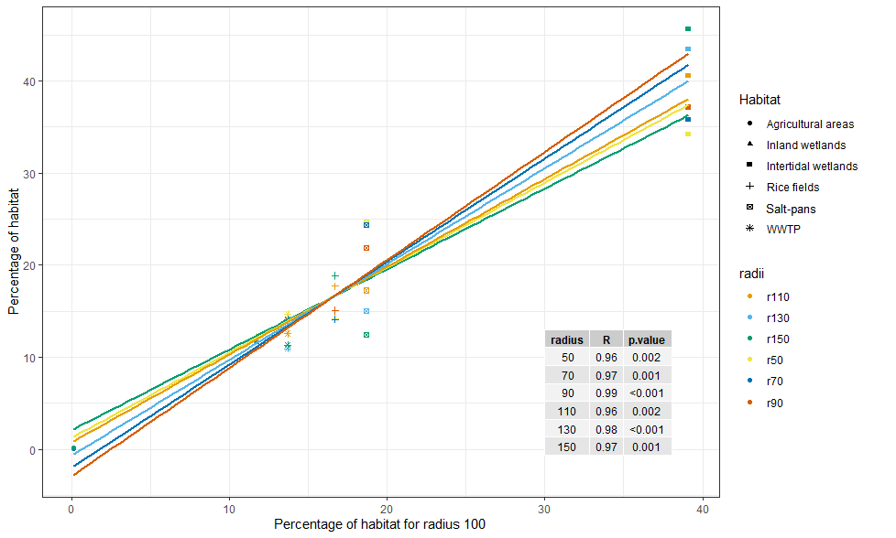
Figure S3: Effects of varying the value of radius in the revisitation analysis. The lines, R- and p-values show the level of association between the percentage of habitat selected in the revisitation analysis using a radius of 100 m and several other proposed radii (from -50 to +50m).

References
Bracis, C., Bildstein, K. L. and Mueller, T. (2018) Revisitation analysis uncovers spatio‐temporal patterns in animal movement data. Ecography 41: 1801-1811.
Killick, R. and Eckley, I. (2014) changepoint: An R package for changepoint analysis. J. Statisti. Softw. 58: 1-19.

