Supplementary Material

The effects of powerlines on bustard populations: how best to mitigate, how best to monitor?

JOÃO PAULO SILVA, ANA TERESA MARQUES, JOANA BERNARDINO, TRIS ALLINSON, YURI ANDRYUSHCHENKO, SUTIRTHA DUTTA, MIMI KESSLER, RICARDO C. MARTINS, FRANCISCO MOREIRA, JOHN PALLETT, MATTHEUNS D. PRETORIUS, H. ANN SCOTT, JESSICA M. SHAW and NIGEL J. COLLAR

Contents

Figure S1. PRISMA ﬂow chart of literature search and selection process.

Figure S2. Examples of bird flight diverters (BFDs): (a) small spirals, also called single loop BFDs; (b) large spirals, also called double loop BFDs or SWAN diverters; (c) fireflies; (d) disc-shaped diverters; (e) crossed bands; and (f) RIBE diverters.

Figure S3. Two common transmission pylon designs: on the left an example of a pylon design that arranges the conductors horizontally and on the right a pylon design that arranges the conductors vertically. The vertical display obstructs more airspace and poses a great risk for bird collision.

Table S1. Collision data. Power lines.

Table S2. Collision data. Other wires.

Records removed before screening:
Duplicate records removed
(n = 145)
Records identified from:
Web of Knowledge (n = 113)
Scopus databases (n = 176)
Other sources (n = 44)

Identification

Studies excluded by title and abstract screening (out of scope) (n = 92)

Studies screened
(n = 188)

Screening

Studies excluded:
No original data (n = 17)

Studies assessed for eligibility
(n = 96)

Studies included in review
(n = 79):
Mortality data (n = 69)
Displacement effects (n = 6)
Population effects (n = 10)
Included

Figure S1. PRISMA ﬂow chart of literature search and selection process.

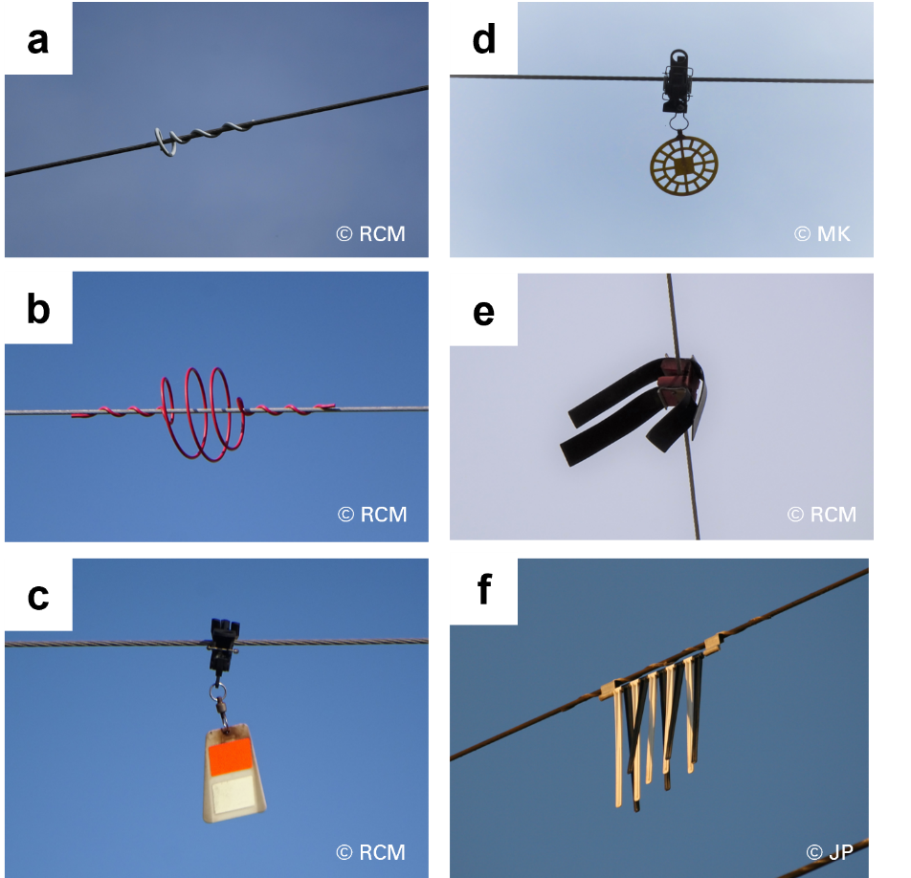

Figure S2. Examples of bird flight diverters (BFDs): (a) small spirals, also called single loop BFDs; (b) large spirals, also called double loop BFDs or SWAN diverters; (c) fireflies; (d) disc-shaped diverters; (e) crossed bands; and (f) RIBE diverters. Photos (a) and (b) correspond to ‘static’ diverters; Photos (c) to (f) correspond to ‘dynamic’ diverters. Photo credits: John Pallett (JP), Mimi Kessler (MK) and Ricardo C. Martins (RCM).

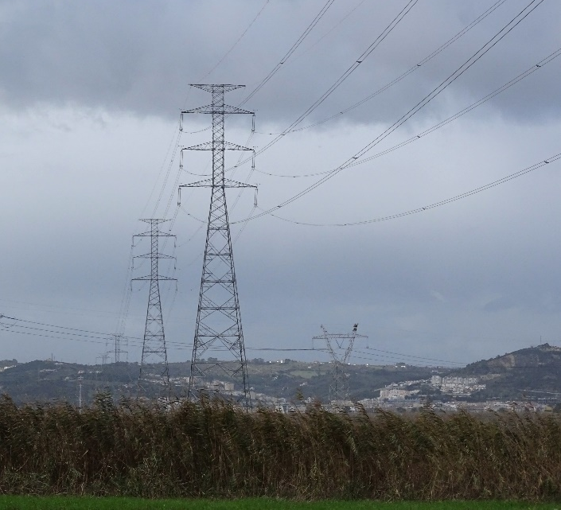
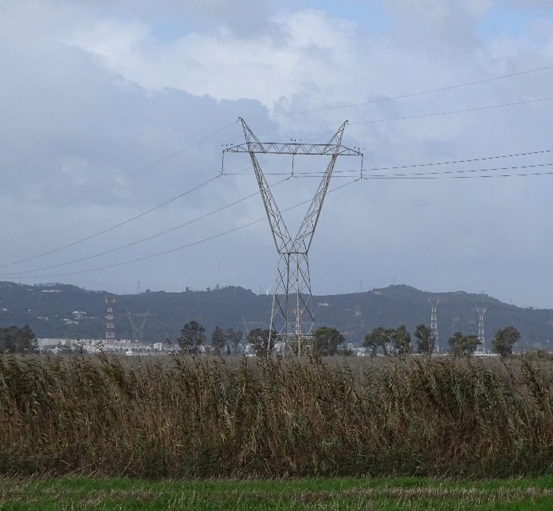

Figure S3. Two common transmission pylon designs: on the left an example of a pylon design that arranges the conductors horizontally and on the right a pylon design that arranges the conductors vertically. The vertical display obstructs more airspace and poses a great risk for bird collision. Photo credits: Ricardo C. Martins.

