Supplementary Material
Marine Important Bird and Biodiversity Areas in the Chagos Archipelago

PETER CARR, ALICE M. TREVAIL, HEATHER J. KOLDEWEY, RICHARD B. SHERLEY, TIM WILKINSON, HANNAH WOOD and STEPHEN C. VOTIER

Contents
Figure S1. Two BirdLife International proposed marine Important Bird and Biodiversity Areas (mIBAs) in the Chagos Archipelago.
Figure S2A/B. Feeding aggregation locations in the northern (a) and southern (b) halves of the Chagos Archipelago of the four Important Bird and Biodiversity Area triggering species, recorded through 2012–2015.
Figure S3. An example of the calculation of the smoothing factor (h) for the Red-footed Booby colony on Diego Garcia (monsoon seasons combined), Chagos Archipelago, used to define Kernel Density Estimates (KDEs) following Lascelles et al. (2016), and derived from Area-Restricted Search (ARS) using First Passage Time (FPT).
Figure S4. An example of the calculation of the representativeness (99.7%) of the tracked sample of Red-footed Booby to the entire breeding population from the breeding colony on Diego Garcia (monsoon seasons combined), Chagos Archipelago after 100 iterations.
Figure S5. The ‘core-use area’ of Red-footed Booby from the Diego Garcia colony (monsoon seasons combined) demonstrating the number of individuals estimated to be using the area.
Table S1. Western Indian Ocean regional breeding populations and 1% IBA qualifying populations and associated calculations.
Appendix S1
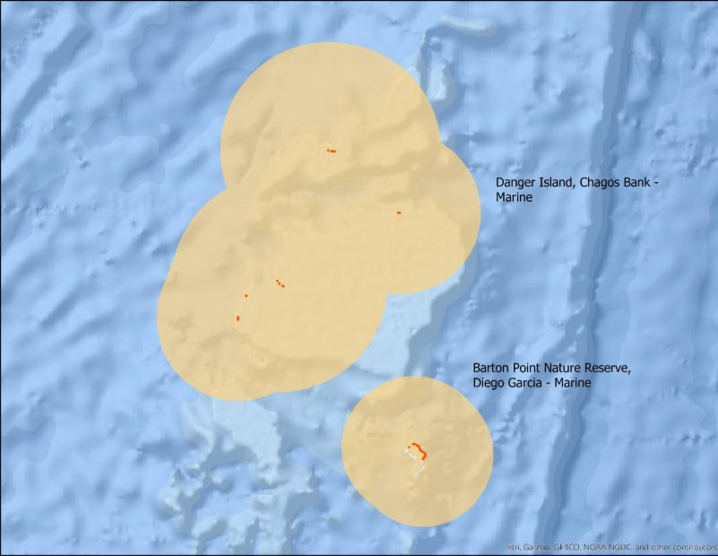
Figure S1. Two BirdLife International proposed marine Important Bird and Biodiversity Areas (mIBAs) in the Chagos Archipelago. Downloaded from http://www.birdlife.org on 02 June 2021.

Figure S2A/B. Feeding aggregation locations in the northern (a) and southern (b) halves of the Chagos Archipelago of the four Important Bird and Biodiversity Area triggering species, recorded through 2012–2015.
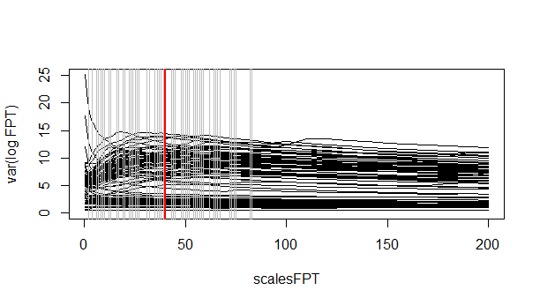
Figure S3. An example of the calculation of the smoothing factor (h) for the Red-footed Booby colony on Diego Garcia (monsoon seasons combined), Chagos Archipelago, used to define Kernel Density Estimates (KDEs) following Lascelles et al. (2016), and derived from Area-Restricted Search (ARS) using First Passage Time (FPT). The calculation is from hVals function in the R package ‘track2KBA’ (Beal et al. 2020). The red line denotes where the ARS value lies.

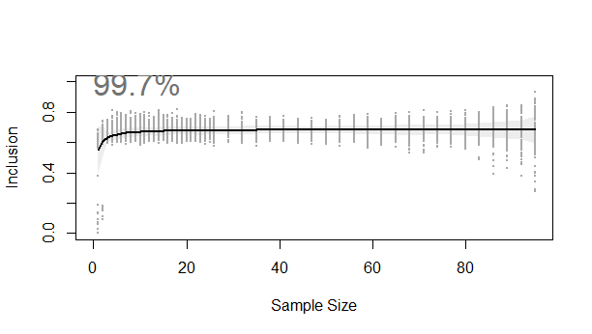
Figure S4. An example of the calculation of the representativeness (99.7%) of the tracked sample of Red-footed Booby to the entire breeding population from the breeding colony on Diego Garcia (monsoon seasons combined), Chagos Archipelago after 100 iterations. The calculation is from the repAssess function in the R package ‘track2KBA’ (Beal et al. 2020).

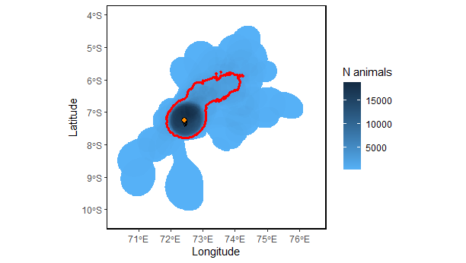
Figure S5. The ‘core-use area’ of Red-footed Booby from the Diego Garcia colony (monsoon seasons combined) demonstrating the number of individuals estimated to be using the area. The area within the red boundary qualifies as an IBA at the global (A4) scale. Orange diamond denotes the colony location.

Table S1. Western Indian Ocean regional breeding populations and 1% IBA qualifying populations and associated calculations. Mascarenes, Seychelles, South Mozambique, Somalia and Red Sea and North Mozambique regions follow Danckwerts et al. (2014).

Breeding colony area | Tropical Shearwater | Red-footed Booby | Sooty Tern | Lesser Noddy
Mascarenes | 4,000¹ | 0⁵ | 734,271⁶ | 106,250⁶
Seychelles | 120,000¹ | 70,437⁶ | 6,381,354⁶ | 883,333⁶
South Mozambique | Unknown¹ | 6,250⁶ | 1,583,542⁶ | 0⁷
Somalia and Red Sea | Unknown¹ | 0⁵ | Unknown | 0⁷
North Mozambique | Unknown¹ | 0⁵ | 4,758,333⁶ | 0⁷
Chagos Archipelago | 1,632² | 22,871² | 197,500² | 50,780²
Maldives | Unknown³ | 0⁵ | Unknown³ | 0³
Lakshadweep | 0⁴ | 0⁵ | 4,750⁴ | 0⁴
Total breeding pairs | 125,632 | 99,558 | 4,553,250 | 346,788
Total individuals | 376,896 | 298,674 | 13,659,750 | 1,040,363
1% Regional breeding pairs | 1,256 | 996 | 45,533 | 3,468
1% Regional individuals | 3,769 | 2,987 | 136,598 | 10,403

Notes to Table S1:
^{1.} Kirwan GM, del Hoyo J. and Collar N. 2020. Tropical Shearwater (Puffinus bailloni), version 1.0. In: Billerman SM, Keeney BK, Rodewald PG and Schulenberg TS. (Eds.). Birds of the World. Cornell Lab of Ornithology, Ithaca, NY, USA.
^{2.} Carr P, Votier SC, Koldewey HJ, Godley B, Wood H and Nicoll MAC. 2021. Status and phenology of breeding seabirds and a review of Important Bird and Biodiversity Areas in the British Indian Ocean Territory. Bird Conservation International 31(1): 14-34.
^{3.} Anderson RC and Shimal M. 2020. A checklist of birds of the Maldives. IndianBIRDS Monographs 3: 1–52.
^{4.} Mondreti R, Priya D and Gremillet D. 2018. Illegal egg harvesting and population decline in a key pelagic seabird colony of the Eastern Indian Ocean. Marine Ornithology.
^{5.} Nelson B. 1978. The Sulidae: gannets and boobies (No. 154). Oxford University Press, USA.
^{6.} Danckwerts DK, McQuaid CD, Jaeger A, McGregor GK, Dwight R, Le Corre M and Jaquemet S. 2014. Biomass consumption by breeding seabirds in the western Indian Ocean: indirect interactions with fisheries and implications for management. ICES Journal of Marine Science 71(9): 2589-2598.
^{7.} BirdLife International. 2021. Species factsheet: Anous tenuirostris. http://www.birdlife.org/ accessed on 12/05/2021.

Appendix S1
Danckwerts et al. (2014) regional totals included a single chick produced by every adult (breeding) pair corrected with a 50% breeding success correction factor. To be able to use the Danckwerts’ figures, they needed to be converted back to breeding pairs (B), then to individuals (I). This was achieved using the equation:
$$B=D-\frac{D/3}{2},$$
$$I=B×3$$
Where D = the Danckwerts et al. (2014) total figure for the population of a colony/country. A factor of 3 was used to convert breeding pairs to individuals following advice from BirdLife International (Pearmain, pers. com.).

