Supplementary Material

Exploring potential reasons for the increase in the East Asian Greylag Goose Anser anser population by assessing habitat use and use of protected areas

JUNJIAN ZHANG, XIANGHUANG LI, NYAMBAYAR BATBAYAR, ZHENGGANG XU, LEI CAO and ANTHONY DAVID FOX

Contents

Table S1. Bird information and selected data from each individual.
Table S2. Model selection results for the top five habitat selection analysis models for the Greylag Geese in four seasons respectively.
Figure S1. In summer, GPS fixes identified as bare land mainly were distributed in Dauria Region, Huihe NNR and Wulagai Wetland (Ng = 3,261).
Figure S2. In summer, GPS fixes attributed to cropland and forest mainly were distributed in the Huihe NNR (Ng = 3,670).
Figure S3. In spring, GPS fixes identified as cropland mainly were distributed in Nandagang and Yangcheng Reservoir, Hebei Province (Ng = 869).
Figure S4. Night distribution map of tracked Greylag Geese around Longgan Lake Nature Reserve. A large number of GPS fixes were located in lakeside croplands (Ng in the croplands = 2,227, Ng in the lakes = 1,127).
Table S1. Bird information and selected data from each individual.
ID | Bird ID | Captured  Date | Captured  Location | Selected data (from started date to ended date)ª
 |  |  |  | Summer | Autumn | Winter | Spring
1 | cas003 | 2014/12/30 | Poyang lake,  China | 2015/4/15–2015/10/23  191d, Ns = 1, Ng = 1,761 | 2015/10/23–2015/11/25  33d, Ns = 2, Ng = 723 | 2015/11/25–2016/2/29  96d, Ns = 1, Ng = 2,682 | 2016/2/29–2016/4/17  48d, Ns = 2, Ng = 833
2 | cas004 | 2014/12/30 | Poyang lake,  China | 2015/4/15–2015/10/27  195d, Ns = 4, Ng = 3,961 | 2015/10/27–2015/10/30  3d, Ns = 0, Ng = 0 | 2015/10/30–2016/2/17  110d, Ns = 2, Ng = 2,300 | 2016/2/17–2016/4/1  44d, Ns = 1, Ng = 730
3 | 15 | 2016/10/27 | Anhui lakes,  China | 2017/4/15–2017/10/13  181d, Ns = 6, Ng = 3,634 | 2017/10/13–2017/11/11  29d, Ns = 1, Ng = 577 | 2017/11/11–2018/3/20  129d, Ns = 6, Ng = 2,389 | 2017/3/16–2017/4/15  30d, Ns = 2, Ng = 428
4 | 31 | 2016/10/27 | Anhui lakes,  China | – | – | 2016/10/28–2017/2/25  120d, Ns = 3, Ng = 2,259 | 2017/2/25–2017/4/1  35d, Ns = 2, Ng = 627
5 | 149 | 2016/11/3 | Anhui lakes,  China | 2017/4/1–2017/10/13  195d, Ns = 1, Ng = 4,263 | 2017/10/13–2017/12/11  59d, Ns = 2, Ng = 1,250 | 2017/12/11–2018/2/25  76d, Ns = 1, Ng = 1,386 | 2017/3/6–2017/4/1  26d, Ns = 1, Ng = 405
6 | 150 | 2016/10/27 | Anhui lakes,  China | – | – | 2016/10/28–2017/3/16  139d, Ns = 4, Ng = 2,362 | 2017/3/16–2017/4/28  43d, Ns = 2, Ng = 684
7 | 159 | 2016/10/27 | Anhui lakes,  China | 2017/4/2–2017/10/2  183d, Ns = 4, Ng = 3,859 | 2017/10/2–2017/11/15  44d, Ns = 1, Ng = 836 | 2017/11/15–2018/2/25  102d, Ns = 5, Ng = 1,784 | 2017/3/16–2017/4/2  17d, Ns = 1, Ng = 233
8 | 2042 | 2017/7/20 | Buir lake,  Mongolia | – | 2017/9/27–2017/11/26  60d, Ns = 3, Ng = 902 | – | –
9 | 2342 | 2017/7/20 | Buir lake,  Mongolia | 2018/4/1–2018/10/7  189d, Ns = 3, Ng = 3,972 | 2017/10/13–2017/12/5  53d, Ns = 1, Ng = 854 | 2017/12/5–2018/2/26  83d, Ns = 3, Ng = 1,447 | 2018/2/26–2018/4/1  34d, Ns = 1, Ng = 485
10 | 2347 | 2017/7/20 | Buir lake,  Mongolia | – | 2017/9/26–2017/11/4  39d, Ns = 3, Ng = 750 | – | –

Notes:
- ª d, days; Ns, number of sites where are the ‘non-fly’ segments during the summering/wintering period and spring/autumn migration of each track; Ng, number of GPS fixes in the ‘non-fly’ segments during different seasons.
- More details, such as logger’s manufacturers, country of origin, logger mass of each device fitted to each individual and so on, see Li et al. (2020).

Table S2. Model selection results for the top five habitat selection analysis models for the Greylag Geese in four seasons respectively.
Season | ID | Model structureª | df | ΔAIC^{b} | Weight
Summer | 1 | BL+GL+WL+PA+ROA+WET | 9 | 0.0 | 1.0
 | 2 | BL+GL+WL+ROA+WET | 8 | 22.0 | 0.0
 | 3 | BL+GL+WL+PA+WET | 8 | 1933.9 | 0.0
 | 4 | BL+GL+WL+WET | 7 | 1982.5 | 0.0
 | 5 | BL+WL+PA+ROA+WET | 8 | 3401.4 | 0.0
Winter | 1 | CL+WT+WL+PA+ROA+WET | 9 | 0.0 | 1.0
 | 2 | CL+WT+WL+ROA+WET | 8 | 697.3 | 0.0
 | 3 | CL+WT+WL+PA+ROA | 8 | 949.3 | 7.2
 | 4 | CL+WT+WL+PA+WET | 8 | 1115.6 | 5.7
 | 5 | CL+WT+WL+WET | 7 | 1374.7 | 3.0
Spring | 1 | BA+CL+GL+WT+WL+PA+ROA+WET | 11 | 0.0 | 1.0
 | 2 | CL+GL+WT+WL+PA+ROA+WET | 10 | 10.7 | 0.0
 | 3 | BA+CL+GL+WT+WL+ROA+WET | 10 | 81.5 | 0.0
 | 4 | CL+GL+WT+WL+ROA+WET | 9 | 82.3 | 0.0
 | 5 | BA+GL+WT+WL+PA+ROA+WET | 10 | 127.7 | 0.0
Autumn | 1 | BA+CL+GL+WT+WL+PA+ROA+WET | 11 | 0.0 | 0.9
 | 2 | BA+CL+GL+WT+WL+ROA+WET | 10 | 5.7 | 0.0
 | 3 | CL+GL+WT+WL+PA+ROA+WET | 10 | 16.5 | 0.0
 | 4 | CL+GL+WT+WL+ROA+WET | 9 | 20.9 | 0.0
 | 5 | BA+CL+GL+WT+WL+PA +WET | 10 | 23.3 | 0.0
Note: ª BL, bare land; CL, cropland; GL, grassland; WL, wetland; WT, water; PA, Distance to the national level protected areas; ROA, Distance to the roads; WET, Distance to the lakes/wetlands.
^{b} ΔAIC, the difference between the current model AIC value and the minimum AIC value.

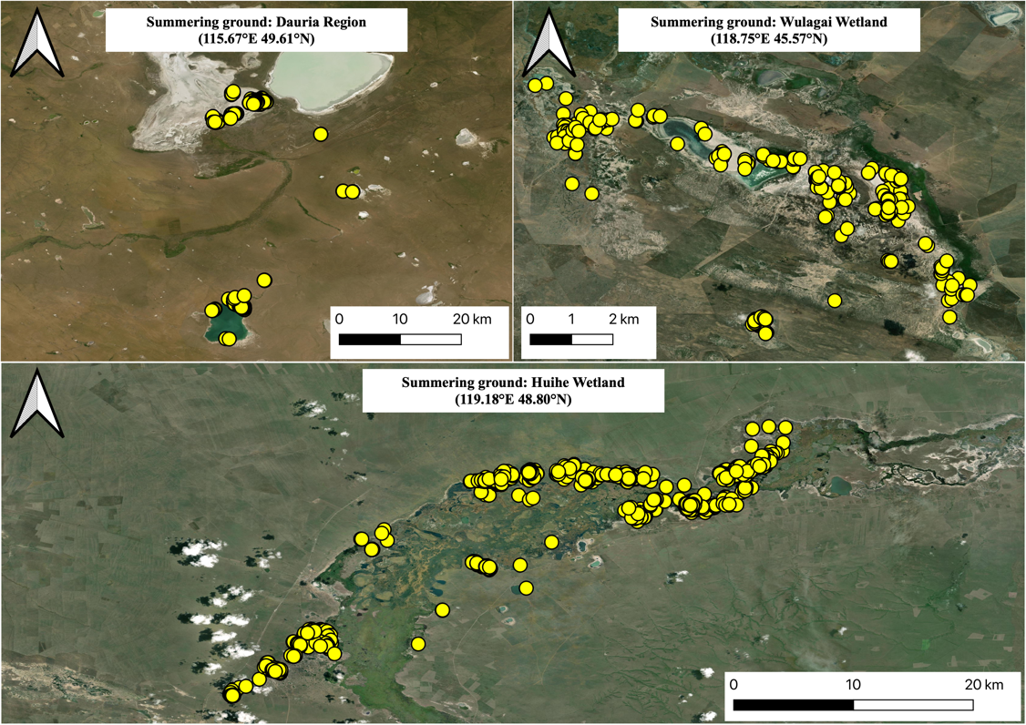
Figure S1. In summer, GPS fixes identified as bare land mainly were distributed in Dauria Region, Huihe NNR and Wulagai Wetland (Ng = 3,261). Based on satellite images, we found these fixes were actually located in dry lakes, which were defined as bare land in the “FROM-GLC 2015” dataset.

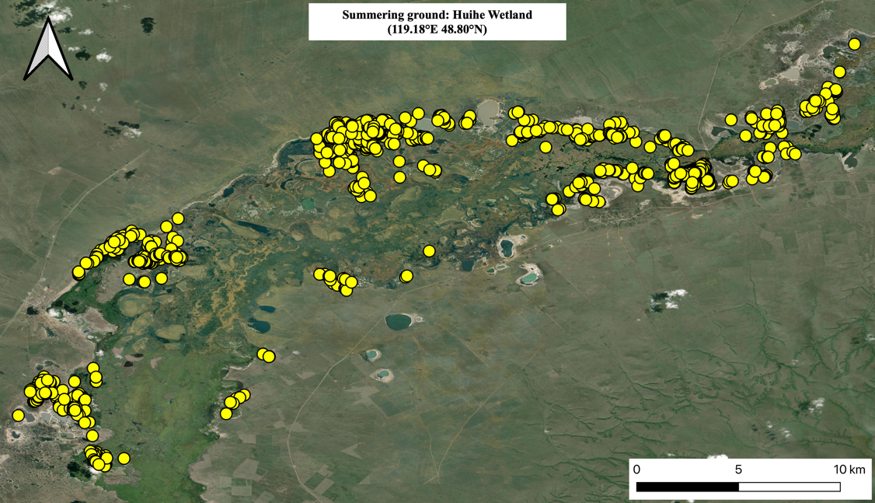
Figure S2. In summer, GPS fixes attributed to cropland and forest mainly were distributed in the Huihe NNR (Ng = 3,670). Based on satellite images and field surveys, we found these fixes were actually located in Common Reed Phragmites australis and Bulrush Typha orientalis marsh so reattributed accordingly.

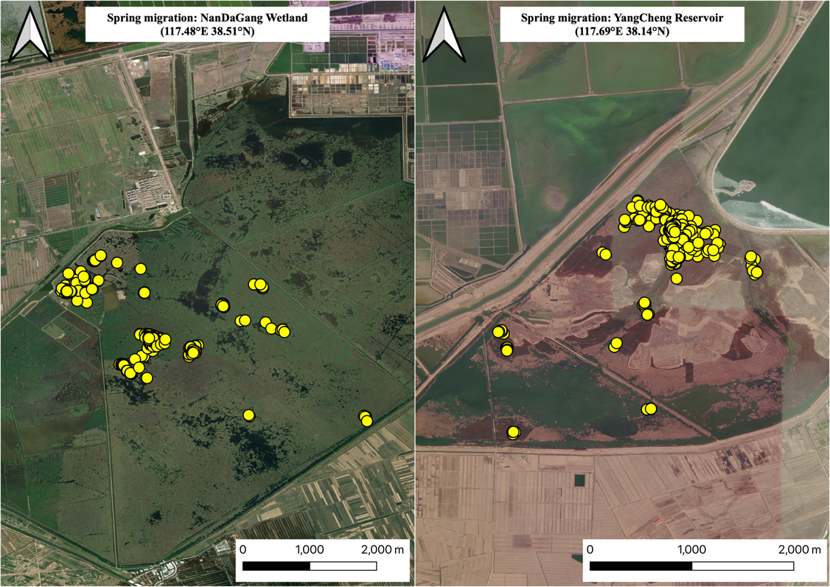
Figure S3. In spring, GPS fixes identified as cropland mainly were distributed in Nandagang and Yangcheng Reservoir, Hebei Province (Ng = 869). Based on satellite images, we found these fixes were actually located in reedbeds, so these habitat assignments were reattributed accordingly.

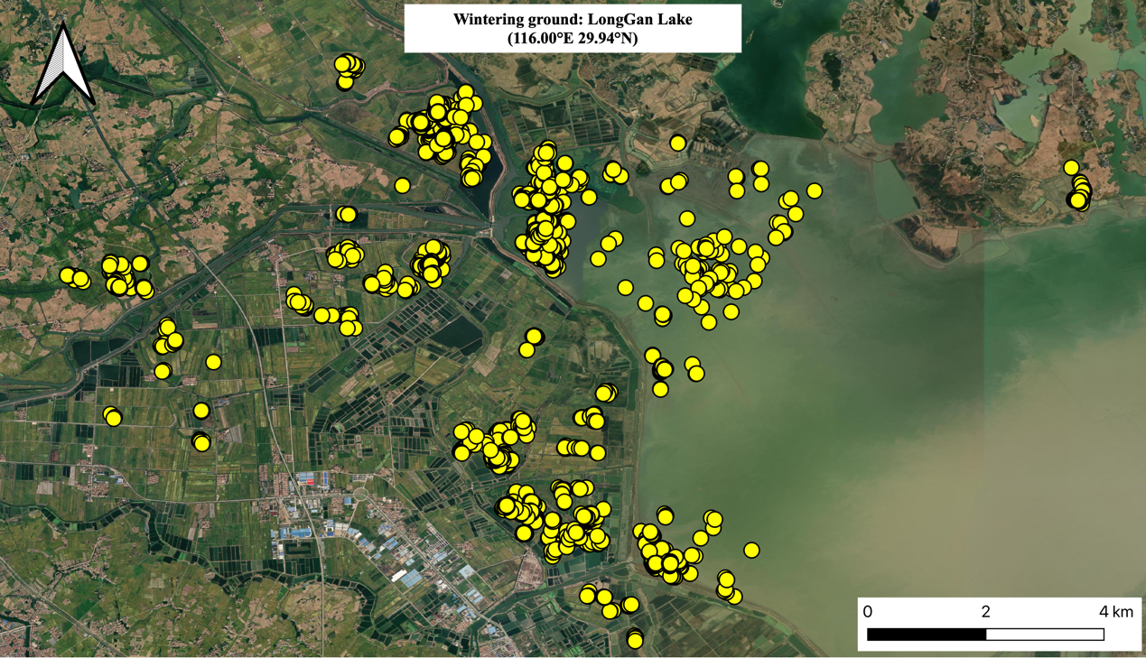
Figure S4. Night distribution map of tracked Greylag Geese around Longgan Lake Nature Reserve. A large number of GPS fixes were located in lakeside croplands (Ng in the croplands = 2,227, Ng in the lakes = 1,127).

