Supplementary Material

The impact of timber harvesting on nest site availability for the Cape Parrot Poicephalus robustus in native Southern Mistbelt forests of the Eastern Cape, South Africa

JESSICA LEAVER, JOHANN C. CARSTENS, KIRSTEN WIMBERGER, KATE F. CARSTENS, MICHAEL I. CHERRY

Contents
Appendix S1. Detailed methods.

Figure S1. Cape Parrot on yellowwood cavity.

Table S1. Frequency of tree species harvested between 1992 and 2017 from Schwarzwald and Wolf River forests in the Amathole region, Eastern Cape.

Table S2. Consolidation of the full list of all tree conditions described in original harvest record into four primary groups.

Appendix S1: Methods

1. Defining criteria to identify nestable and harvestable stems
To assess the impact of harvesting on potential nest tree availability, criteria were developed to define recorded yellowwood stems as: i) potential nest trees, henceforth, ‘nestable’, and ii) candidate harvest trees, henceforth ‘harvestable’.
Nestable tree criteria
Criteria to define nestable trees were developed from assessment of available Cape Parrot nest tree data, and thus based on species, minimum DBH and height, and decay stage of recorded nest trees. Based on analysis of these data (section 3.1: Table 1), nestable stems were defined as: i) A. falcatus, and P. latifolius; ii) ≥ 50 cm DBH; iii) ≥ 12 m in height; and iv) of decay stages 1 – 7. While nest site data included only nests observed in snags of decay stage 2 – 6 (Table 1), this selection was extended to include stage 7 (as per Wirminghaus et al. 2001). Inclusion of decay stage 1 is supported by the recorded use of successive decay stages, i.e. stage 1 trees are considered nestable as they represent future, if not current, nest trees.
Harvestable tree criteria
To define recorded yellowwood stems as harvestable or not, existing selection criteria to select were used, based on a review of relevant documents (Seydack 1995; Vermuelen et al. 2000; Department of Water Affairs and Forestry 2003; Mpiskekaya et al. 2008). From this, harvestable stems were defined as A. falcatus and P. latifolius with: i) rotting stems; ii) signs of dying (i.e. main shoot dead; ≥ 1/3 of crown dead; moribund), iii) crown damage (i.e. bole snapped; main shoot broken/dead; major branch broken/dead; bark removed; split), and iv) leaning (i.e. main stem > 30˚ from vertical axis). Based on these tree condition descriptions, followed by consultation with a local forester and tree marker (pers. comm, M. Kitsi, August 2020), stems of decay stage 2–5 (as per Downs and Symes, 2004) were considered harvestable, while stems of decay stage 1, 6, 7 and 8 were not. Specifically, snags at advanced stages of decay (i.e. 6–8) were not considered harvestable given the poor quality timber yielded, whereas trees of decay stage 1 are characterised by crowns not damaged enough to be selected for harvesting. No minimum DBH or height for harvestable trees is stipulated i.e. a tree of any size can be harvested provided its condition is consistent with defined mortality pre-emption indicators (Seydack et al. 1995).

2. Assessing availability of nestable and harvestable stems, and extent of overlap
Based on these criteria, the availability of nestable and harvestable yellowwood stems was assessed across the two harvested study forests combined, by applying a binary code to define all recorded stems of A. falcatus and P. latifolius as nestable (1) or not (0); and as harvestable (1) or not (0). The proportion of recorded stems that were nestable and harvestable, respectively was assessed for each species at two levels: i) as a proportion of the overall population (i.e. intact/healthy trees plus snags) and; ii) and as a proportion of the snag population (i.e. stems in decay stages 1 – 8). Lastly, the extent of overlap between nestable and harvestable trees was determined based on the proportion of nestable trees that were also defined as harvestable, at the species-level.

3. Assessing the nature of overlap between nestable and harvestable stems
The size class distribution of yellowwood snags was assessed and compared across three groups: i) available; ii) used for nesting; and iii) harvested. Harvested stems included were those described as “dry standing”, “crown damage” and “crownless”, (i.e. excluding windfalls), to be comparable to those recorded during forest surveys. Data were assessed at the species-level, with records of available- and harvested snags from the two harvested forests pooled, respectively.

Figure S1. Cape Parrot on yellowwood cavity.
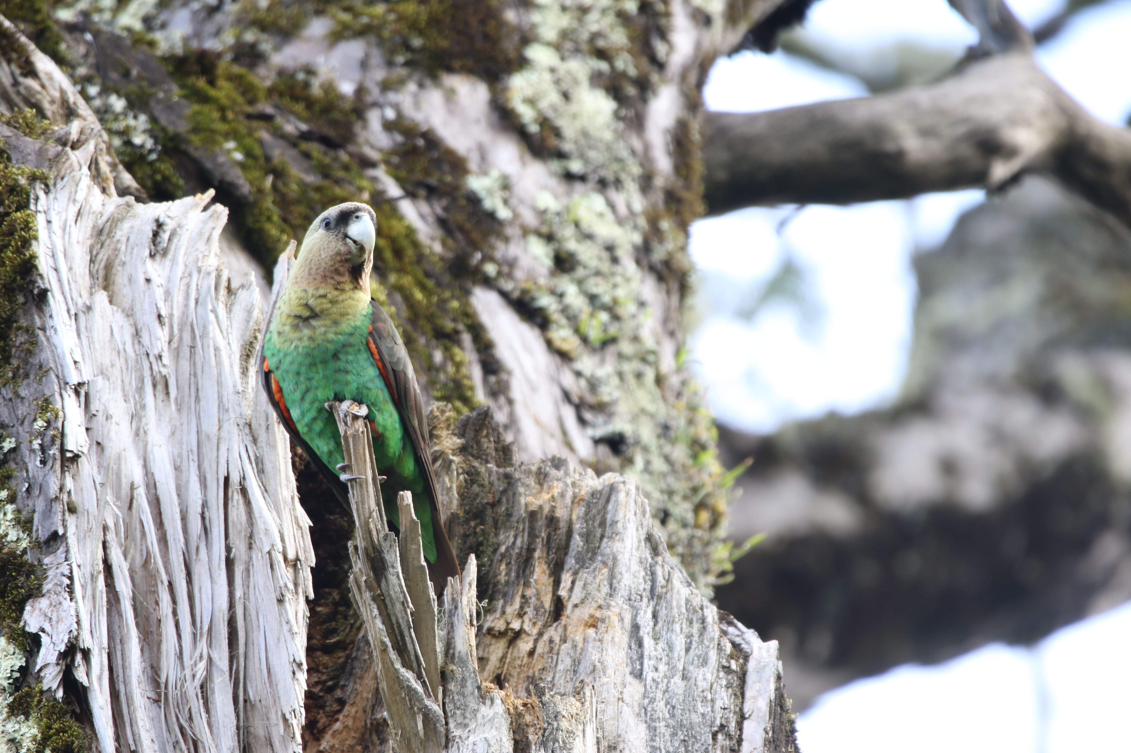

Table S1. Frequency of tree species harvested between 1992 and 2017 from Schwarzwald and Wolf River forests in the Amathole region, Eastern Cape.
Species | Common name | No. harvested | Percent of total
Podocarpus latifolius | Real yellowwood | 578 | 79
Afrocarpus falcatus | Outeniqua yellowwood | 119 | 16
Celtis africana | White stinkwood | 11 | 2
Olea capensis | Black ironwood | 10 | 1
Curtisia dentata | Assagaai | 5 | 1
Xymalos monospora | Lemonwood | 3 | <1
Unknown |  | 2 | <1
Acacia melanoxylonª | Australian blackwood | 1 | <1
Vepris lanceolata | White ironwood | 1 | <1
Zanthoxylum davyi | Knobwood | 1 | <1
ª Non-indigenous species

Condition (Grouped) | Condition (Original DEFF dataset)
1. Crownless | Crownless
 | 75% crownless
2. Crown damage | Crown damage
 | Main branch broken
 | Broken crown
3. Windfall | Windfall
 | Windfall (block road)
4. Dry standing | Dry standing
 | Dying
 | Dry crown
 | Crown dead
 | Crown dying
 | Dead
 | Dead crown
 | Die back
5. Other | Unknown
 | Branch fall
 | Drought
 | Leaning
 | Lightning
 | Rotten
Table S2. Consolidation of the full list of all tree conditions described in original harvest record into four primary groups.

