Supplementary Material

Current status of the Critically Endangered Black-winged Trumpeter (Psophia obscura) in one of its last strongholds
ELILDO A.R. CARVALHO JR, ELOÍSA N. MENDONÇA, ALEXANDRE M. C. LOPES and TORBJØRN HAUGAASEN

Contents
Table S1. Summary information about camera-trap sampling at Gurupi Biological Reserve.
Figure S1. Posterior distribution of beta coefficients representing the effects of covariates on Black-winged Trumpeter occupancy probabilities.
Figure S2. Mean and 95% posterior credible interval for between-year growth rate (λ) for Black-winged Trumpeter at Gurupi Biological Reserve, 2016-2020.
Figure S3. A camera-trap record of a Psophia obscura group at Gurupi Biological Reserve.
Table S1. Summary information about camera-trap sampling at Gurupi Biological Reserve. Mean effort is the mean number of days cameras were operational in a given year. Total effort is the sum of the effort in days of all individual cameras in a given year. Photos is the number of Black-winged Trumpeter photos obtained in a given year. Detection events is the number of independent (>60 minute- interval) detections of Black-winged Trumpeter obtained in a given year.
Year | N. sites | Mean effort | Total effort | Photos | Detection events
2016 | 57 | 30 | 1710 | 534 | 38
2017 | 59 | 30 | 1770 | 282 | 20
2018 | 57 | 30 | 1710 | 927 | 49
2019 | 60 | 30 | 1727 | 469 | 42
2020 | 59 | 30 | 1757 | 664 | 32

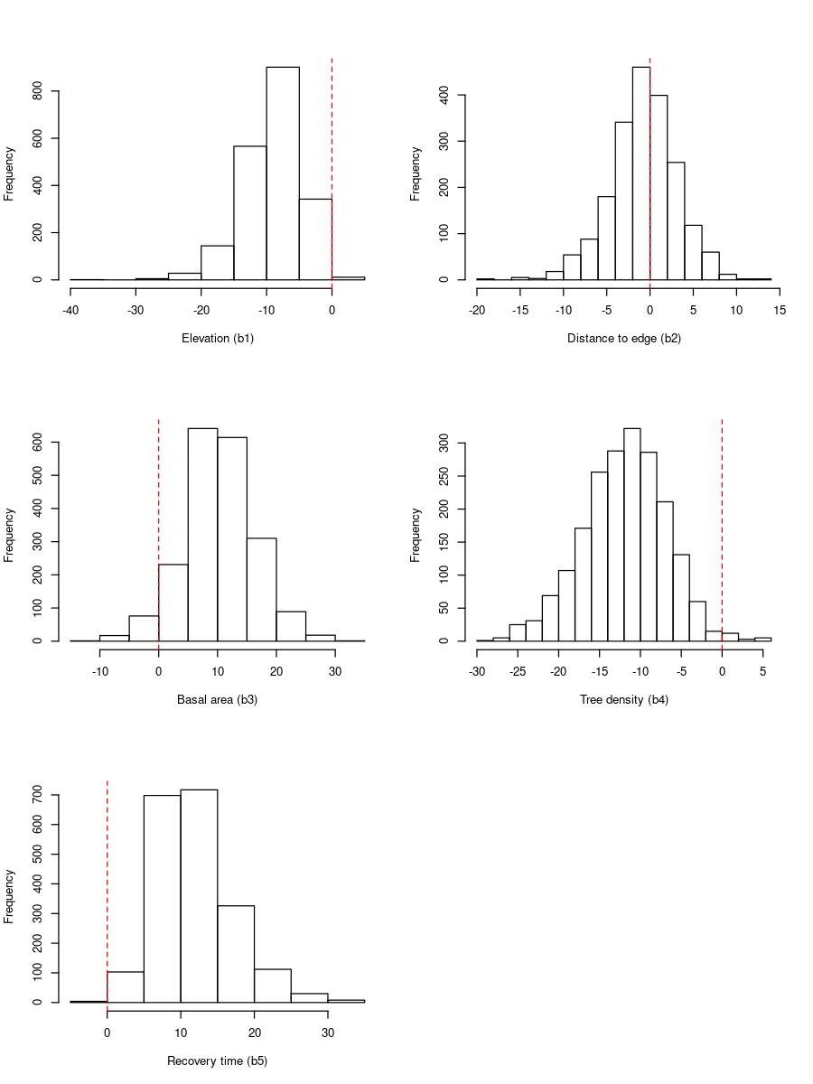
Figure S1. Posterior distribution of beta coefficients representing the effects of covariates on Black-winged Trumpeter occupancy probabilities.

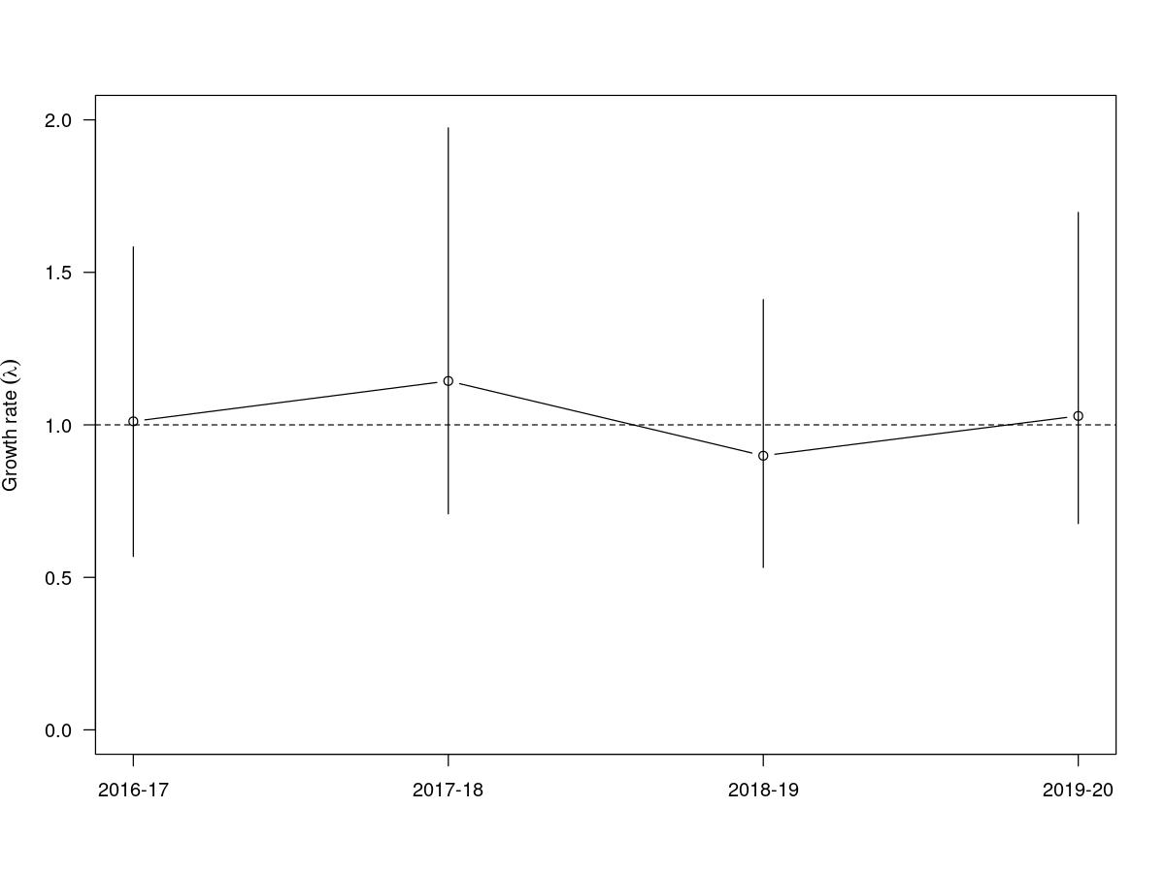
Figure S2. Mean and 95% posterior credible interval for between-year growth rate (λ) for Black-winged Trumpeter at Gurupi Biological Reserve, 2016-2020.

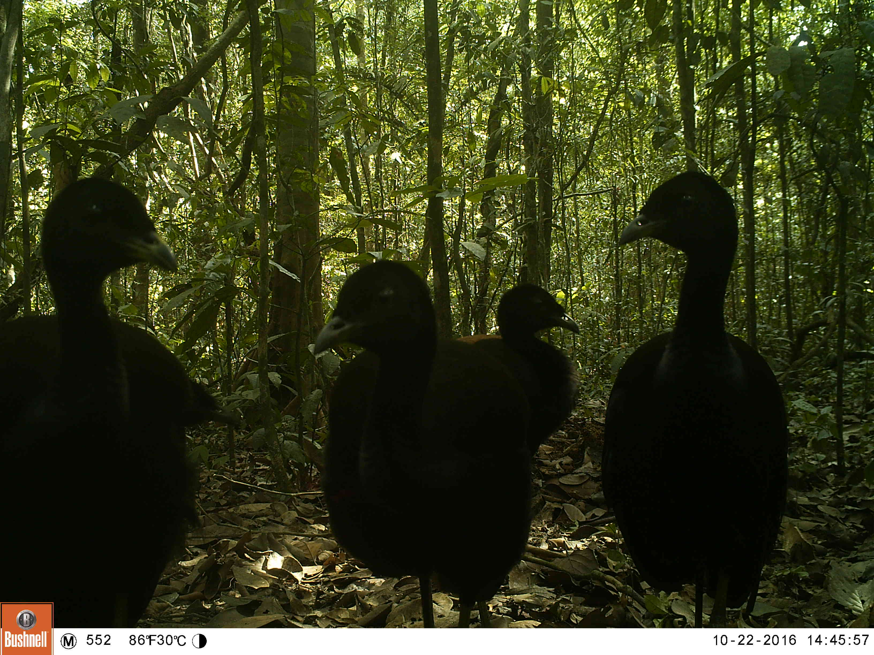
Figure S3. A camera-trap record of a Psophia obscura group at Gurupi Biological Reserve.

