Supplementary Material

Phylogenetic placement and life history trait imputation for Grenada Dove Leptotila wellsi

CATHERINE PETERS, MATTHEW GEARY, HOWARD P. NELSON, BONNIE L. RUSK, ACHAZ VON HARDENBERG and ANNA MUIR

Contents
Appendix S1. List of primers and primer sequences used in this study along with
the specific annealing temperature and product sizes.

Appendix S2. Phylogenetic tree built using *BEAST.
Appendix S3.
Appendix S4. Alignment of the nuclear β-fibrinogen gene for Leptotila species showing the indel present in Leptotila plumbeiceps and Leptotila cassinii sequences.
Appendix S5. Appendix S5. Phylogenetic signal lambda (λ) value per life history trait.

Appendix S1. List of primers and primer sequences used in this study along with
the specific annealing temperature and product sizes.
Gene | Primer | Sequence (5'->3') | T_{a}  (°  C) | Amplic on size | Referen  ce
COI | AWCF1¹ | CGC YTW AAC AYT CYG CCA TCT TAC C | 50  * | 328bps | (Patel et al.  2010)
COI | AWCR2 | ATG TTG TTT ATG AGT GGG AAT GCT ATG | 50  *
COI | AWCF2 | ATC GGA GCC CCA GAC ATA GCA  TT | 50  * | 314bps
COI | AWCR4 | TTG ATG GCT GTT GTG ATA AAG TTG AT | 50  *
COI | AWCF4 | TCC TCA ATC CTG GGA GCA ATC AAC TT | 50  * | 352bps
COI | AW CR6j | ATT CCT ATG TAG CCG AAT GGT TCT TT | 50  *
Cyt b | L14841 | AAA AGC TTC CAT CCA ACA TCT CAG CAT GAT GAA A | 54 | 1042bp  s | (Kocher et al. 1989)
Cyt b | H4a | AAG TGG TAA GTC TTC AGT CTT TGG TTT ACA AGA CC | 54 |  | (Harshm  an  1996)
Cyt b | CYTB 32  F | ACC CAG ATC YTA ACA GGY CT | 55 | 350bps | Designe d by this study
Cyt b | CYTB 32  R | GTT TGG CCG ATG TAG GGG AT | 55
Cyt b | CYTB 316  F | GTG CCA CAG TCA TCA CCA AC | 55 | 358bps
Cyt b | CYTB 316  R | GGG TGT AAA GTT TTC TGG GTC  T | 55
Cyt b | CYTB 585  F | AAG ACA TCC TCG GCT TCA CA | 55 | 362bps
Cyt b | CYTB 585  F | GTA GGT GAG GGA GGC AAG TT | 55
ND2 | L5216 | GGC CCA TAC CCC GRA AAT | 60 | 550bps | (Sorens  on  2003)
ND2 | H5766 | RGA KGA GAA RGC YAG GAT YTT KCG | 60
ND2 | L5758 | GGC TGA ATR GGM CTN AAY CAR AC | 54 | 555bps
ND2 | H6131 | CTCTTATTTAAGGCTTTGAAGGC | 54
ND2 | ND2 420  F | CTG CCC TGC TAC TCT CAA CT | 55 | 408bps | Designe d by this study
ND2 | ND2 420  R | GGT GAG TTC TTG GAT GAT GAG | 55
FIB B I7 | FIB-BI7L | GGA GAA AAC AGG ACA ATG AC  A ATT CAC | 50 | 1000bp  s | (Prychit ko and

FIB B  I7 | FIB-BI7U | TCC CCA GTA GTA TCT GCC ATT A GG GTT | 50 |  | Moore  1997)
FIB B  I7 | FIB BI7 1  5F | CAG AGA CAA TGA TGG ATG GTA CG | 55 | 464bps | Designe d for this study
FIB B  I7 | FIB BI7 1  5R | CCT CAG TAC TGC CAC CCT C | 55
FIB B I7 | FIB BI7 2 48F | CCT GCA AGT TAC CAG CCA AA | 55 | 407bps
FIB B I7 | FIB BI7 2 48R | TGA AAG CAG AGC ACA CAG TT | 55
FIB B I7 | FIB BI7 4 79F | ACA CTG TCT TGC TTG AGT AGG | 55 | 500bps
FIB B I7 | FIB BI7 4 79R | CTA GAC CTG CCC CAG TAC TG | 55
*PCR parameters contain an initial 10 cycles with the Ta: 55°C followed by an ac 35 cycles at Ta:50°C as described in the methods section. |  |  |  |  | ditional

Harshman, J. (1996) Phylogeny, evolutionary rates, and ducks PhD Thesis. University of Chicargo
Kocher, T. D., Thomas, W. K., Meyer, A, Edwards, S. V., Paabo, S., Villablanca, F. X. and Wilson, A. C. (1989) Dynamics of mitochondrial DNA evolution in animals: Amplification and sequencing with conserved primers. Proc Natl Acad Sci U S A 86: 6196-6200.
Patel, S., Waugh, J., Millar, C. D. and Lambert, D. M. (2010) Conserved primers for DNA barcoding historical and modern samples from New Zealand and Antarctic birds. Mol Ecol Resour 10: 431-438.
Prychitko, T. M. and Moore, W. S. (1997) The Utility of DNA Sequences of an Intron from the b-Fibrinogen Gene in Phylogenetic Analysis of Woodpeckers (Aves: Picidae) Mol. Phylogenet. 8: 193-204
Sorenson, M. D. (2003) Avian mtDNA primers.
https://people.bu.edu/msoren/Bird.mt.Primers.pdf (Accessed 6 April 2020)

Appendix S2. Phylogenetic tree built using *BEAST.
There are variety of approaches to building a phylogenetic tree when the data consists of mitochondrial and nuclear genes. The approach we have used in the manuscript is to concatenate genes in a single matrix and estimate a tree based on the combined evidence in addition to analysing them separately (Leyva-Valencia et al., 2015; Patterson et al., 2011; Wang et al., 2020; Zhao et al., 2020). Another approach is to use a phylogenetic method that can infer the species tree while allowing discordant gene trees (Maddison & Knowles, 2006). Different phylogenetic methods can produce different phylogenetic trees. We therefore re-built the phylogenetic tree also using the *BEAST approach (Heled & Drummond, 2010) implemented in BEAST v2.6.6 (Bouckaert et al., 2019) in order to check the consistency of the relationships observed in the tree presented in the manuscript. For all gene sequences the HKY substitution model was selected. Tree models were linked across all mitochondrial genes. The species tree was built assuming a strict clock and a ‘linear with constant root’ multi-species coalescent model. The following priors were specified: the Yule tree model with a log-normal prior for birth rate, exponential priors for the clock rate and log-normal priors for the HKY transition-transversion parameters. MCMC was run for 5,000,000 iterations thinning by saving every 5,000 steps (Barido-Sottani et al., 2018). The species tree built using *BEAST (Fig. S.1) supported the tree obtained using the concatenated data presented in the manuscript (Figure 1) as it provided the same topology.
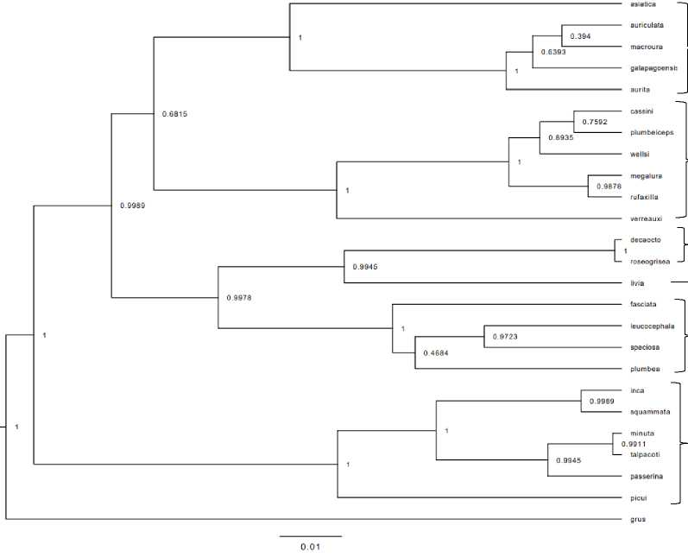
Fig. S.2 Species tree for 24 Neotropical columbid species and outgroup using the *BEAST method. Branch labels indicate the posterior probability of each node.
Zenaida
Leptotila
Streptopelia
Columba
Patagioenas
Columbina
References
Bouckaert, R., Vaughan, T. G., Barido-Sottani, J., Duchene, S., Fourment, M., Gavryushkina, A., Heled, J., Jones, G., Kuhnert, D., De Maio, N., Matschiner, M., Mendes, F. K., Muller, N. F., Ogilvie, H. A., Du Plessis, L., Popinga, A., Rambaut, A., Rasmussen, D., Siveroni, I., Suchard, M. A., Wu, C. H., Xie, D., Zhang, C., Stadler, T. and Drummond, A. J. (2018) Taming the BEAST—A Community Teaching Material Resource for BEAST 2. Syst. Biol. 67:170174.
Bouckaert, R., Vaughan, T. G., Barido-Sottani, J., Duchene, S., Fourment, M., Gavryushkina, A., Heled, J., Jones, G., Kuhnert, D., De Maio, N., Matschiner, M., Mendes, F. K., Muller, N.F., Ogilvie, H. A., Du Plessis, L., Popinga, A., Rambaut, A., Rasmussen, D., Siveroni, I., Suchard, M. A., Wu, C. H., Xie, D., Zhang, C., Stadler, T. and Drummond, A. J. (2019) BEAST 2.5: An advanced software platform for Bayesian evolutionary analysis. PLOS Comput. Biol. 15: 1-28.
Heled, J. and Drummond, A. J. (2010) Bayesian inference of species trees from multilocus Data. Mol. Biol. Evol. 27: 570-580.
Leyva-Valencia, I., Cruz-Hernandez, P., Alvarez-Castanda, S. T., Rojas-Posadas, D. I., Correa- Ramirez, M. M., Vadopalas, B. and Lluch-Cota, D. B. (2015) Phylogeny and Phylogeography of the Geoduck Panopea (Bivalvia: Hiatellidae). J. Shellfish Res. 34: 11-20.
Maddison, W. and Knowles, L. (2006) Inferring Phylogeny Despite Incomplete Lineage Sorting. Syst. Biol. 55: 21-30.
Patterson, S. A., Morris-Pocock, J. A. and Friesen, V. L. (2011) A multilocus phylogeny of the Sulidae (Aves: Pelecaniformes). Mol. Phylogenet. Evol. 58: 181-191.
Wang, E., Zhang, D., Braun, M. S., Hotz-Wagenblatt, A., Part, T., Arlt, D., Schmaljohann, H., Bairlein, F., Lei, F. and Wink, M. (2020) Can mitogenomes of the Northern Wheatear (Oenanthe oenanthe) reconstruct its phylogeography and reveal the origin of migrant birds? Sci. Rep. 10: 9290.
Wang, E., Zhang, D., Braun, M. S., Hotz-Wagenblatt, A., Part, T., Arlt, D., Schmaljohann, H., Bairlein, F., Lei, F., and Wink, M. (2020) Unraveling the diversification and systematic puzzle of the highly polymorphic Psammobates tentorius (Bell, 1828) complex (Reptilia: Testudinidae) through phylogenetic analyses and species delimitation approaches. J. Zool. Syst. Evol. Res. 58: 308-326.

Appendix S4. Alignment of the nuclear β-fibrinogen gene for Leptotila species showing the indel present in Leptotila plumbeiceps and Leptotila cassinii sequences. Conserved regions are denoted by • and variable regions denoted by -. Alignments of β-fibrinogen intron 7 sequences were constructed using the method outlined in Prychitko and Moore 2003.

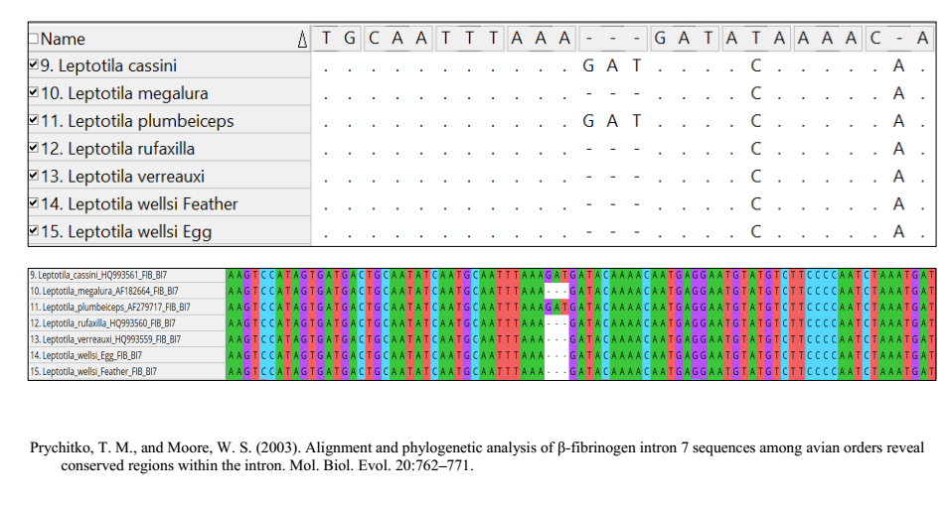
Appendix S5. Phylogenetic signal lambda (λ) value per life history trait.
Life History Trait | X value
litter or clutch size n | 1.03537452
litters or clutches_per y | 7.61E-05
incubation days | 0.05452824
fledging age days | 6.84E-05
adult body mass g | 1.0246996
female body mass g | 1.02162865
male body mass g | 1.02560503
no sex body mass g | 1.00869828
Generation length years | 1.03537452
male maturity d | 4.84E-05
female maturity d | 0.32784191
longevity | 6.98E-05
birth or hatching weight g | 7.80E-05

