Supplementary Material

Space use and site fidelity in the endangered Northern Bald Ibis Geronticus eremita: Effects of age, season, and sex

VERENA PUEHRINGER-STURMAYR, JULIA KREJCI, RICHARD SCHUSTER, SONIA KLEINDORFER, KURT KOTRSCHAL, DIDONE FRIGERIO and MATTHIAS-CLAUDIO LORETTO

Contents
Figure S1. Minimum convex polygon (MCP) area of the breeding season by a logarithmic step wise increase of the number of GPS points per calculation.
Figure S2. Minimum convex polygon (MCP) area of the non-breeding season by a logarithmic step wise increase of the number of GPS points per calculation.
Figure S3. Elevation variable used to model step-selection function.
Figure S4. Flyways between study areas.
Figure S5. Space use [95%, km²] separately for each combination of age class and season.
Figure S6. Site fidelity (number of top 5% of highly visited locations) as a function of season (i.e. breeding and non-breeding season).
Figure S7. Site fidelity (number of top 5% of highly visited locations) as a function of age (i.e. juvenile and adult).
Figure S1. Minimum convex polygon (MCP) area of the breeding season by a logarithmic step wise increase of the number of GPS points per calculation. 0% percentile of MCP area – blue bottom line, 25% percentile of MCP area – red bottom line, 50% percentile of MCP area – black middle line, 75% percentile of MCP area – red top line, 100% percentile of MCP area – blue top line, real MCP area size of all locations – horizontal dot-dashed black line.

Figure S2. Minimum convex polygon (MCP) area of the non-breeding season by a logarithmic step wise increase of the number of GPS points per calculation. 0% percentile of MCP area – blue bottom line, 25% percentile of MCP area – red bottom line, 50% percentile of MCP area – black middle line, 75% percentile of MCP area – red top line, 100% percentile of MCP area – blue top line, real MCP area size of all locations – horizontal dot-dashed black line.
Figure S3. Elevation variable used to model step-selection function. Elevation is given in meters. Global digital elevation model (spatial resolution 1 arc second, 30 m) derived using the environmental-data automated track annotation (Env-DATA) System of Movebank.

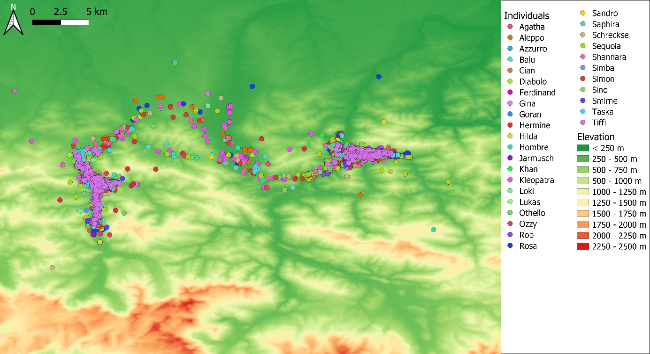Figure S4. Flyways between study areas. The coloured dots represent the individuals. Background digital elevation model (DEM) was derived from oe3d in spatial resolution 1 arc second (approximately 20-30 m, http://www.oe3d.at/).

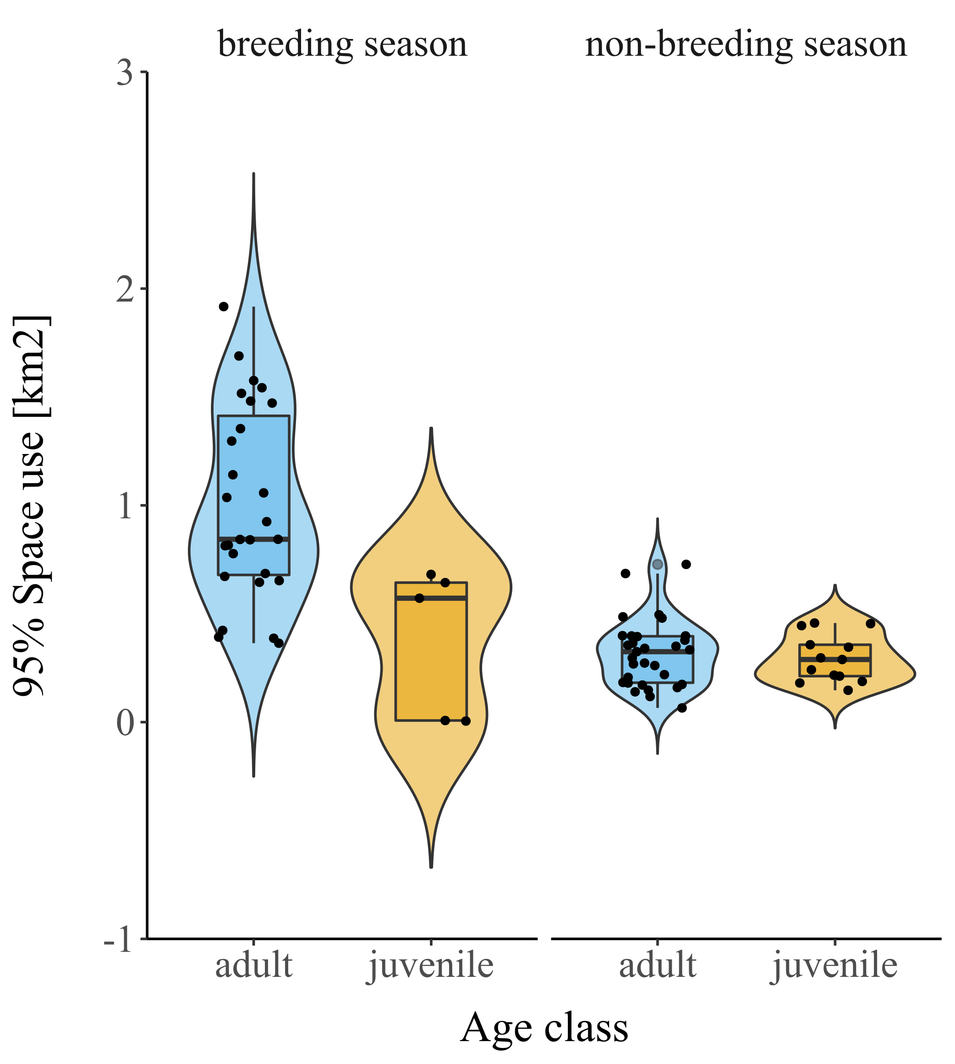
Figure S5. Space use [95%, km²] separately for each combination of age class and season.

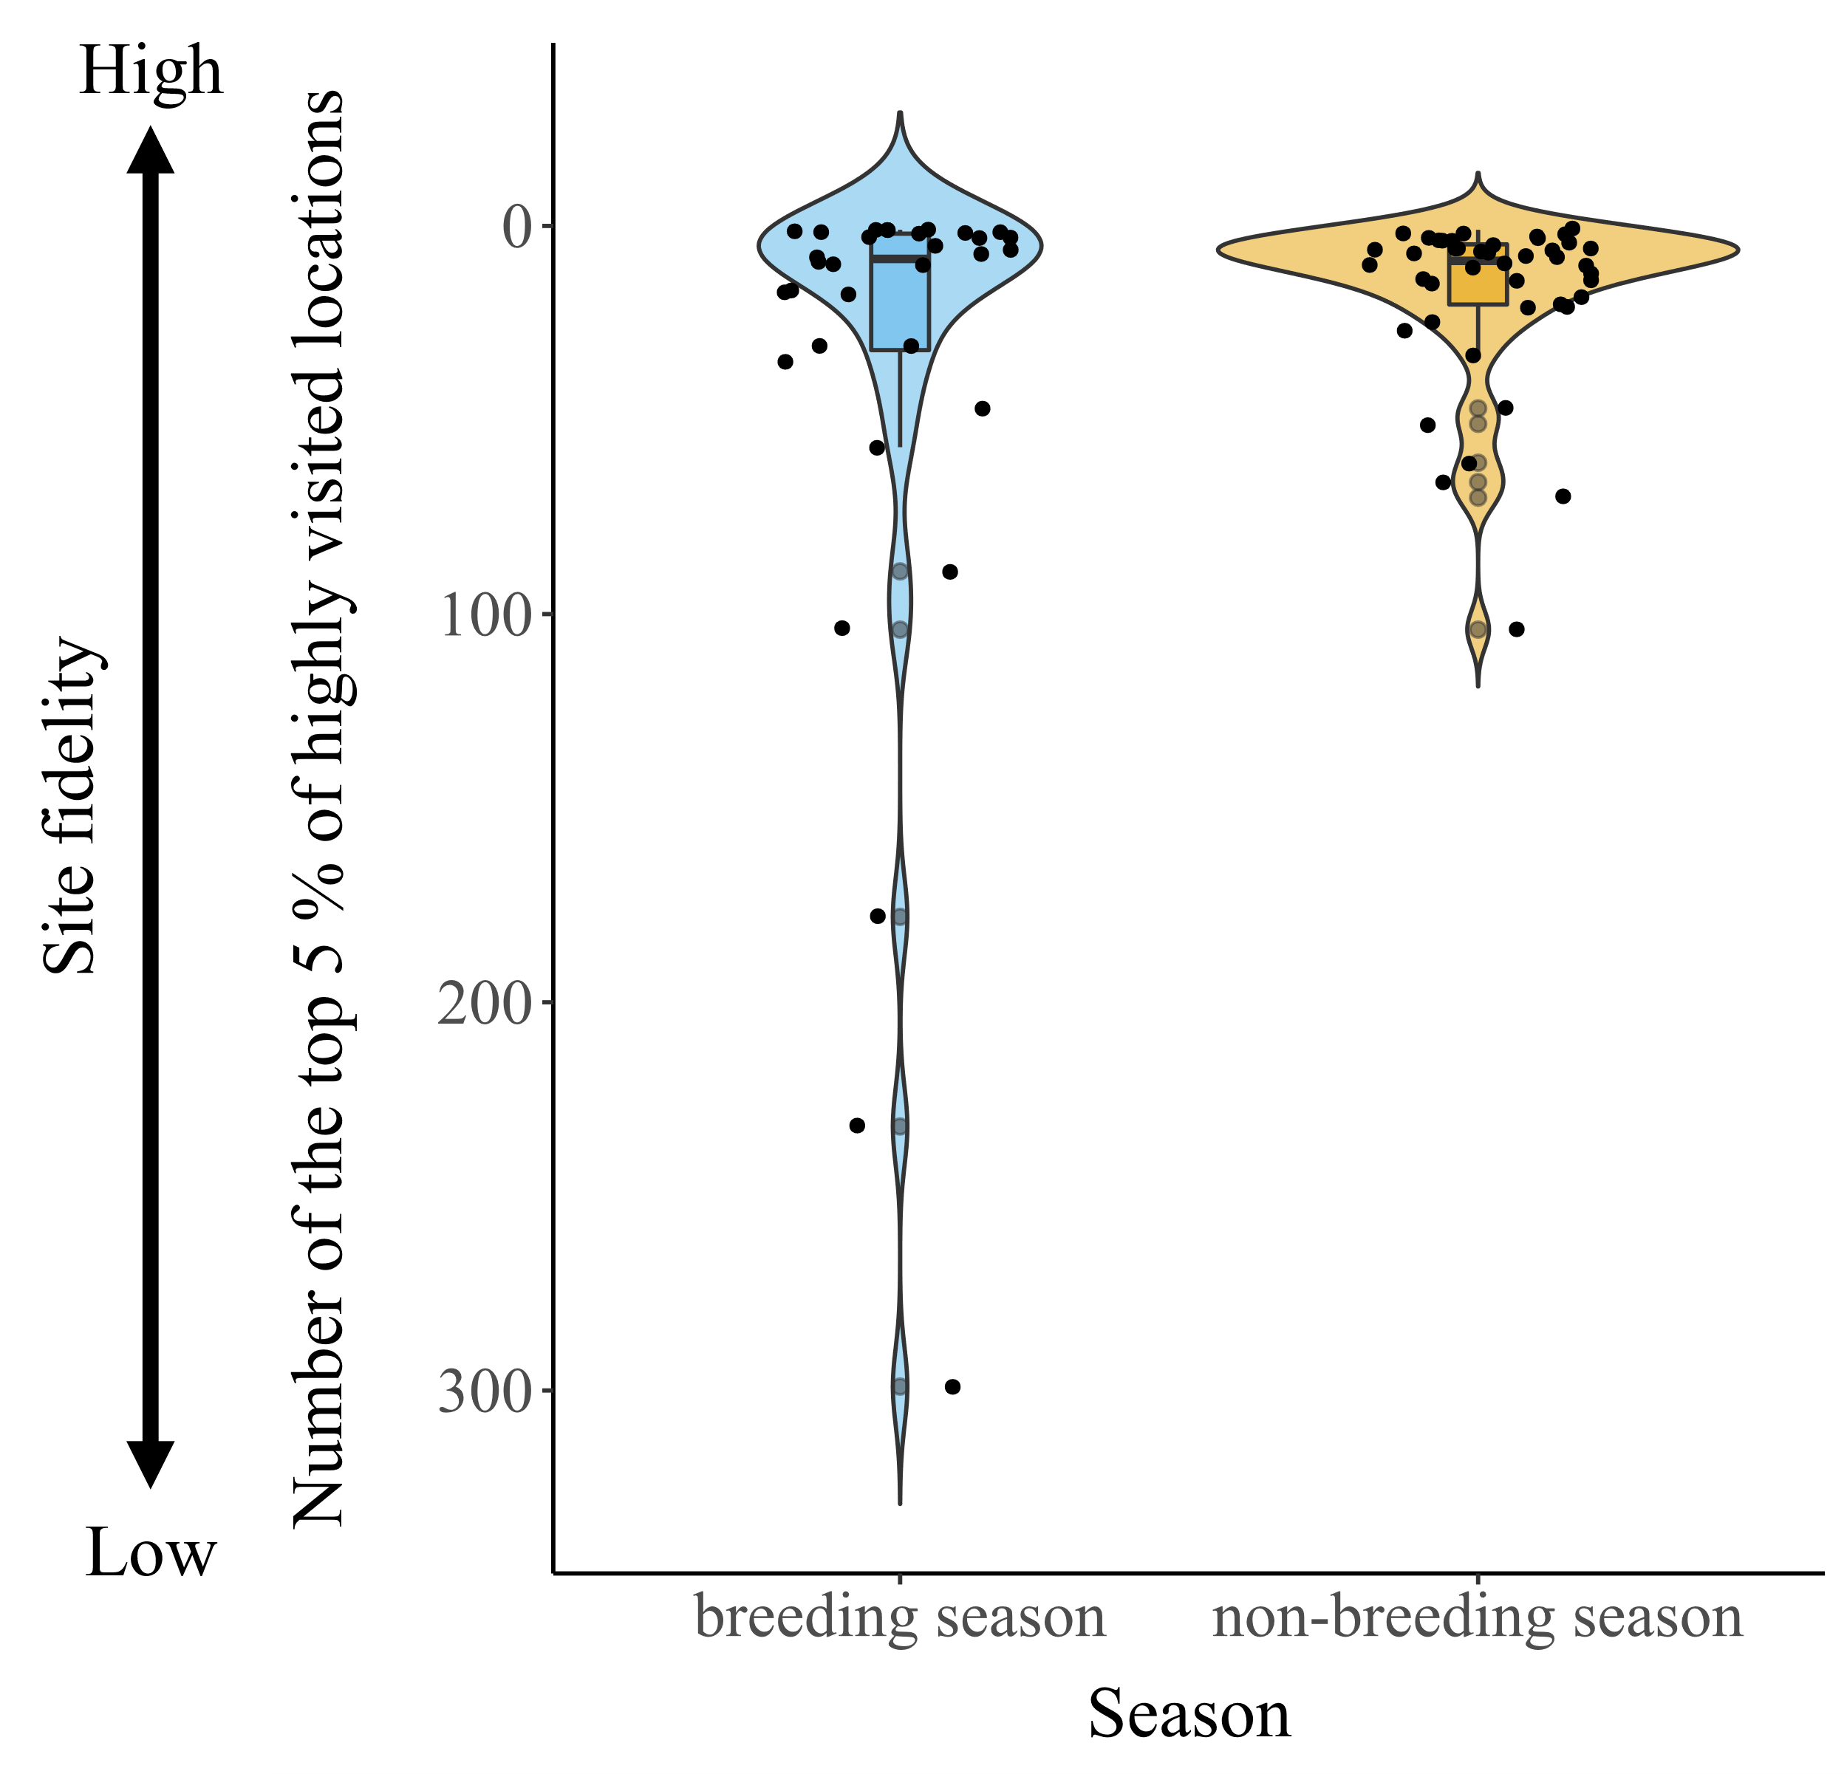
Figure S6. Site fidelity (number of top 5% of highly visited locations) as a function of season (i.e. breeding and non-breeding season). High site fidelity depicts low number of revisited locations, while low site fidelity depicts high number of revisited locations.

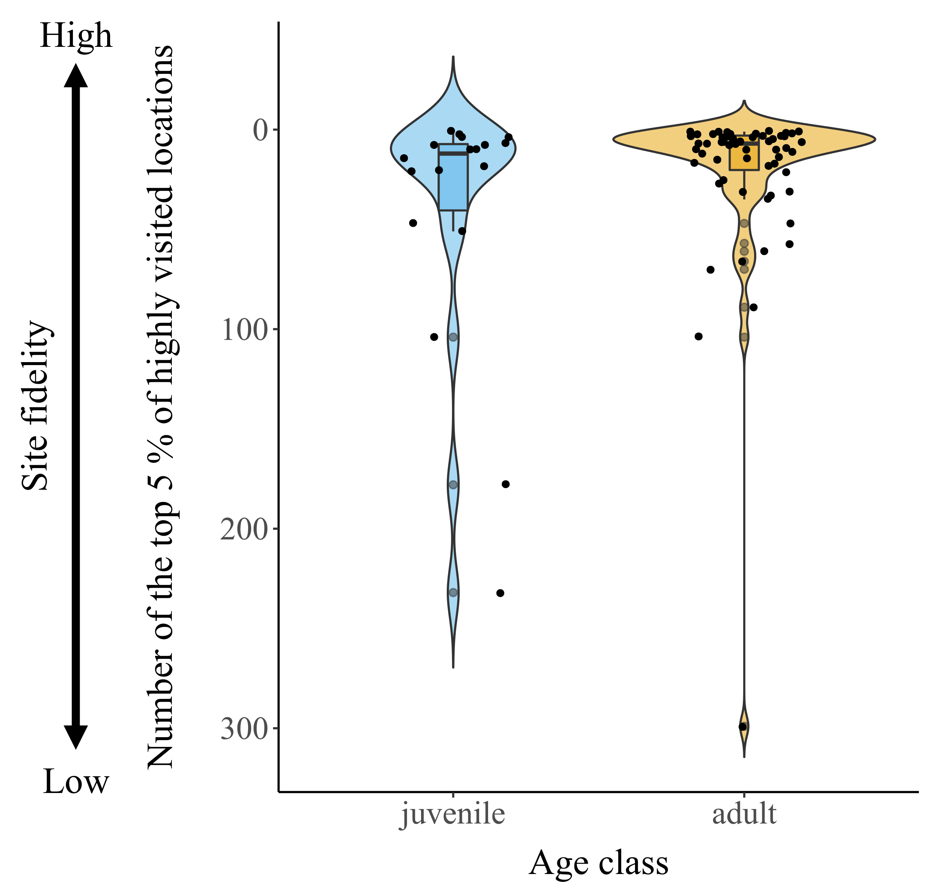
Figure S7. Site fidelity (number of top 5% of highly visited locations) as a function of age (i.e. juvenile and adult). High site fidelity depicts low number of revisited locations, while low site fidelity depicts high number of revisited locations.

