Supplementary Material

The effect of shade tree species on bird communities in central Kenyan coffee farms

DEVEN KAMMERICHS-BERKE, FANTER J. LANE, FRANK JUMA ONG’ONDO, EDSON M. MLAMBA, WILLIAM T. BEAN, JULIE A. JEDLICKA, PETER NJOROGE and MATTHEW D. JOHNSON

Contents

Appendix S1. Detected abundances of all detected bird species for each vegetation level on coffee farms in Kiambu County, Kenya, winter 2018-2019.

Appendix S2. Two pairs of curves generated from rarefying the foraging survey data.

Appendix S3. AICc results of the competing general linear model set.

Appendix S4. Results from top models for insectivorous bird species richness and abundance in the crop layer of coffee farms in Kiambu County, Kenya, winter 2018-2019.

Appendix S5. Simpson’s diversity and evenness indices for each vegetation level.

Appendix S6. Tukey HSD results of temperature data (minimum, maximum, and mean daily temperatures) collected under Cordia and Grevillea trees, as well as an unshaded control, on coffee farms in Kiambu County, Kenya, winter 2018-2019.

Appendix S1. Detected abundances of all detected bird species for each vegetation level on coffee farms in Kiambu County, Kenya, winter 2018-2019. Birds were detected at the canopy level using 10-minute focal tree observations and at the understory level using mist nets.
Common Name | Latin Name | Vegetation Level
 |  | Canopy-Cordia | Understory-Cordia | Canopy-Grevillea | Understory-Grevillea
Dusky Turtle-Dove | Streptopelia lugens | 1 | 0 | 0 | 0
Ring-necked Dove | Streptopelia capicola | 0 | 0 | 2 | 0
Red-eyed Dove | Streptopelia semitorquata | 0 | 0 | 1 | 0
African Green Pigeon | Treron calvus | 1 | 0 | 0 | 0
Speckled Mousebird | Colius striatus | 0 | 0 | 0 | 1
African Pygmy-Kingfisher | Ispidina picta | 0 | 4 | 0 | 5
Cinnamon-chested Bee-Eater | Merops oreobates | 2 | 0 | 2 | 0
Eurasian Bee-Eater | Merops apiaster | 0 | 1 | 0 | 0
Yellow-rumped Tinkerbird | Pogoniulus chrysoconus | 1 | 0 | 1 | 0
Spot-flanked Barbet | Tricholaema lacrymosa | 0 | 1 | 0 | 0
Green-backed Honeyguide | Prodotiscus zambesiae | 0 | 0 | 1 | 0
Cardinal Woodpecker | Chloropicus fuscescens | 1 | 0 | 0 | 0
Brown-backed Woodpecker | Chloropicus obsoletus | 0 | 1 | 0 | 0
Chinspot Batis | Batis molitor | 6 | 4 | 7 | 2
African Paradise-Flycatcher | Terpsiphone viridis | 6 | 8 | 6 | 10
Northern Fiscal | Lanius humeralis | 0 | 1 | 0 | 0
White-bellied Tit | Melaniparus albiventris | 2 | 8 | 0 | 4
Red-faced Crombec | Sylvietta whytii | 1 | 9 | 2 | 7
Yellow-breasted Apalis | Apalis flavida | 7 | 8 | 6 | 5
Wire-tailed Swallow | Hirundo smithii | 0 | 0 | 0 | 1
Common Bulbul | Pycnonotus barbatus | 30 | 37 | 49 | 21
Willow Warbler | Phylloscopus trochilus | 43 | 7 | 4 | 7
Eurasian Blackcap | Sylvia atricapilla | 6 | 7 | 2 | 6
Garden Warbler | Sylvia borin | 1 | 1 | 0 | 1
Pale White-Eye | Zosterops flavilateralis | 18 | 4 | 21 | 1
Kikuyu White-Eye | Zosterops kikuyuensis | 22 | 46 | 31 | 20
Abyssinian Thrush | Turdus abyssinicus | 9 | 2 | 11 | 3
African Dusky Flycatcher | Muscicapa adusta | 0 | 0 | 0 | 2
Pale Flycatcher | Agricola pallidus | 13 | 4 | 2 | 2
White-eyed Slaty-Flycatcher | Melaenornis fischeri | 5 | 2 | 0 | 5
Cape Robin-Chat | Cossypha caffra | 11 | 14 | 1 | 8
Ruppell's Robin-Chat | Cossypha semirufa | 0 | 0 | 0 | 3
Collared Sunbird | Hedydipna collaris | 3 | 4 | 0 | 0
Green-headed Sunbird | Cyanomitra verticalis | 1 | 1 | 1 | 0
Amethyst Sunbird | Chalcomitra amethystina | 3 | 0 | 1 | 1
Scarlet-chested Sunbird | Chalcomitra senegalensis | 5 | 1 | 3 | 9
Bronze Sunbird | Nectarinia kilimensis | 31 | 21 | 9 | 14
Variable Sunbird | Cinnyris venustus | 46 | 13 | 13 | 12
Baglafecht Weaver | Ploceus baglafecht | 19 | 12 | 5 | 12
Spectacled Weaver | Ploceus ocularis | 2 | 0 | 3 | 0
Speke's Weaver | Ploceus spekei | 0 | 1 | 0 | 0
Village Weaver | Ploceus cucullatus | 1 | 12 | 3 | 1
Yellow-bellied Waxbill | Coccopygia quartinia | 0 | 2 | 0 | 2
Common Waxbill | Estrilda astrild | 0 | 0 | 0 | 1
Red-cheeked Cordonbleu | Cuculus solitarius | 5 | 7 | 1 | 8
Purple Grenadier | Granatina ianthinogaster | 0 | 3 | 0 | 5
Red-billed Firefinch | Lagonosticta senegala | 1 | 11 | 2 | 5
Bronzed Manakin | Spermestes cucullata | 5 | 4 | 1 | 0
Village Indigobird | Vidua chalybeata | 2 | 1 | 0 | 0
Kenya Rufous Sparrow | Passer rufocinctus | 2 | 2 | 2 | 3
Western Yellow Wagtail | Motacilla flava | 0 | 1 | 0 | 0
Tree Pipit | Anthus trivialis | 10 | 10 | 2 | 11
African Citril | Crithagra citrinelloides | 30 | 20 | 51 | 19
Reichenow's Seedeater | Crithagra reichenowi | 17 | 1 | 5 | 0
White-bellied Canary | Crithagra dorsostriata | 1 | 1 | 0 | 0
Brimstone Canary | Crithagra sulphurata | 4 | 3 | 5 | 0
Streaked Seedeater | Crithagra striolata | 14 | 54 | 19 | 48
Golden-breasted Bunting | Emberiza flaviventris | 6 | 7 | 1 | 5

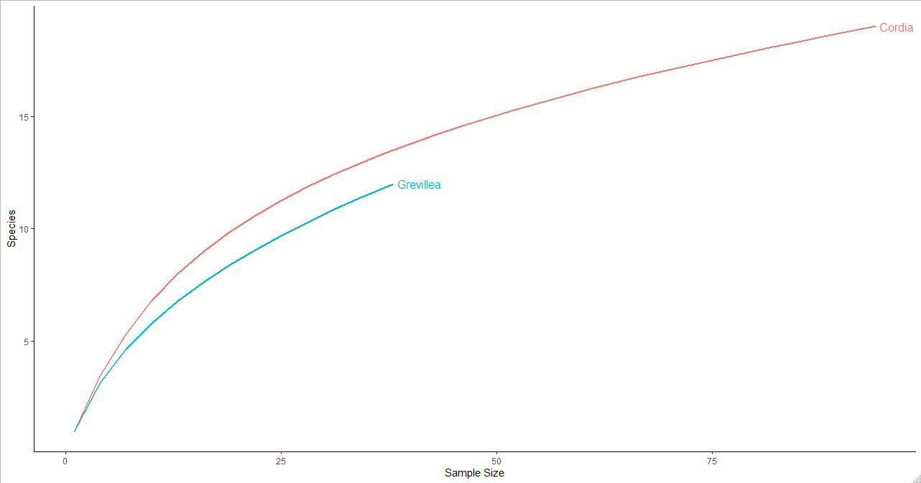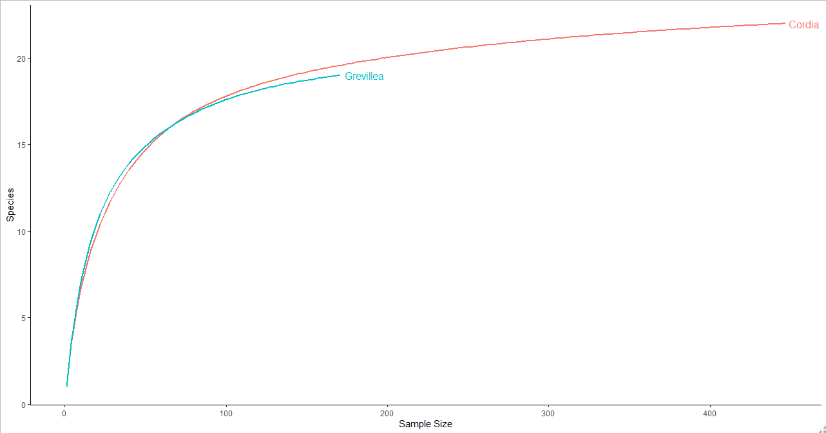
a

a
b

b

Appendix S2. Two pairs of curves generated from rarefying the foraging survey data. Plot (a) shows the rarefaction curves generated from trees which had full vegetation variables sampled (n = 146), while plot (b) shows the curves generated from the full sample of trees (n = 353). The curve flattened more thoroughly with the inclusion of all trees, suggesting an adequate survey effort.
Appendix S3. AICc results of the competing general linear model set which included tree species, tree height, diameter at breast height (dbh), average coffee flower score, canopy cover, and understorey cover as predictors to insectivorous bird species richness and abundance in the crop layer of coffee farms in Kiambu County, Kenya, winter 2018-2019.
Response Variable | Model | Kª | Log_{e}(L)^{b} | AIC_{c}^{c} | Delta AIC_{c}^{d} | Wi^{e}
Richness | Coffee Flower Score + Canopy Cover + (1|Site) | 4 | -253.93 | 516.13 | 0.00 | 0.29
 | Coffee Flower Score + Canopy Cover + Understory Cover + (1|Site) | 5 | -253.03 | 516.48 | 0.34 | 0.24
 | dbh + Coffee Flower Score + Understory Cover + Understory Cover +  (1|Site) | 6 | -252.28 | 517.16 | 1.02 | 0.17
 | Coffee Flower Score + (1|Site) | 3 | -255.77 | 517.71 | 1.57 | 0.13
 | Species + dbh + Coffee Flower Score + Canopy Cover + Understory Cover +  (1|Site) | 7 | -251.57 | 517.94 | 1.81 | 0.12
 | Species + Height + dbh + Coffee Flower Score + Canopy Cover +  Understory Cover + (1|Site) | 8 | -251.47 | 519.98 | 3.84 | 0.04
 | Canopy Cover + (1|Site) | 3 | -261.99 | 530.14 | 14.01 | 0.00
 | 1 + (1|Site) | 2 | -265.20 | 534.47 | 18.34 | 0.00
 | Understory Cover + (1|Site) | 3 | -264.97 | 536.09 | 19.96 | 0.00
 | Species + (1|Site) | 3 | -265.02 | 536.20 | 20.07 | 0.00
 | dbh + (1|Site) | 3 | -265.03 | 536.22 | 20.09 | 0.00
 | Height + (1|Site) | 3 | -265.06 | 536.28 | 20.15 | 0.00
Abundance | Coffee Flower Score + Canopy Cover + Understory Cover + (1|Site) | 5 | -349.11 | 708.64 | 0.00 | 0.35
 | dbh + Coffee Flower Score + Canopy Cover + Understory Cover + (1|Site) | 6 | -348.09 | 708.79 | 0.15 | 0.68
 | Height + dbh + Coffee Flower Score + Canopy Cover + Understory Cover +  (1|Site) | 7 | -347.60 | 710.02 | 1.38 | 0.18
 | Coffee Flower Score + Canopy Cover + (1|Site) | 4 | -351.61 | 711.50 | 2.86 | 0.94
 | Species + Height + dbh + Coffee Flower Score + Canopy Cover +  Understory Cover + (1|Site) | 8 | -347.55 | 712.16 | 3.52 | 0.06
 | Coffee Flower Score + (1|Site) | 3 | -357.84 | 712.84 | 13.20 | 0.00
 | Canopy Cover + (1|Site) | 3 | -359.61 | 725.40 | 16.76 | 0.00
 | Species + (1|Site) | 3 | -367.18 | 725.54 | 31.90 | 0.00
 | 1 + (1|Site) | 2 | -368.62 | 741.32 | 32.68 | 0.00
 | Understory Cover + (1|Site) | 3 | -367.67 | 741.51 | 32.87 | 0.00
 | Tree Height + (1|Site) | 3 | -368.07 | 742.31 | 33.67 | 0.00
 | dbh + (1|Site) | 3 | -368.59 | 743.36 | 34.72 | 0.00
ªNumber of parameters
^{b}Log_{e}(likelihood)
^{c}Akaike’s Information Criterion corrected for small sample size
^{d}Difference between AIC_{c} and top model AIC_{c}
^{e}AIC_{c} weight
Appendix S4. Results from top models for insectivorous bird species richness and abundance in the crop layer of coffee farms in Kiambu County, Kenya, winter 2018-2019.
Response | Covariate | β | SE | CI (95%)
Richness | Intercept | 0.005 | 0.291 | -0.581, 0.728
 | Av. Coffee Flower Score | -0.899 | 0.241 | -1.393, -0.440
 | Canopy Cover | 0.038 | 0.009 | -0.0001, 0.0147
Abundance | Intercept | -0.249 | 0.318 | -0.900, 0.871
 | Av. Coffee Flower Score | -0.688 | 0.184 | -1.061, -0.333
 | Canopy Cover | 0.013 | 0.003 | 0.006, 0.019
 | Understory Cover | 0.006 | 0.003 | 0.0008, 0.013

Appendix S5. Simpson’s diversity and evenness indices for each vegetation level (Canopy-Cordia, Understory-Cordia, Canopy-Grevillea, Understory-Grevillea).

Common Name | Latin Name |  | Vegetation Level
 |  |  | Canopy-Cordia |  |  |  |  |  | Understory-Cordia |  |  |  |  |  | Canopy-Grevillea |  |  |  |  |  | Understory-Grevillea
 |  |  | i* |  | pi** |  | pi ² |  | i |  | pi |  | pi ² |  | i |  | pi |  | pi ² |  | i |  | pi |  | pi ²
Chinspot Batis | Batis molitor |  | 2 |  | 0.0213 |  | 0.0005 |  | 4 |  | 0.0258 |  | 0.0007 |  | 0 |  | 0 |  | 0 |  | 2 |  | 0.0163 |  | 0.0003
African Paradise-Flycatcher | Terpsiphone viridis |  | 3 |  | 0.0319 |  | 0.001 |  | 7 |  | 0.0452 |  | 0.002 |  | 2 |  | 0.0526 |  | 0.0028 |  | 11 |  | 0.0894 |  | 0.008
White-bellied Tit | Melaniparus albiventris |  | 1 |  | 0.0106 |  | 0.0001 |  | 9 |  | 0.0581 |  | 0.0034 |  | 0 |  | 0 |  | 0 |  | 3 |  | 0.0244 |  | 0.0006
Red-faced Crombec | Sylvietta whytii |  | 1 |  | 0.0106 |  | 0.0001 |  | 7 |  | 0.0452 |  | 0.002 |  | 1 |  | 0.0263 |  | 0.0007 |  | 9 |  | 0.0732 |  | 0.0054
Yellow-breasted Apalis | Apalis flavida |  | 1 |  | 0.0106 |  | 0.0001 |  | 8 |  | 0.0516 |  | 0.0027 |  | 5 |  | 0.1316 |  | 0.0173 |  | 5 |  | 0.0407 |  | 0.0017
Willow Warbler | Phylloscopus trochilus |  | 17 |  | 0.1809 |  | 0.0327 |  | 7 |  | 0.0452 |  | 0.002 |  | 1 |  | 0.0263 |  | 0.0007 |  | 7 |  | 0.0569 |  | 0.0032
Eurasian Blackcap | Sylvia atricapilla |  | 4 |  | 0.0426 |  | 0.0018 |  | 6 |  | 0.0387 |  | 0.0015 |  | 0 |  | 0 |  | 0 |  | 7 |  | 0.0569 |  | 0.0032
Garden Warbler | Sylvia borin |  | 1 |  | 0.0106 |  | 0.0001 |  | 1 |  | 0.0065 |  | 4E-05 |  | 0 |  | 0 |  | 0 |  | 1 |  | 0.0081 |  | 7E-05
Pale White-Eye | Zosterops flavilateralis |  | 7 |  | 0.0745 |  | 0.0055 |  | 3 |  | 0.0194 |  | 0.0004 |  | 7 |  | 0.1842 |  | 0.0339 |  | 2 |  | 0.0163 |  | 0.0003
Kikuyu White-Eye | Zosterops kikuyuensis |  | 9 |  | 0.0957 |  | 0.0092 |  | 47 |  | 0.3032 |  | 0.0919 |  | 13 |  | 0.3421 |  | 0.117 |  | 19 |  | 0.1545 |  | 0.0239
Pale Flycatcher | Agricola pallidus |  | 7 |  | 0.0745 |  | 0.0055 |  | 4 |  | 0.0258 |  | 0.0007 |  | 0 |  | 0 |  | 0 |  | 2 |  | 0.0163 |  | 0.0003
White-eyed Slaty-Flycatcher | Melaenornis fischeri |  | 4 |  | 0.0426 |  | 0.0018 |  | 2 |  | 0.0129 |  | 0.0002 |  | 0 |  | 0 |  | 0 |  | 5 |  | 0.0407 |  | 0.0017
Collared Sunbird | Hedydipna collaris |  | 1 |  | 0.0106 |  | 0.0001 |  | 4 |  | 0.0258 |  | 0.0007 |  | 0 |  | 0 |  | 0 |  | 0 |  | 0 |  | 0
Green-headed Sunbird | Cyanomitra verticalis |  | 1 |  | 0.0106 |  | 0.0001 |  | 1 |  | 0.0065 |  | 4E-05 |  | 1 |  | 0.0263 |  | 0.0007 |  | 0 |  | 0 |  | 0
Amethyst Sunbird | Chalcomitra amethystina |  | 1 |  | 0.0106 |  | 0.0001 |  | 0 |  | 0 |  | 0 |  | 1 |  | 0.0263 |  | 0.0007 |  | 1 |  | 0.0081 |  | 7E-05
Scarlet-chested Sunbird | Chalcomitra senegalensis |  | 4 |  | 0.0426 |  | 0.0018 |  | 1 |  | 0.0065 |  | 4E-05 |  | 1 |  | 0.0263 |  | 0.0007 |  | 9 |  | 0.0732 |  | 0.0054
Bronze Sunbird | Nectarinia kilimensis |  | 12 |  | 0.1277 |  | 0.0163 |  | 20 |  | 0.129 |  | 0.0166 |  | 2 |  | 0.0526 |  | 0.0028 |  | 15 |  | 0.122 |  | 0.0149
Variable Sunbird | Cinnyris venustus |  | 16 |  | 0.1702 |  | 0.029 |  | 12 |  | 0.0774 |  | 0.006 |  | 3 |  | 0.0789 |  | 0.0062 |  | 13 |  | 0.1057 |  | 0.0112
Baglafecht Weaver | Ploceus baglafecht |  | 2 |  | 0.0213 |  | 0.0005 |  | 12 |  | 0.0774 |  | 0.006 |  | 1 |  | 0.0263 |  | 0.0007 |  | 12 |  | 0.0976 |  | 0.0095
Total |  |  | 94 |  | 1 |  | 0.1064 |  | 155 |  | 1 |  | 0.1369 |  | 38 |  | 1 |  | 0.1842 |  | 123 |  | 1 |  | 0.0894
Total Number of Species (S)  Simpson's Diversity Index  Simpson's Evenness Index |  | 19 |  |  |  |  |  | 18 |  |  |  |  |  | 12 |  |  |  |  |  | 17
 |  |  |  |  |  | 9.4 |  |  |  |  |  | 7.3047 |  |  |  |  |  | 5.4286 |  |  |  |  |  | 11.182
 |  |  |  |  |  | 0.4947 |  |  |  |  |  | 0.4058 |  |  |  |  |  | 0.4524 |  |  |  |  |  | 0.6578
*Number of individuals per species i
**Proportion of total number of species (S) made up of species i.

Appendix S6. Tukey HSD results of temperature data (minimum, maximum, and mean daily temperatures) collected under Cordia and Grevillea trees, as well as an unshaded control, on coffee farms in Kiambu County, Kenya, winter 2018-2019.
Response Variable | Group Comparison | Difference | 95% CI LL | 95% CI UL | P_{adj}
Minimum Daily Temperature | Cordia-Control | 1.264 | 0.310 | 2.218 | 0.005**
 | Grevillea-Control | 0.811 | -0.217 | 1.840 | 0.153
 | Grevillea-Cordia | -0.453 | -1.483 | 0.576 | 0.555
Maximum Daily Temperature | Cordia-Control | -3.191 | -4.299 | -2.084 | 0.000**
 | Grevillea-Control | -3.526 | -4.721 | -2.331 | 0.000**
 | Grevillea-Cordia | -0.334 | -1.530 | 0.861 | 0.788
Mean Daily Temperature | Cordia-Control | -0.283 | -0.810 | 0.244 | 0.418
 | Grevillea-Control | 0.243 | -0.326 | 0.812 | 0.574
 | Grevillea-Cordia | 0.526 | -0.043 | 1.096 | 0.077
**Statistically significant (p_{adj} < 0.05)

