Supplementary Material

Evidence of the effectiveness of conservation interventions from long-term aerial monitoring of three crane species in KwaZulu-Natal, South Africa

TAMSYN GALLOWAY-GRIESEL, LIZANNE ROXBURGH, TANYA SMITH, KEVIN MCCANN, BRENT COVERDALE, JOHN CRAIGIE, MATTHEUNS PRETORIUS, SAMANTHA NICHOLSON, MICHAEL MICHAEL, KAAJIAL DURGAPERSAD and KISHAYLIN CHETTY

Contents
Table S1. The approximate frequency of mitigation for both distribution and transmission lines for crane incidents only within the study area.
Table S2. The number of hectares of protected area that were formally proclaimed in the study area and buffer zone, every year from 1996 to 2018, and the cumulative total of protected hectares at the end of each year.
Figure S1. Reactive mitigation for distribution (dx) and transmission (tx) lines within the study area for incidents involving a crane.
Figure S2. Declared protected areas within the buffer zone around the study region in KwaZulu-Natal before and after 2003, when the study period began.
Figure S3. The number of Crane Custodians per municipality.

Table S1. The approximate frequency of mitigation for both distribution and transmission lines for crane incidents only within the study area.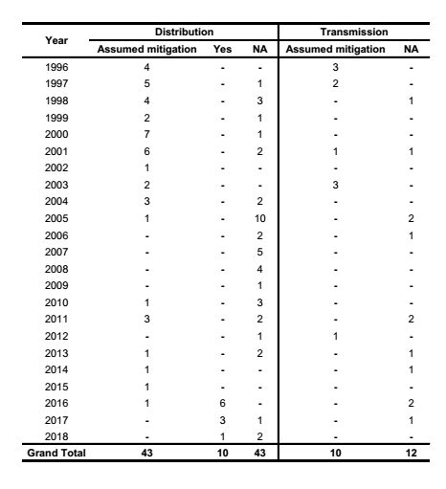

Table S2. The number of hectares of protected area that were formally proclaimed in the study area and buffer zone, every year from 1996 to 2018, and the cumulative total of protected hectares at the end of each year.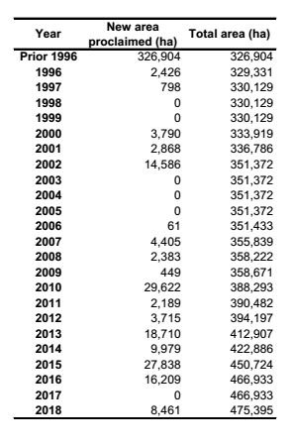

Figure S1. Reactive mitigation for distribution (dx) and transmission (tx) lines within the study area for incidents involving a crane (circles for dx and grey with black line for txn) and without (triangle for dx and grey line for tx) from 1996 to 2018, A) collision, B) electrocution. The number of spans show where more mitigation effort has been made.

Figure S2. Declared protected areas within the buffer zone around the study region in KwaZulu-Natal before and after 2003, when the study period began.

Figure S3. The number of Crane Custodians per municipality. Where exact farms are known, these are shown in white.

