Supplementary Material

The dynamics of songbird ownership and community interconnectedness in Singapore

WEN XUAN CHIOK, REBECCA Y. Y. LEE, JESSICA G. H. LEE and ANUJ JAIN

Contents
Figure S1. Examples of flyers for bird singing competitions in Singapore.
Figure S2. Levels of bird-keeping experience of respondents (n = 114).
Figure S3. Demographics of respondents showing (a) ethnicity (n = 107), (b) age (n = 104) and (c) income (n = 89).
Figure S4. Frequency of visit to natural spaces or nature reserves (n = 103).
Figure S5. Pictures depicting examples of a typical standalone bird hanging spot/gathering site (top), and a pet bird shop with cage-hanging structures erected (bottom) around a public housing estate.
Figure S6. Respondents’ memberships in hobbyist groups (n = 114).
Figure S7. Scores of respondents when presented with questions regarding their knowledge about nature (n = 114). The first question asked respondents about their general knowledge of nature in Singapore (top). The second question asked respondents to identify native species in Singapore (bottom). No negative marking scheme was implemented.
Figure S8. Pictures depicting how Singaporean bird owners display and/or keep their birds at their private residences (top) and public housing estates (bottom).
Figure S9. Educational levels of respondents (n = 100).
Figure S10. Religion types reported by respondents (n = 101).
Figure S11. Occupations of respondents (n = 95).
Figure S12. Number of family members at home (n = 104).
Appendixc S1. Survey template.

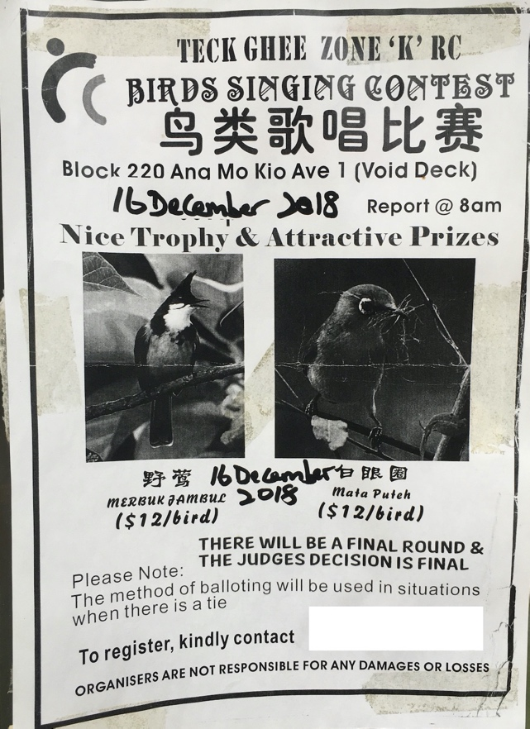
Supplementary Information
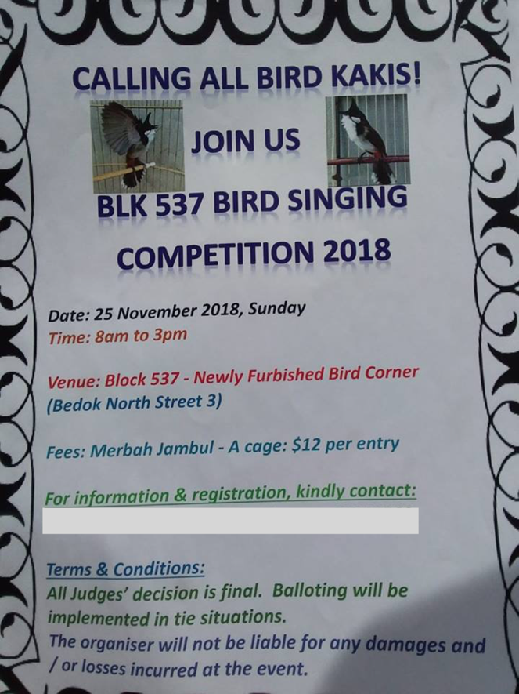
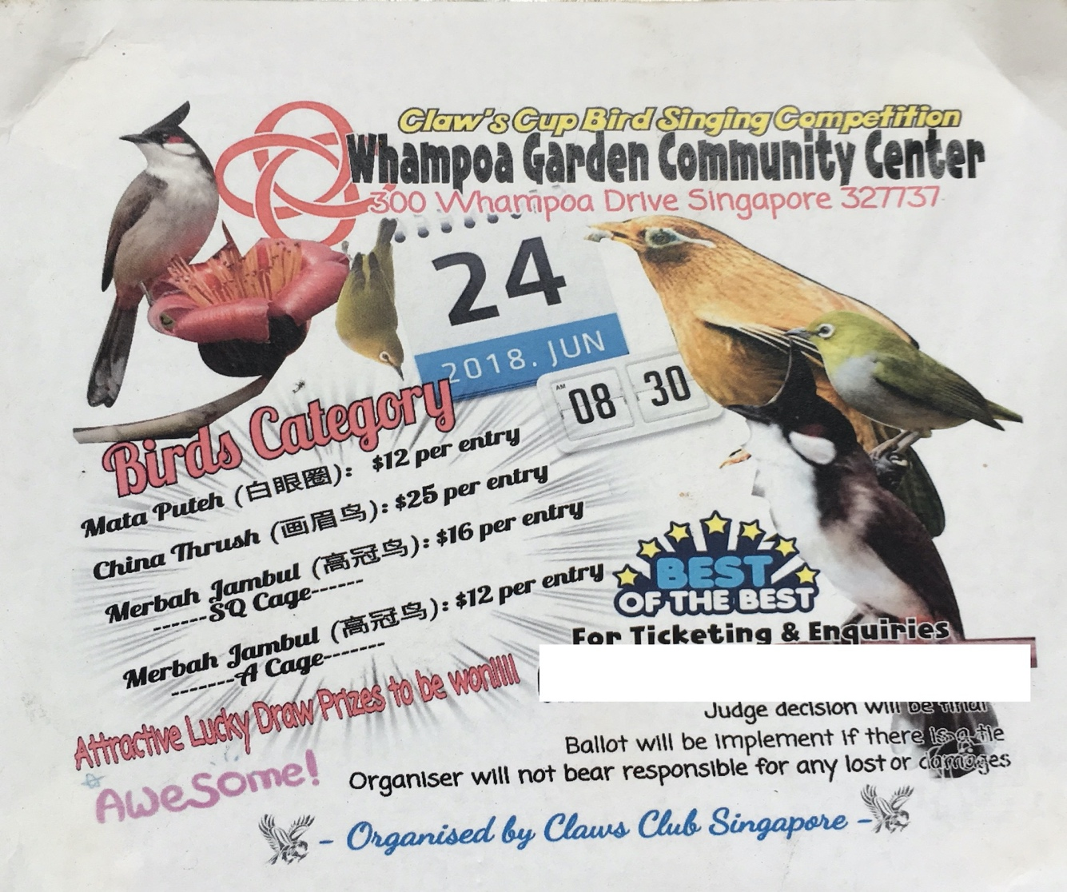
Figure S1. Examples of flyers for bird singing competitions in Singapore.
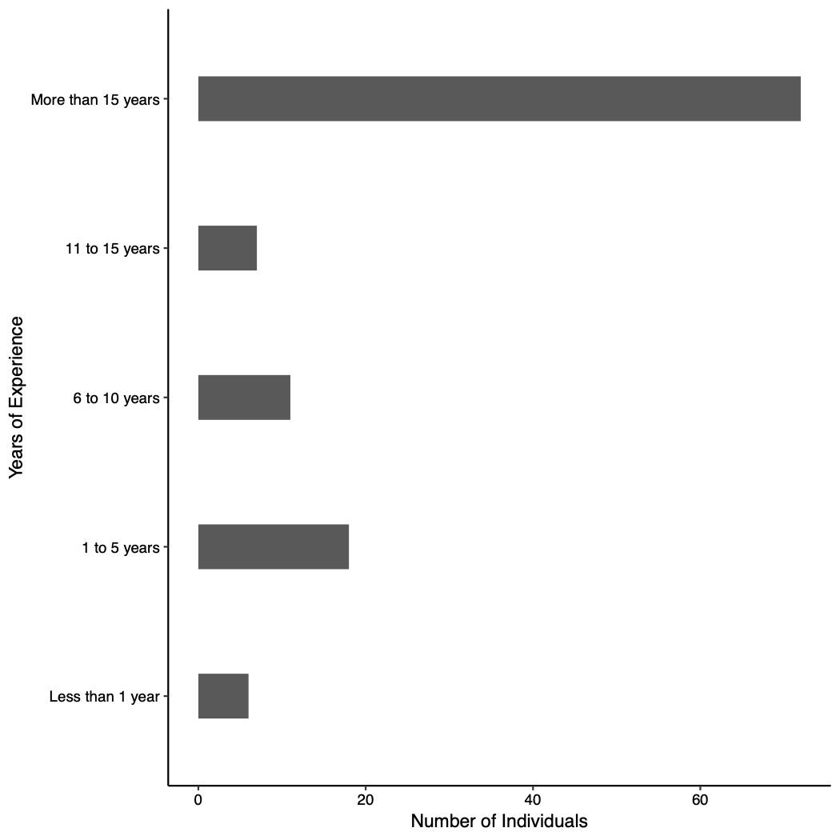
Figure S2. Levels of bird-keeping experience of respondents (n = 114).

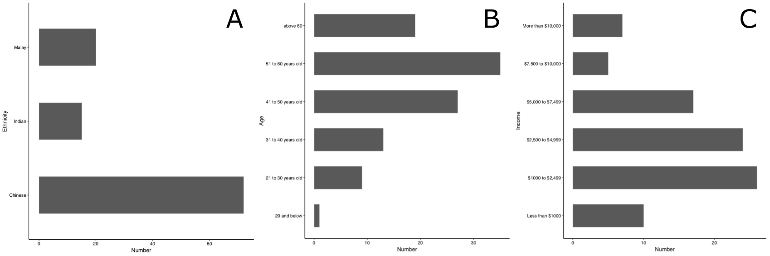
Figure S3. Demographics of respondents showing (a) ethnicity (n = 107), (b) age (n = 104) and (c) income (n = 89).

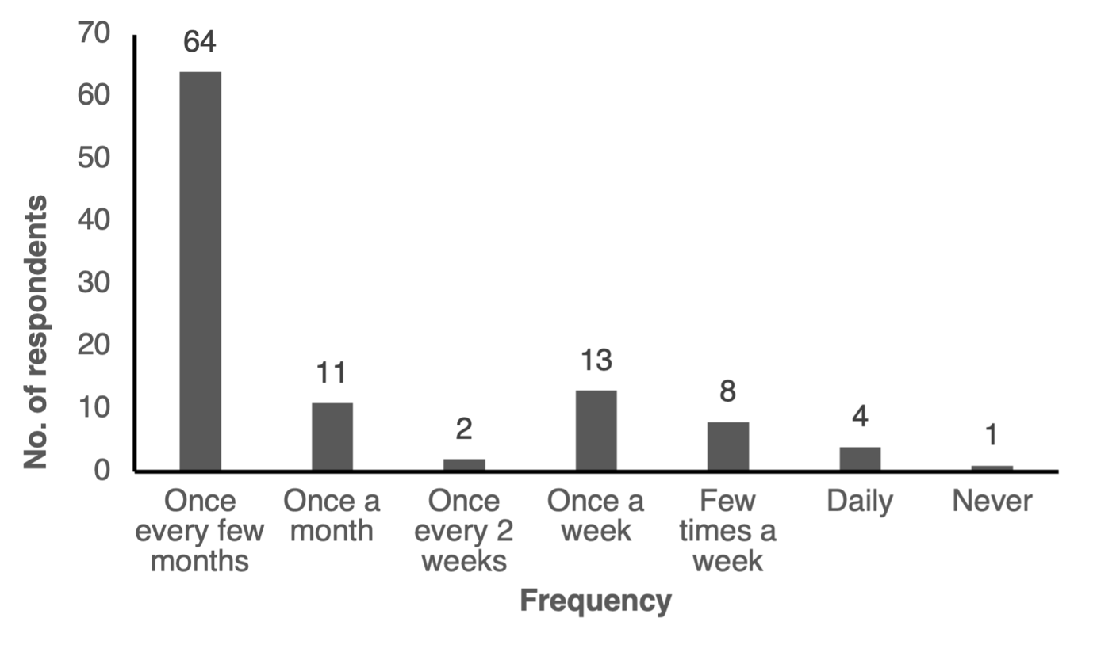
Figure S4. Frequency of visit to natural spaces or nature reserves (n = 103).
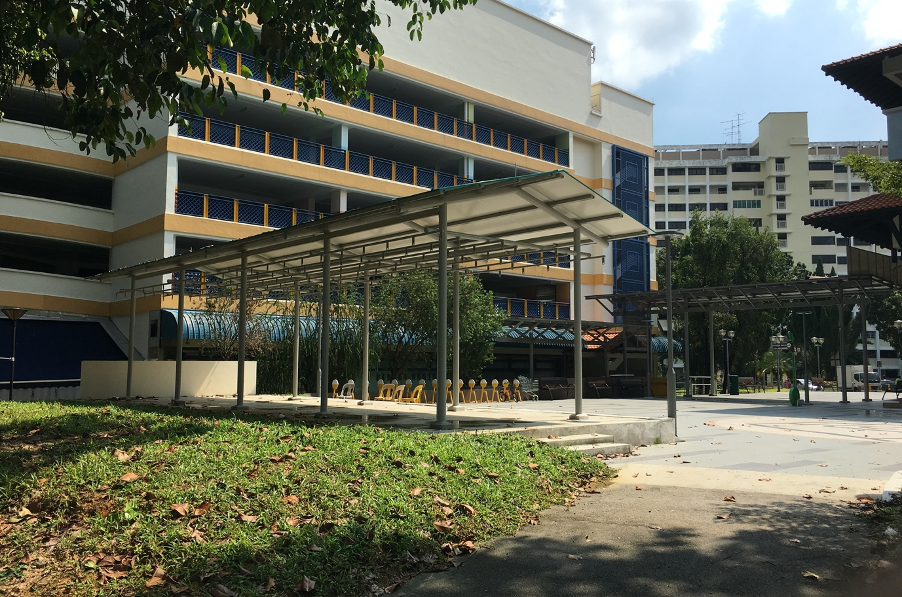
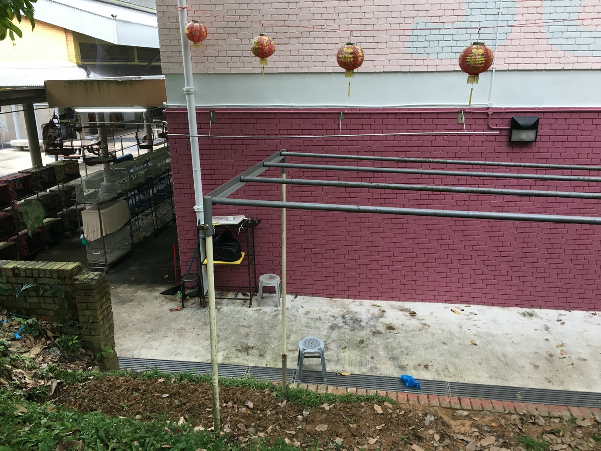
Figure S5. Pictures depicting examples of a typical standalone bird hanging spot/gathering site (top), and a pet bird shop with cage-hanging structures erected (bottom) around a public housing estate.
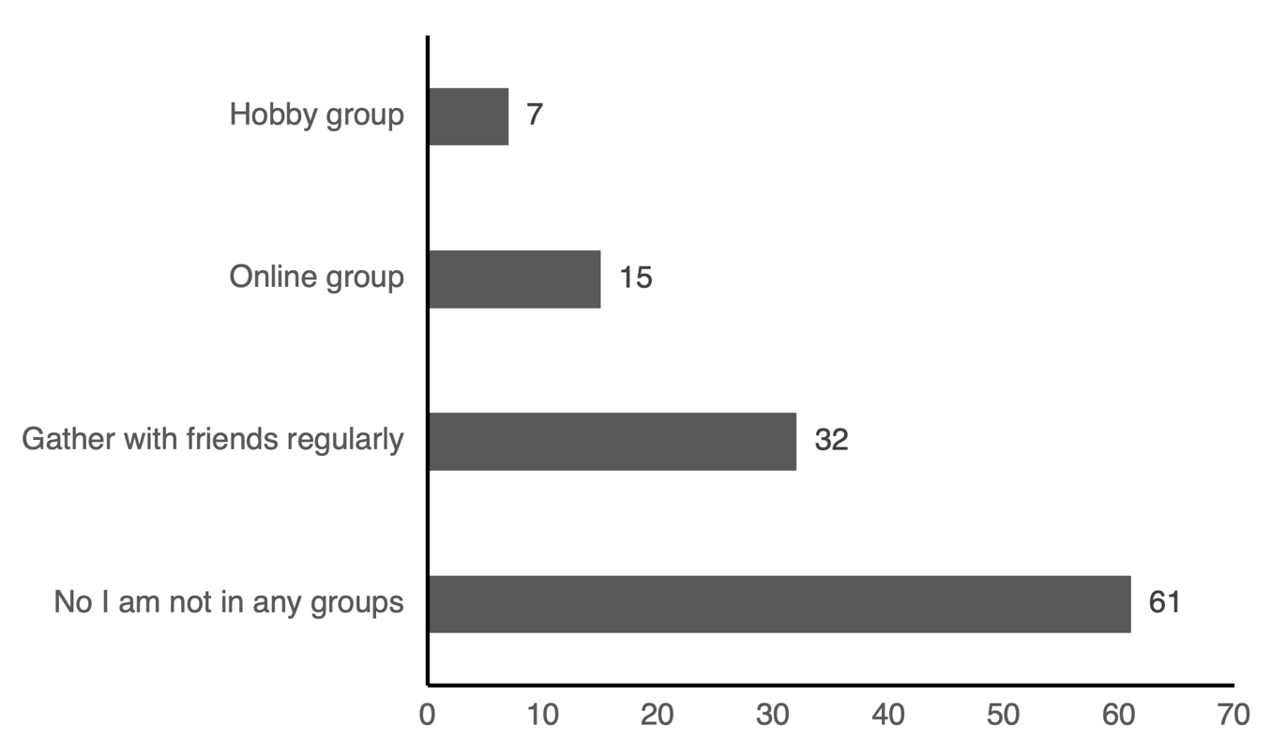
Figure S6. Respondents’ memberships in hobbyist groups (n = 114).
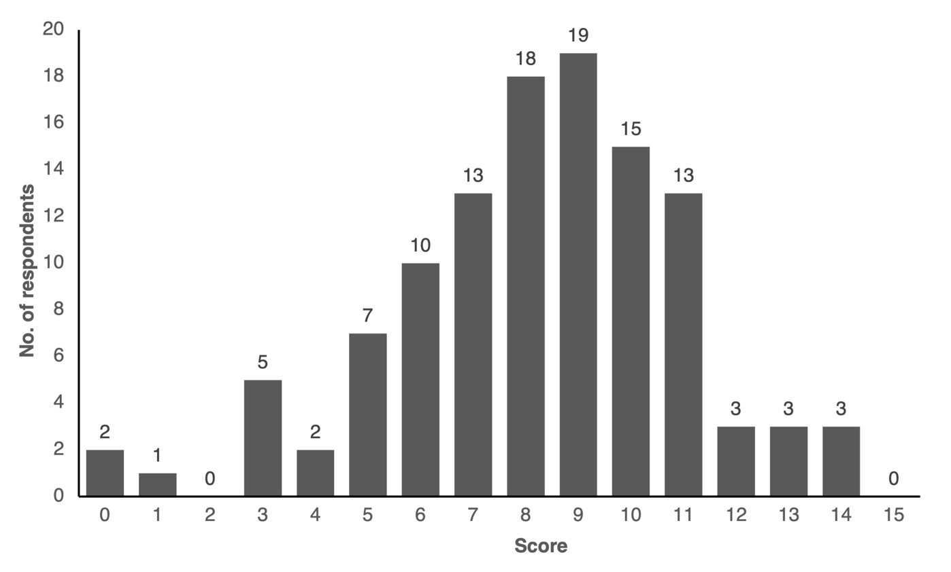
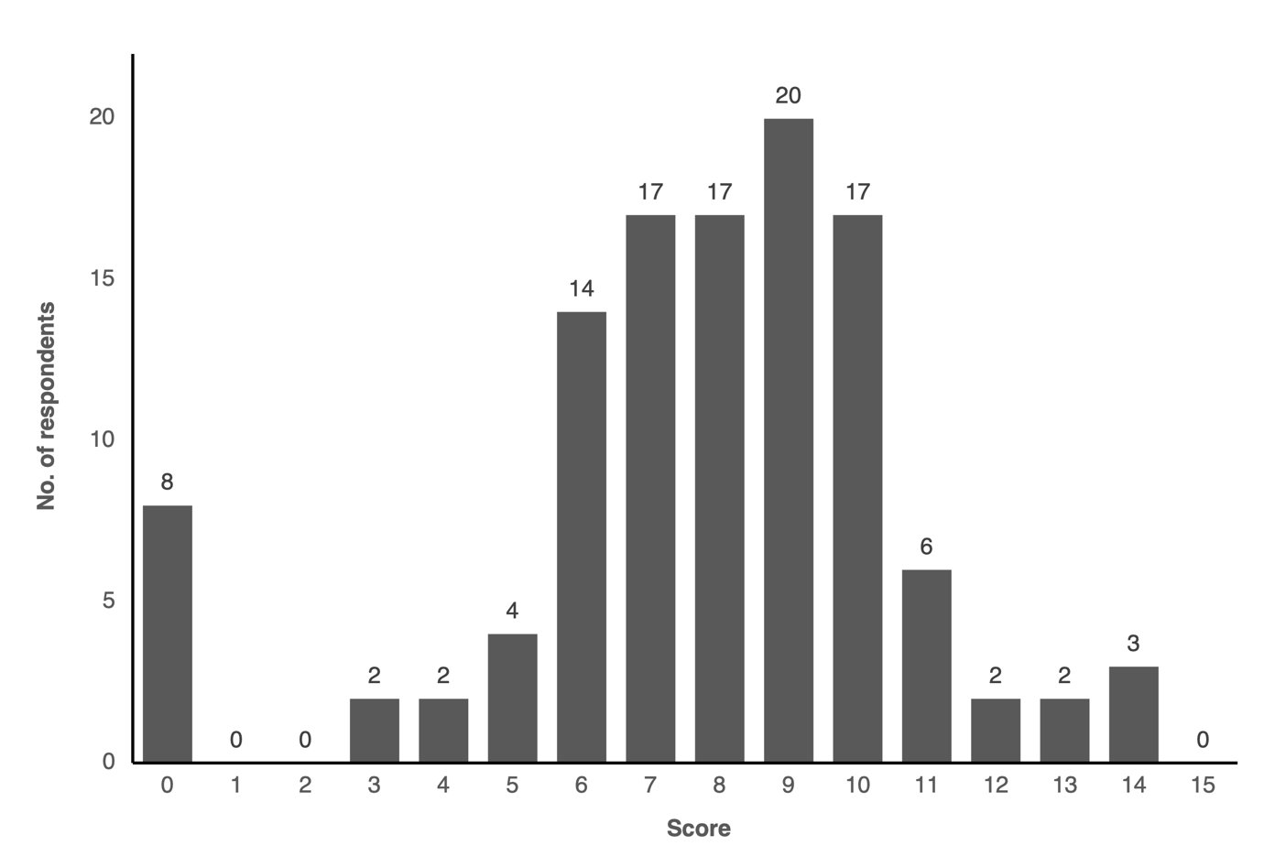
Figure S7. Scores of respondents when presented with questions regarding their knowledge about nature (n = 114). The first question asked respondents about their general knowledge of nature in Singapore (top). The second question asked respondents to identify native species in Singapore (bottom). No negative marking scheme was implemented.
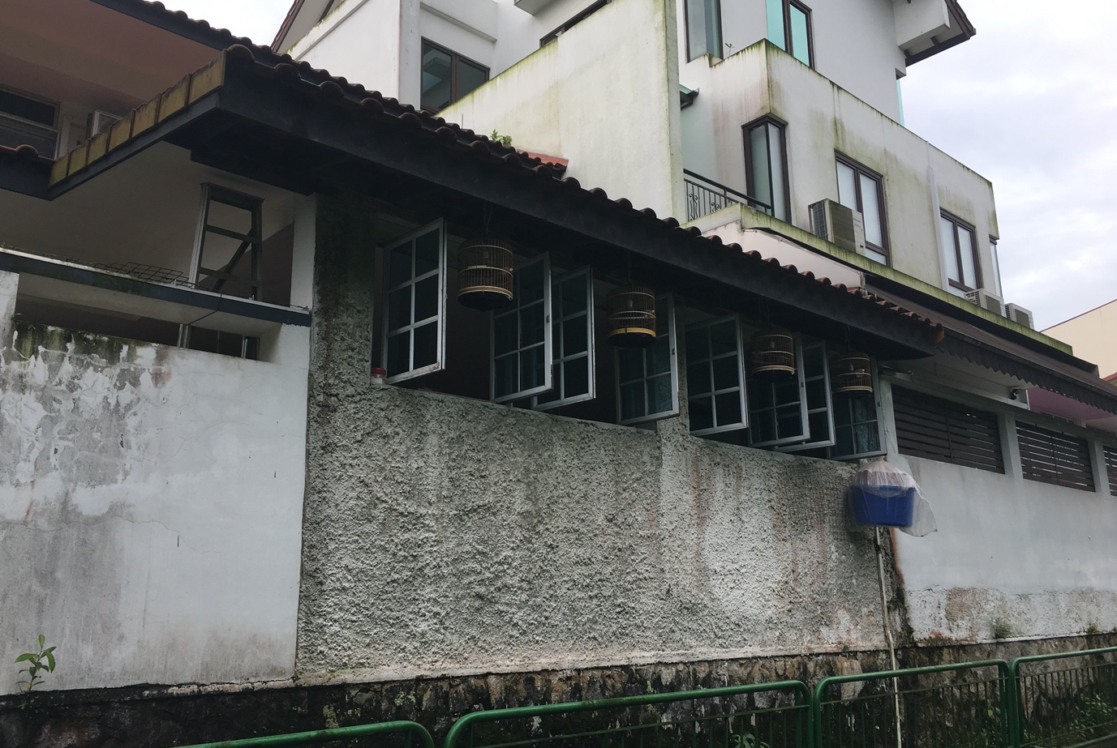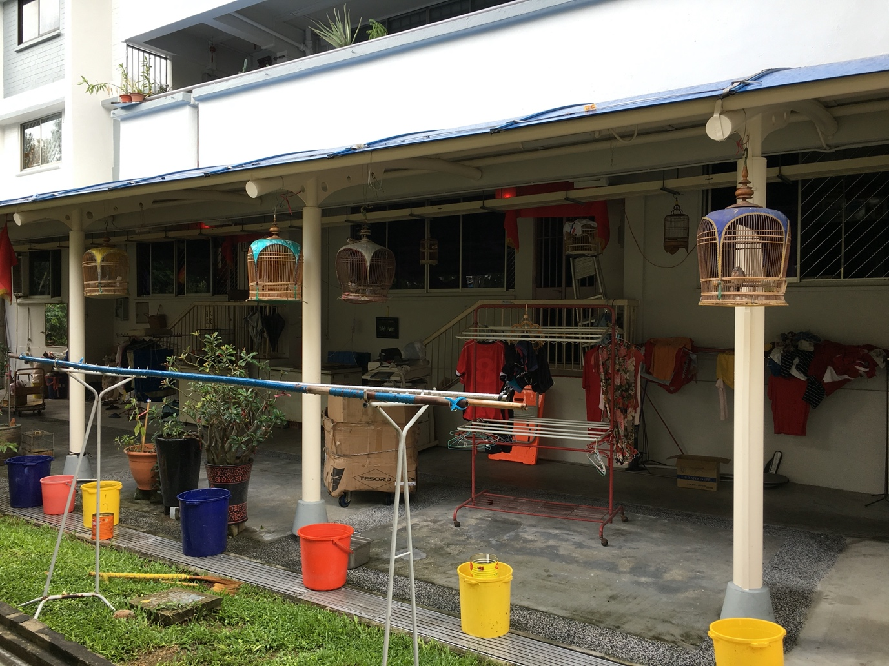
Figure S8. Pictures depicting how Singaporean bird owners display and/or keep their birds at their private residences (top) and public housing estates (bottom).
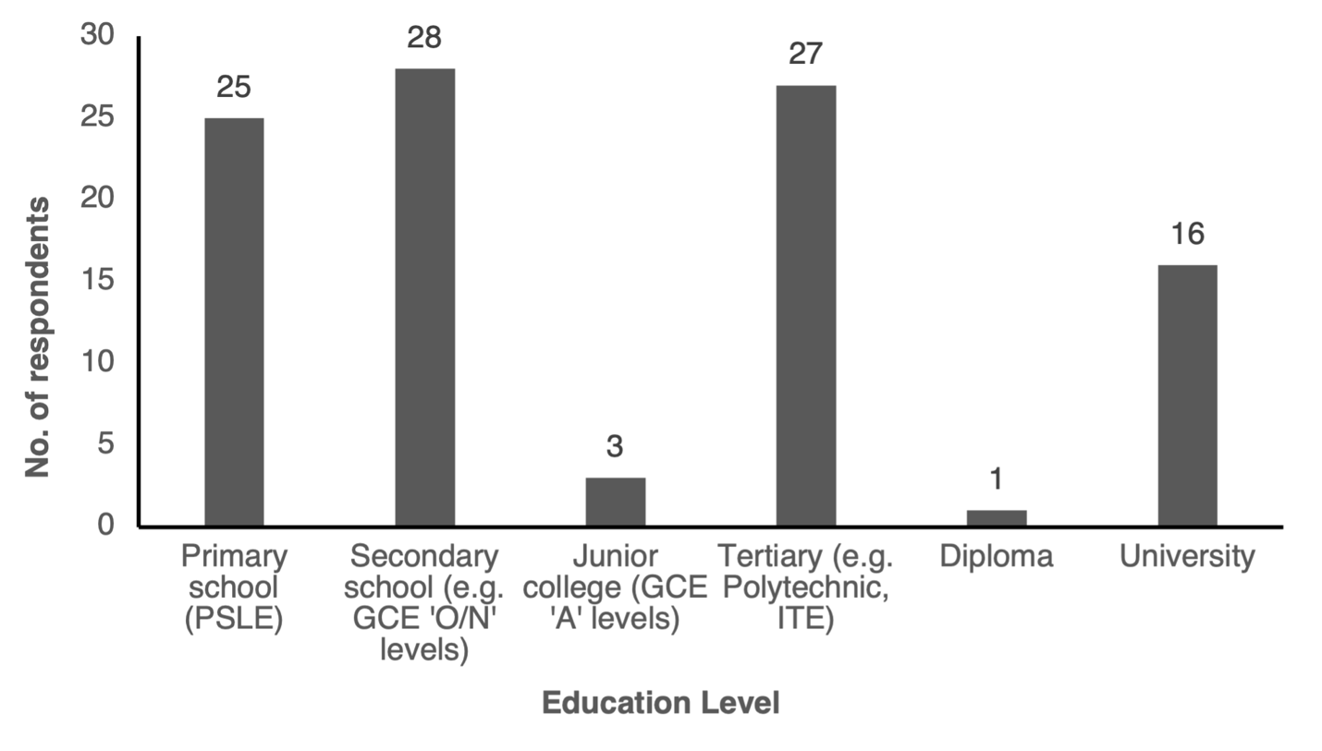
Figure S9. Educational levels of respondents (n = 100).
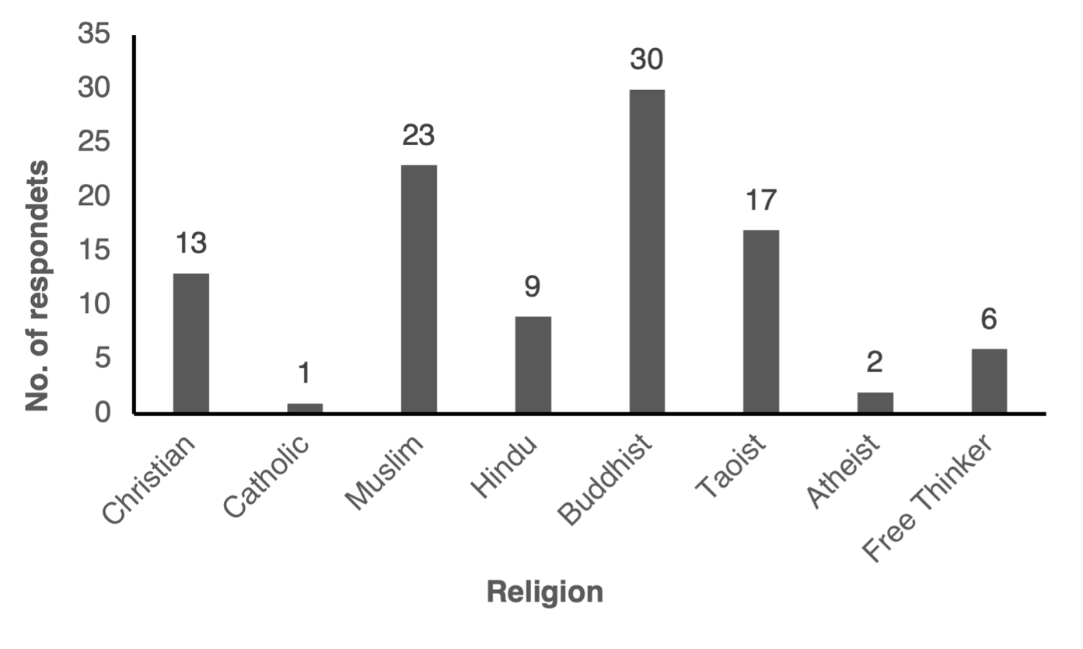
Figure S10. Religion types reported by respondents (n = 101).
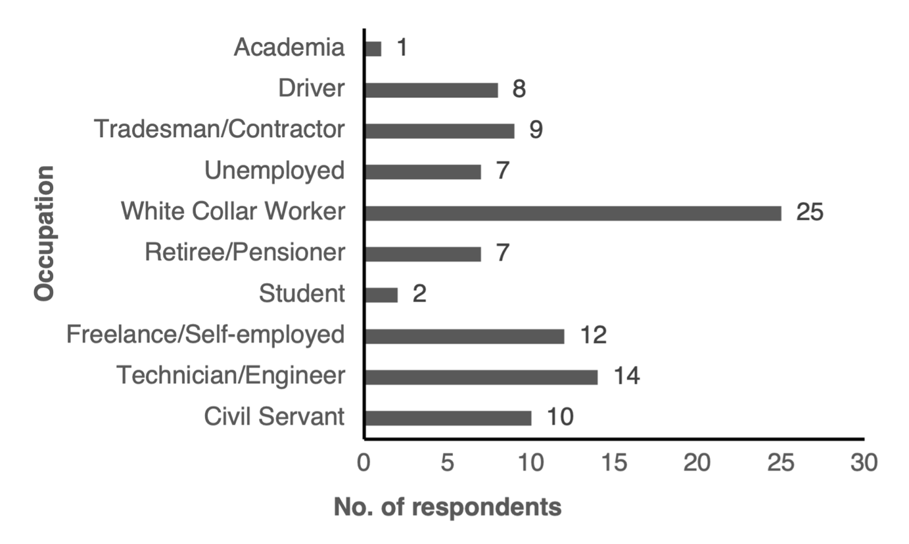
Figure S11. Occupations of respondents (n = 95).
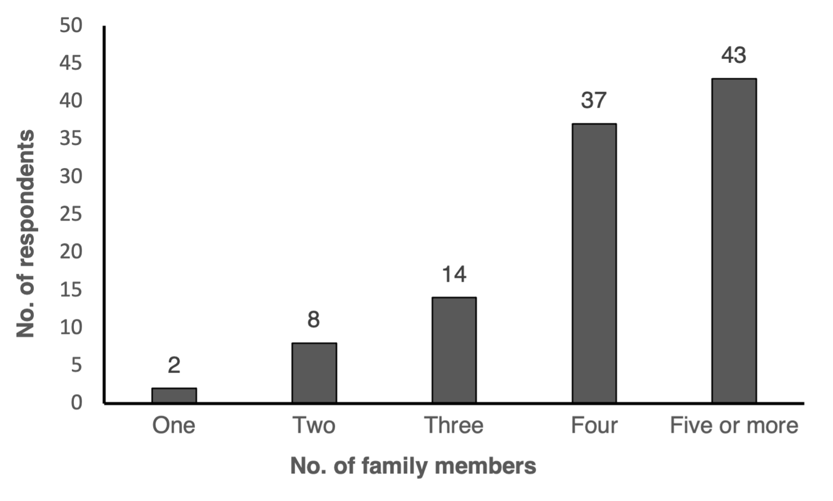
Figure S12. Number of family members at home (n = 104).
Appendixc S1. Survey template.
Songbird Questionnaire

We are researchers currently studying the consumer demand of songbirds in Singapore.
The purpose of this study is to examine:
(i) the factors that motivate people to keep songbirds in Singapore and the
(ii) perceptions and knowledge of owners on how the trade affects the conservation of songbirds.
This survey should not take up more than 20 minutes of your time, and your anonymity is assured. For any questions you can email: songbirdsofsg@gmail.com

Explanation of terms used:
Songbirds—birds with song-singing capabilities. Some examples are: White-rumped Shama, Red-whiskered Bulbul (Jambul) & Oriental White-eye (Mata Puteh)
Conservation—refers to the saving/preservation of animals that are threatened, to prevent them from going extinct.
Wild-caught—refers to birds that are caught from the wild.
Captive-bred—refers to birds that are bred by humans in captivity.

I hereby acknowledge my participation in this questionnaire and give my consent for my answers to be used for research purposes.

The respondents would be kept anonymous and data collected would be used solely for research purposes.

Section I: Reasons for keeping songbirds
1. Are you keeping songbirds now or have you done so in the past?
o Currently keeping songbirds
o Kept songbird(s) before, in the last 5 years
o Kept songbird(s) before, more than 5 years ago
o Others (please specify):

2. How many years (in total) have you been keeping songbird(s)?
o Less than 1 year
o 1–5 years
o 6–10 years
o 11–15 years
o More than 15 years

3. What are the species of songbirds that you own (or once owned)? Please list the species and quantity. (Pictures would be included)
Songbird | Qty | Songbird | Qty
Oriental White-eye (Mata Puteh) |  | Javan Myna
Red-whiskered Bulbul (Jambul) |  | Straw-headed Bulbul
Common Hill Myna (Burung Beo) |  | White-crested Laughingthrush
Oriental Magpie Robin (Opek) |  | Chinese Hwamei
Common Myna |  | Black-naped Oriole

If the songbird you own is not found above you can list them here:
Songbird | Quantity

4. How were you introduced to keeping songbird(s)? You can select more than one option.
Influenced by family members/relatives/friends
Inherited from parents/family/friends
Observed songbird competitions/events/hobby groups
Visited bird shops
Social media (Facebook, YouTube, Twitter, Instagram)/songbird forums online
Others (please specify):

5. Please select the top 3 factors that motivate you to keep songbird(s) as pets. You may add other factors if they are not listed below.
Companionship
Influence from family/friends/relatives
Influence from social media or other online mediums
General interest in keeping pets
Interest in nature
The melodious songs produced by the bird
The physical appearance of the bird (e.g. plumage colour)
Status symbol
Religion/beliefs (e.g. the bird brings wealth to its owner)
Rarity/Exotic
Trend/popularity (e.g. my friends own the same bird)
Others (please specify):

6. Would you prefer a wild-caught or captive-bred songbird?
o Wild-caught
o Captive-bred
o Does not matter to me

7. To me, a ____ songbird would have better song-singing skills.
o Wild-caught
o Captive-bred
o I don’t know/not sure
o Same/no difference

8. Are you part of a songbird hobbyist group?
o No, I am not in any groups
o I am in an informal hobby group (e.g. a group that has a name) which has regular meetings
o I regularly gather with a group of friends that own songbirds
o I am in a formal hobby/club that has official membership (e.g. groups that host competitions)
o I am in a Facebook group/online forum for specific songbirds (e.g. Shama Club SG Forum)

9. Do you take part in songbird competitions?
o No
o Yes

9a. Do you breed songbirds?
o Yes
o No

The following questions would talk about sustainably-sourced birds.
‘Sustainable’ — in this context refers to songbirds that are legally obtained and captive-bred in accordance to rules and regulations. The laws also regulate trade (where permitted) at sustainable levels, to ensure that the species is protected from over-hunting.
‘Unsustainable’ — trade refers to the over-hunting of animals (most of the time illegal), which is one of the main causes of extinction. Unsustainable hunting levels lead to the decline of songbird populations as the rate of trapping exceeds the rate of natural reproduction.

10. What information would be helpful to aid in your decision when buying songbird(s)? You can select more than one option.
Conservation status of the songbird
An indication that the songbird is sustainably sourced
Information regarding husbandry (how to care) of the songbird
Certified bird shops that sell sustainably (and legally) sourced birds
Others (please specify):

11. What are the sources that you usually check out/browse your songbirds from? (You can select more than one option)
Source/Seller | Buy | Browse
Online markets (Facebook groups, forums, Gumtree etc.)
Pet bird shops
From commercial breeders
From friends or through recommendations from them
Others (please specify):

12. How often do you buy a new songbird? (E.g. sell your current songbird and buy a new one OR buy an additional songbird)
o Every 2 weeks or shorter
o Every month
o Every 6 months
o Yearly
o Depends on the status of the bird (can sing well or not)
o I keep the bird until it passes away or becomes sick
o Others (please specify):

Section II: General knowledge about nature and wildlife
13. Please answer the following questions by choosing from one of the three options provided:
 | True | False | Don’t know
Sambar Deers can be found in Singapore
Animals like leopards and otters are not mammals
Many flowering plants rely on birds and bats to pollinate them
Hummingbirds are found in Singapore
Singapore has coral reefs
Most mammals lay eggs
Singapore has more than one species of monkey
Some turtles can live longer than humans
Apart from Africa, rhinos can be found in Indonesia as well
Singapore has Slow Lorises
Unlogged primary (tropical) forests still exist in Singapore
Some bats use sonar to find their way around in the dark
Sungei Buloh is the only place in Singapore that has a mangrove forest
ALL forested areas, parks and nature reserves are under National Parks Board (NParks)
Caterpillars undergo a transformation in their cocoons and then emerge as butterflies

14. Below are a list of animals that can be found in Singapore. To the best of your knowledge, please indicate if they are native/non-native to Singapore.
‘Native’ refers to species which naturally occur in Singapore.
‘Non-native’ species are those that are introduced to the island via trade or immigration from nearby land masses.

Animal Found in Singapore | Native | Non-native | Don’t know
Yellow-vented Bulbul
Oriental White-eye (Mata Puteh)
Changeable Lizard
Straw-headed Bulbul (Barau Barau)
Raffles’ Banded Langur
Oriental Magpie-robin (Opek)
Chinese Hwamei
Red-eared Terrapin
White-rumped Shama
Common Hill Myna (Burung Beo)
Sunda Pangolin
Wild Boar
Red-whiskered Bulbul (Jambul)
Green-crested Lizard
White-crested Laughingthrush

Section III: Personal particulars
This section is optional. You can choose not to answer certain questions that you are not comfortable with.

15. Gender
o Male
o Female
o Prefer not to answer

16. Ethnicity
o Chinese
o Malay
o Indian
o Eurasian
o Others:

17. Religion
o Christian
o Muslim
o Hindu
o Buddhist
o Taoist
o Others:

18. Education Level
o Primary school (PSLE)
o Secondary school (GCE ‘O/N’ levels)
o Junior college (GCE ‘A’ levels)
o Tertiary (Polytechnic, ITE)
o University
o Others:

19. How often do you visit parks/nature reserves?
o Once every few months
o Once a month
o Once every 2 weeks
o Once a week
o Few times a week
o Daily

20. Occupation
o Business/Executive
o Professional/Managerial
o Technician/Engineer
o Civil servant
o Army
o Retiree
o Freelance/Self-employed
o Housewife/Househusband
o Student
o Unemployed
o Volunteer work/social service
o Prefer not to answer
o Others:

21. Monthly income
o Less than S$1,000
o S$1,000–S$2,499
o S$2,500–S$4,999
o S$5,000–S$7,499
o S$7,500–S$10,000
o More than S$10,000

22. Age
o 0–20
o 21–30
o 31–40
o 41–50
o 51–60
o above 60

23. Number of people in your family
o 1
o 2
o 3
o 4
o 5 or more

Thank you very much for taking the time to do the survey.

