Supplementary Material

Raptor migration at Guantouling, south-west China: phenology, weather influence and persecution pressure

XU SHI, XIAOBO XIAO, XINYI ZHAO, RENJIE SUN, XINGFENG ZHAO, CHI-YEUNG CHOI, WUYING LIN

Contents
Table S1. Raptor species recorded at Guantouling forest park from 2015 to 2019.
Figure S1. The distribution of wind speed (in scale) during the study period.

Table S1. Raptor species recorded at Guantouling forest park from 2015 to 2019, showing the annual sum, total, proportion, mean and coefficient of variation (CV, for species with means more than 50 per year) of each species. Species marked with asterisk are locally common. Accipiter sp stands for Japanese Sparrowhawk, Besra, Shikra and unidentified accipiters.

Species | 2015 | 2016 | 2017 | 2018 | 2019 | Total | % of Total | Mean | CV (%)
Grey-faced Buzzard Butastur indicus | 1835 | 3452 | 2944 | 3757 | 3937 | 15925 | 37.1 | 3185.0 | 26.5
Crested Honey Buzzard Pernis ptilorhynchus | 1841 | 1702 | 1646 | 1217 | 2231 | 8637 | 20.1 | 1727.4 | 21.2
Amur Falcon Falco amurensis | 2449 | 1240 | 646 | 2240 | 2041 | 8616 | 20.1 | 1723.2 | 43.9
Accipiter sp. | 700 | 515 | 1085 | 369 | 763 | 3432 | 8.0 | 686.4 | 39.6
Eurasian Hobby Falco subbuteo | 182 | 356 | 208 | 170 | 206 | 1122 | 2.6 | 224.4 | 33.6
Eastern Buzzard Buteo japonicus﹡ | 120 | 79 | 237 | 234 | 325 | 995 | 2.3 | 199.0 | 49.7
Black Baza Aviceda leuphotes | 140 | 240 | 125 | 34 | 175 | 714 | 1.7 | 142.8 | 52.7
Pied Harrier Circus melanoleucos | 121 | 37 | 158 | 76 | 147 | 539 | 1.3 | 107.8 | 47.0
Eurasian Kestrel Falco tinnunculus﹡ | 49 | 86 | 76 | 104 | 145 | 460 | 1.1 | 92.0 | 38.8
Crested Serpent Eagle Spilornis cheela | 88 | 76 | 80 | 26 | 105 | 375 | 0.9 | 75.0 | 39.4
Black-eared Kite Milvus migrans | 35 | 36 | 153 | 38 | 102 | 364 | 0.8 | 72.8 | 72.9
Jerdon's Baza Aviceda jerdoni | 56 | 42 | 108 | 76 | 75 | 357 | 0.8 | 71.4 | 34.8
Eastern Marsh Harrier Circus spilonotus | 30 | 74 | 37 | 87 | 38 | 266 | 0.6 | 53.2 | 48.0
Chinese Sparrowhawk Accipiter soloensis | 80 | 20 | 80 | 11 | 27 | 218 | 0.5 | 43.6 | -
Falco sp. | 0 | 68 | 53 | 43 | 25 | 189 | 0.4 | 37.8 | -
Peregrine Falcon Falco peregrinus | 8 | 15 | 12 | 32 | 60 | 127 | 0.3 | 25.4 | -
Crested Goshawk Accipiter trivirgatus﹡ | 36 | 20 | 57 | 9 | 4 | 126 | 0.3 | 25.2 | -
Unidentified Raptor | 0 | 2 | 9 | 86 | 8 | 105 | 0.2 | 21.0 | -
Eurasian Sparrowhawk Accipiter nisus | 18 | 29 | 23 | 7 | 19 | 96 | 0.2 | 19.2 | -
Black-winged Kite Elanus caeruleus﹡ | 3 | 1 | 2 | 15 | 50 | 71 | 0.2 | 14.2 | -
Osprey Pandion haliaetus | 17 | 14 | 2 | 7 | 11 | 51 | 0.1 | 10.2 | -
Greater Spotted Eagle Clanga clanga | 4 | 5 | 7 | 10 | 6 | 32 | 0.1 | 6.4 | -
Circus sp. | 1 | 17 | 8 | 2 | 0 | 28 | 0.1 | 5.6 | -
Northern Goshawk Accipiter gentilis | 1 | 0 | 6 | 4 | 5 | 16 | 0.0 | 3.2 | -
Booted Eagle Hieraaetus pennatus | 2 | 0 | 5 | 2 | 1 | 10 | 0.0 | 2.0 | -
Imperial Eagle Aquila Heliaca | 2 | 1 | 1 | 1 | 1 | 6 | 0.0 | 1.2 | -
Hen Harrier Circus cyaneus | 0 | 0 | 1 | 0 | 3 | 4 | 0.0 | 0.8 | -
Unidentified Eagle | 0 | 2 | 0 | 0 | 1 | 3 | 0.0 | 0.6 | -
Short-toed Snake Eagle Circaetus gallicus | 1 | 0 | 1 | 0 | 0 | 2 | 0.0 | 0.4 | -
White-bellied Sea Eagle Haliaeetus leucogaster | 1 | 1 | 0 | 0 | 0 | 2 | 0.0 | 0.4 | -
Brahminy Kite Haliastur indus | 0 | 0 | 0 | 1 | 1 | 2 | 0.0 | 0.4 | -
Mountain Hawk Eagle Nisaetus nipalensis | 1 | 0 | 0 | 0 | 0 | 1 | 0.0 | 0.2 | -
Total | 7822 | 8131 | 7770 | 8658 | 10512 | 42891 | 100 | 8579 | -

.

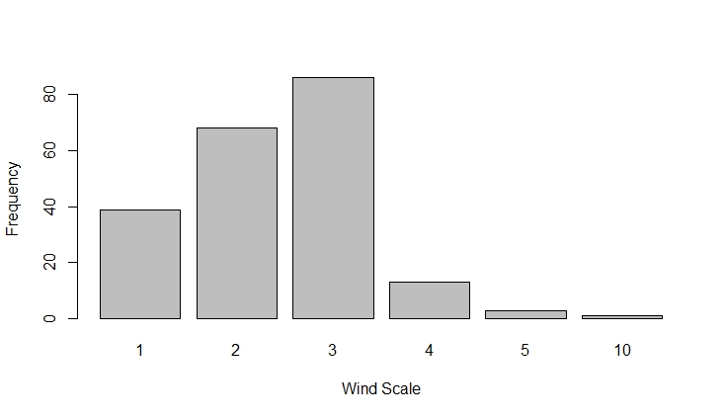

Figure S1. The distribution of wind speed (in scale) during the study period.

