Supplementary Material

Status and habitat description of the globally threatened Udzungwa Forest Partridge Xenoperdix udzungwensis thirty years after discovery

LARS DINESEN, FLEMMING PAGH JENSEN, JESPER SONNE, IRINA LEVINSKY and ELIA MULUNGU

Contents
Figure S1. Map showing the partitioning of surveyed areas used to estimate the partridge’s population density.
Figure S2. A) Barplot showing the average number of observations across different time intervals.
Appendix S1. Detailed overview of revised density estimates.
Table S1. Model summaries for the 13 Minimum adequate model (MAM) presented in Table 1.

Figure S1. Map showing the partitioning of surveyed areas used to estimate the partridge’s population density. Dark blue points are located inside the National park boundary (Average density: 10.19 males per km² ±3.99 standard error [SE]). The cluster of Light blue points is located at a lower elevation (Average density: 11.50 males per km² ±2.30 SE). The red points fall outside the National park boundary (Average density: 14.57 males per km² ±2.81 SE). The Yellow points represent the forest part in north-western Ndundulu from which the partridge may have disappeared. The background contours show the altitudinal variation. See also Fig. 2 in the text.

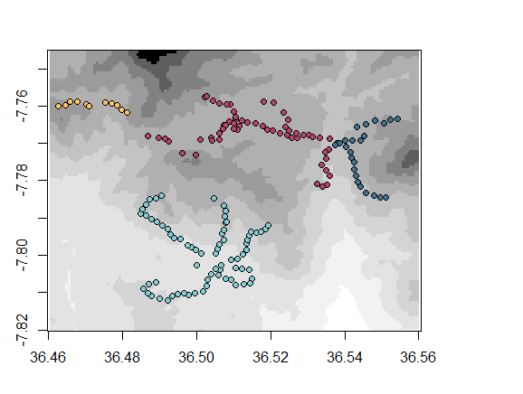

Figure S2. A) Barplot showing the average number of observations across different time intervals. Line Segments mark the standard errors. Few birds were recorded before 08:00, and no Birds were recorded after 15:00, which could result from low sampling effort (B) or reduced bird activity. Hence, we repeated the population density estimates after excluding survey points initiated before 08:00 and after 15:00. Then, the Average male density becomes 12.90 individuals per km² ±1.70 SE:

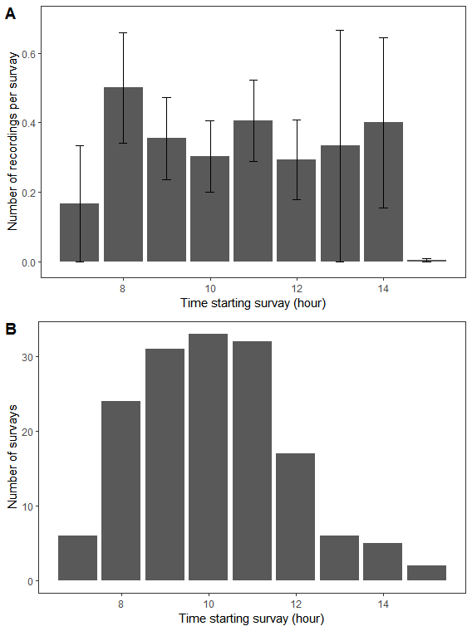

Appendix S1. Detailed overview of revised density estimates after excluding survey points that were initiated before 08:00 and after 15:00.
For the survey cluster located Inside the national park (dark blue points in Fig. S1; Average density: 11.59 males per km2 ±4.46 SE)
For the survey cluster located at a low elevation (light blue points in Fig. S1; Average density: 11.70 males per km2 ±2.39 SE)
For the Northern survey cluster located outside the national park (light blue points in Fig. S1; Average density: 14.81 males per km2 ±2.85 SE)

Table S1. Model summaries for the 13 Minimum adequate model (MAM) presented in Table 1. The first nine columns show standardized coefficients of variables in each model, sorted according to AICc. Df show the degrees of freedom in each model. We include two measures of model fit: The residual deviance compares the loglikelihood of a satuated model (i.e number of estimated parameters equal to the number of observations) to the proposed model. The McFadden (1979) R² is a pseudo-approximation of the linear model’s R². The statistic ranges between zero and one with higher values indicating greater likelihood.
Alltitude | Canopy height | Canopy cover | Grass cover | leaf Litter | Malakati cover | Sedge cover | Shrub cover | Distance to Village | Df | AICc | Residual deviance | McFadden R²
 |  | -0.39 |  | 0.75 |  | 0.31 |  |  | 4 | 198 | 194.67 | 0.03
 |  | -0.4 |  | 0.66 |  | 0.33 |  | 0.28 | 5 | 198 | 192.95 | 0.04
 | 0.31 | -0.45 |  |  |  | 0.35 |  | 0.37 | 5 | 199 | 194.16 | 0.03
 |  | -0.37 | 0.21 | 0.86 |  | 0.34 |  |  | 5 | 199 | 192.95 | 0.04
 |  | -0.36 |  | 0.82 |  |  |  |  | 3 | 199 | 197.15 | 0.02
 |  | -0.38 | 0.21 | 0.76 |  | 0.37 |  | 0.29 | 6 | 199 | 191.17 | 0.05
 |  | -0.32 |  |  |  | 0.36 |  | 0.33 | 4 | 199 | 194.56 | 0.03
 | 0.2 | -0.47 |  | 0.51 |  | 0.33 |  | 0.32 | 6 | 199 | 192.95 | 0.04
 |  | -0.36 |  | 0.73 |  |  |  | 0.24 | 4 | 199 | 195.72 | 0.02
 |  | -0.37 |  | 0.73 |  | 0.34 | 0.14 |  | 5 | 199 | 193.56 | 0.03
 | 0.37 | -0.44 | 0.23 |  |  | 0.38 |  | 0.39 | 6 | 199 | 192.56 | 0.04
 | 0.13 | -0.44 |  | 0.65 |  | 0.3 |  |  | 5 | 200 | 194.65 | 0.03
 |  | -0.39 |  | 0.64 |  | 0.37 | 0.13 | 0.28 | 6 | 200 | 191.98 | 0.04
 |  | -0.29 |  |  |  | 0.34 |  |  | 3 | 200 | 197.07 | 0.02
 |  | -0.39 |  | 0.78 | -0.05 | 0.3 |  |  | 5 | 200 | 194.67 | 0.03
References
McFadden D (1979). Quantitative methods for analysing travel behavior of individuals: Some recent developments. In D. A. Hensher & P. R. Stopher (Eds.), Behavioural travel modelling (pp. 279-318). London: Croom Helm.

