Supplementary Material

Tree characteristics, microhabitat and edge effect in plantations govern Turtle Dove nest habitat selection at the edge of Sahara: implications for conservation of a vulnerable species

NASRINE SAÂD, SAÂD HANANE, KAMILIA FARHI, NACERDDINE MATALLAH, MOHAMED DHAYA EL HAK KHEMIS

Contents
Figure S1. Model diagnostics for TD occurrence using tree characteristics variables.
Figure S2. Model diagnostics for TD occurrence using microhabitat variables.
Figure S3. Model diagnostics for TD occurrence using human presence variables.
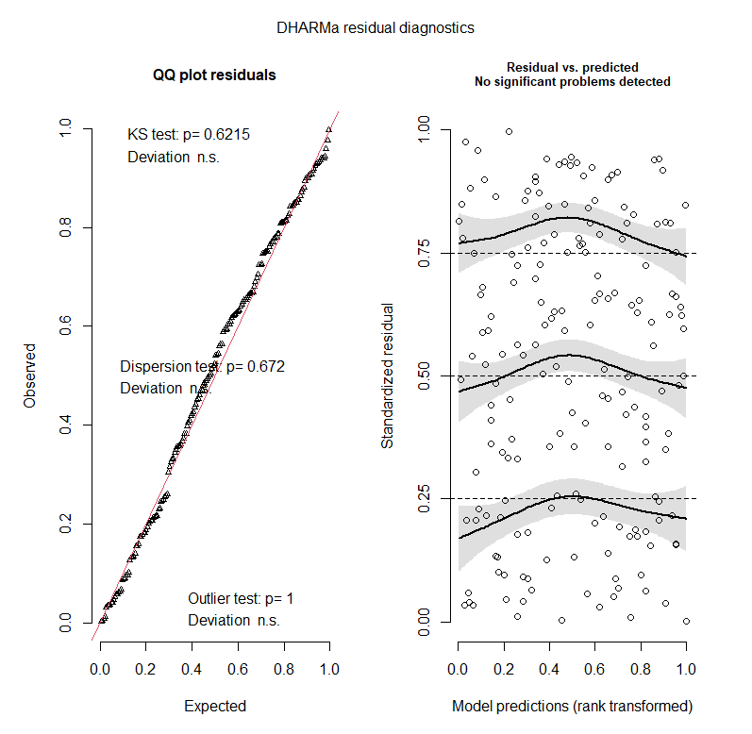
Figure S1. Model diagnostics for TD occurrence using tree characteristics variables. Left panel: Q-Q plot to detect overall deviations from expected distribution. Includes tests for uniformity, dispersion, and outliers. KS (Kolmogorov-Smirnov) test D > 0.05, P = 0.621; Dispersion test > 0.05, P = 0.672; outlier test: tests if there are more simulation outliers than expected, P = 1.0. Right panel: Residuals vs. predicted values.The plot of the residuals vs. model predictions assess the homogeneity of variances and identify outliers (no outliers were identified).

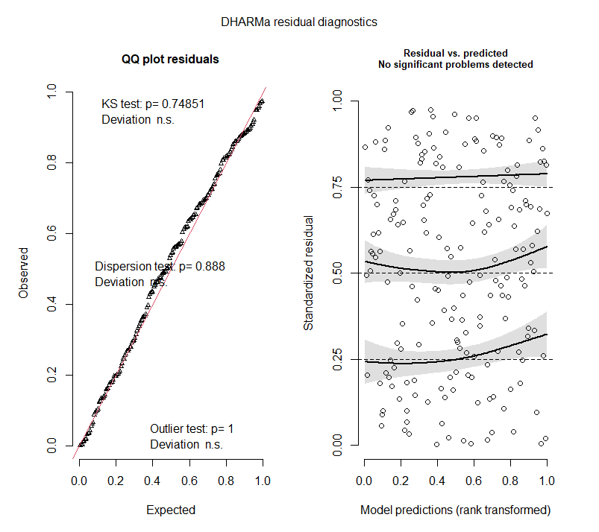

Figure S2. Model diagnostics for TD occurrence using microhabitat variables. Left panel: Q-Q plot to detect overall deviations from expected distribution. Includes tests for uniformity, dispersion, and outliers. KS (Kolmogorov-Smirnov) test D > 0.05, P = 0.749; Dispersion test > 0.05, P = 0.888; outlier test: tests if there are more simulation outliers than expected, P = 1.0. Right panel: Residuals vs. predicted values. The plot of the residuals vs. model predictions assess the homogeneity of variances and identify outliers (no outliers were identified).

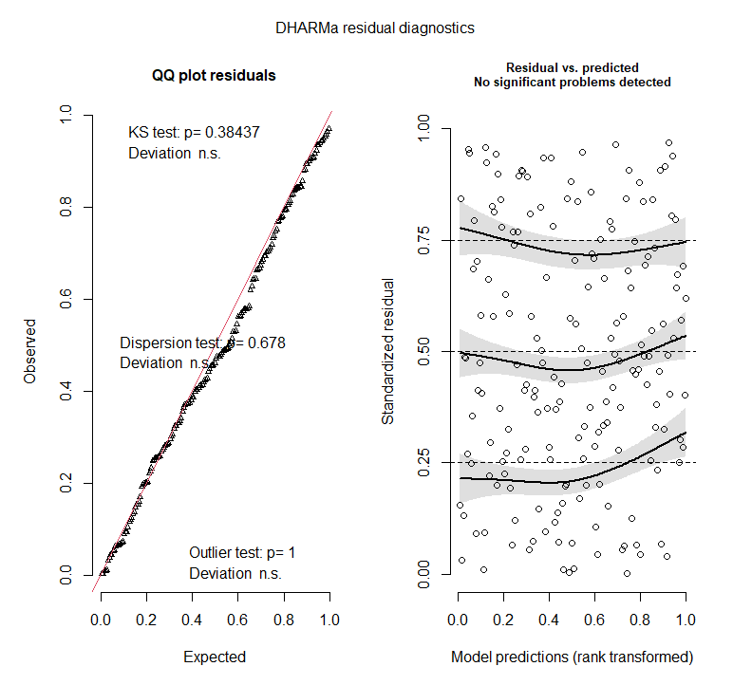
Figure S3. Model diagnostics for TD occurrence using human presence variables. Left panel: Q-Q plot to detect overall deviations from expected distribution. Includes tests for uniformity, dispersion, and outliers. KS (Kolmogorov-Smirnov) test D > 0.05, P = 0.384; Dispersion test > 0.05, P = 0.678; outlier test: tests if there are more simulation outliers than expected, P = 1.0. Right panel: Residuals vs. predicted values. The plot of the residuals vs. model predictions assess the homogeneity of variances and identify outliers (no outliers were identified).

