Supplementary Material

Integrating habitat suitability modelling and assessment of the conservation gaps of nature reserves for the threatened Reeves’s Pheasant

SHAN TIAN, SHUAI LU, JUNQIN HUA, JIANG CHANG, JIANQIANG LI, ZHENGWANG ZHANG, YONG WANG, JILIANG XU and MINGXIANG ZHANG

Contents

Figure S1. The individual model prediction maps which were performed during the modelling process.

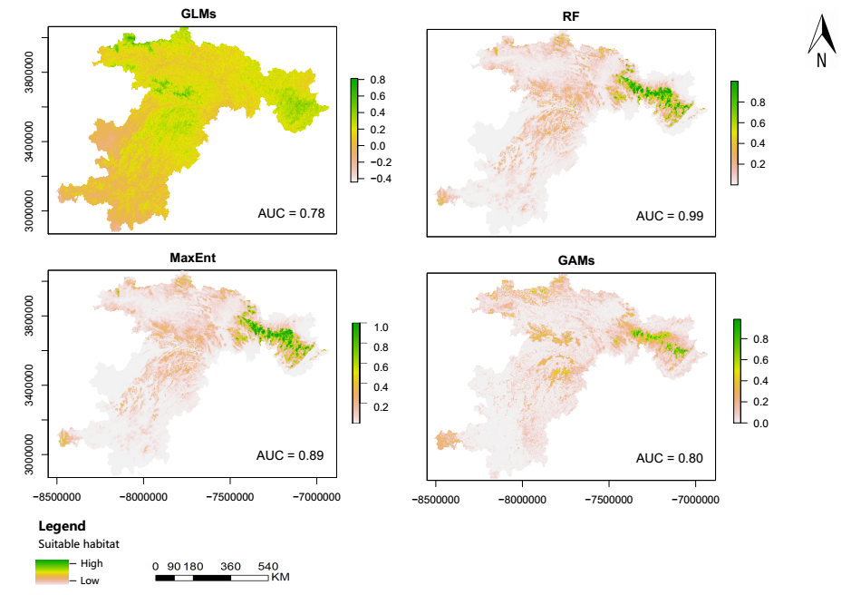
Figure S1. The individual model prediction maps which were performed during the modelling process.

