Supplementary Material

Estimating the conservation cost of the projected new international Lisbon airport for migratory shorebirds of the Tagus estuary, Portugal

TERESA CATRY, FRANCESCO VENTURA, MARIA P. DIAS, CARLOS D. SANTOS, RICARDO C. MARTINS, JORGE M. PALMEIRIM AND JOSÉ P. GRANADEIRO

Contents
Figure S1. Abundance and distribution of the 10 most common shorebird species in the intertidal area of the Tagus estuary during the winter period. Shorebird counts were conducted in 2002 and 2003 (see methods for more details on survey protocol and data analysis).
Appendix S1. Bird distribution rasters

Figure S1.
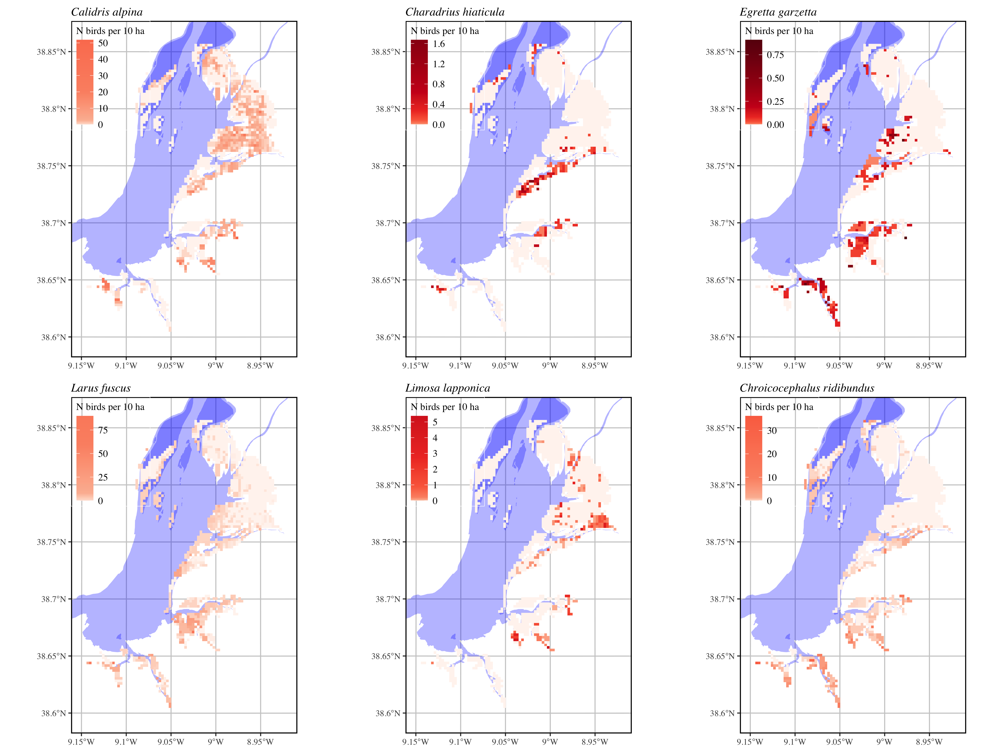

Figure S1 (cont.)

