Supplementary Material
Recent recovery and expansion of Guam’s locally endangered Såli (Micronesian Starling) Aplonis opaca population in the presence of the invasive brown tree snake
HENRY S. POLLOCK, MARTIN KASTNER, GARY J. WILES, HUGO THIERRY, LAURA BARNHART DUEÑAS, EBEN PAXTON, NICOLE M. SUCKOW, JEFF QUITUGUA and HALDRE S. ROGERS
Contents
Table S1. Summary of all opportunistic Såli sightings included in the study from eBird ™ (n = 25; eBird 2019) and the Guam Division of Aquatic and Wildlife Resources (DAWR; n = 39) databases.
Table S2. Counts of Såli from interior (n = 12) and peripheral (n = 16) search areas during weeks 1-3 of the population census on Andersen Air Force Base, Guam, U.S.A., including mean, standard error (SE), and p-values from Student’s t-tests comparing interior and peripheral search areas (boldface indicates significant differences; α = 0.05).
Figure S1. Exemplar plumages of the four different age classes.
Figure S2. Estimates of extrapolated richness (i.e. number of colour-banded individuals in the AAFB Såli population).
Figure S3. Såli pair nesting in a concrete power pole in Yigo, Guam, U.S.A, in 2018.
Figure S4. Raw counts of Såli for each of the 28 on-base search areas and four off-base search areas surveyed on Andersen Air Force Base, Guam
Table S1. Summary of all opportunistic Såli sightings included in the study from eBird ™ (n = 25; eBird 2019) and the Guam Division of Aquatic and Wildlife Resources (DAWR; n = 39) databases. Each entry includes the year(s) of the sighting, the observer, a descriptor of the location of the sighting, the number of Såli observed during the sighting, and the geographic coordinates (longitude and latitude, in UTM) of each sighting. Attached as Supplementary Table S1.xlsx”.

Table S2. Counts of Såli from interior (n = 12) and peripheral (n = 16) search areas during weeks 1-3 of the population census on Andersen Air Force Base, Guam, U.S.A., including mean, standard error (SE), and p-values from Student’s t-tests comparing interior and peripheral search areas (boldface indicates significant differences; α = 0.05).
Week | Interior (mean ± SE) | Peripheral (mean ± SE) | p-value
1 | 31.8 ± 5.0 | 14.3 ± 4.1 | 0.01
2 | 26.3 ± 4.3 | 15.8 ± 3.8 | 0.04
3 | 41.3 ± 7.5 | 21.3 ± 6.2 | 0.10

Figure S1. Exemplar plumages of the four different age classes. Individuals were categorized as ‘fledgling’ if they had dark streaky plumage on the breast, a visible yellow gape, dark eye and/or was being attended to by its parents, ‘juvenile’ if they had light streaky plumage on the breast, a fading gape, eye color was amber or lighter, and had dispersed from the natal territory (i.e. independent from its parents), ‘subadult’ if they exhibited a partial basic molt (Såli undergo a suspended molt where they begin to replace preformative plumage with basic plumage but often retain preformative plumage in certain feather tracts (i.e. breast feathers) for extended periods of time; Radley et al. 2011, H.S. Pollock, personal observations), and ‘adult’ if they were in basic plumage (‘definitive cycle basic’ – DCB sensu Johnson et al. 2009). Photos by Martin Kastner © 2019.
References:
Radley, P., Crary, A. L., Bradley, J., Carter, C., and Pyle, P. (2011) Molt patterns, biometrics, and age and gender classification of landbirds on Saipan, Northern Mariana Islands. The Wilson Journal of Ornithology 123: 588–594.

Wolfe, J. D., Chandler, R. B., and King, D. I. (2009) Molt patterns, age, and sex criteria for selected highland Costa Rican resident landbirds. Ornitologia Neotropical 20: 451–459.

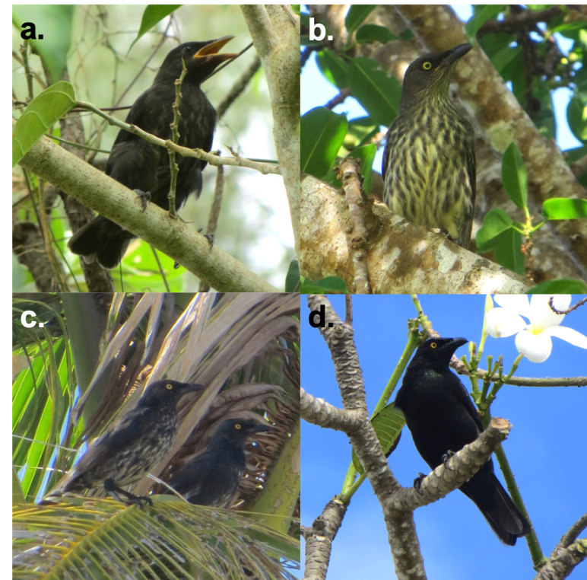
Figure S2. Estimates of extrapolated richness (i.e. number of colour-banded individuals in the AAFB Såli population) generated using the specpool function in the R package ‘vegan’ (Oksanen et al. 2013). S represents the actual number of unique color-banded birds seen during all surveys (n = 42), and the other four panels (Chao, Jackknife1, Jackknife2, Bootstrap) represent the various extrapolated estimators. Blue line represents the mean estimate and the pink lines represent the 95% confidence intervals for each estimator.
Reference: Oksanen, J., Blanchet, F. G., Kindt, R., Legendre, P., Minchin, P. R., O’Hara, R. B., Simpson, G. L., Solymos, P., Stevens, M. H. H, Wagner, H. and Oksanen, M. J. (2013) Package ‘vegan’. Community Ecology Package, version 2.

Figure S3. Såli pair nesting in a concrete power pole in Yigo, Guam, U.S.A, in 2018. Photo by Laura Barnhart Dueñas © 2019.
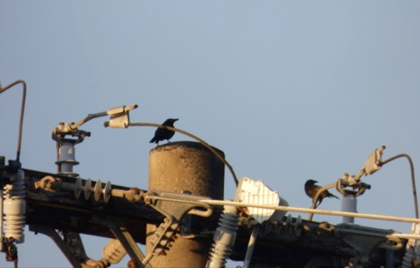

Figure S4. Raw counts of Såli for each of the 28 on-base search areas and four off-base search areas surveyed on Andersen Air Force Base, Guam, USA, during weeks 1, 2, and 3, respectively, in 2018. Attached as “Supplementary Fig. S4.pdf”.

SUPPLEMENTARY FIGURE S5. Accumulation curve of unique colour-banded individuals registered during area searches at Andersen Air Force Base, Guam, U.S.A. in September-October 2018 (21 total sampling days, 42 unique resights of colour-banded individuals).

